Our current project still relates to our goal set up in Fall 2018.
“Stay Glassy looks to recycle glass bottles in the Champaign-Urbana community by creating a product that will benefit the entire UIUC community. By working with fellow students, Stay Glassy aspires to achieve two goals: to reduce glass waste and to raise awareness of glass properties and reuse benefits. These students will turn old glass bottles into glass cups that can then be sold on campus.”
However, the project time has been extended since in addition to reducing glass waste and cutting down landfill space, we have also been training Wade, an individual from the Developmental Services center with an intellectual disability. Our long-term goal is for him to be able to run this business by himself, as he continues to upcycle glass waste into beautiful products and use the business as his source of income to increase the quality of his livelihood. From Fall 2018, we have extended our product line into customized candles and drinkable glasses for local vendors and improved our online presence immensely through our website and Instagram.

Semester goals:
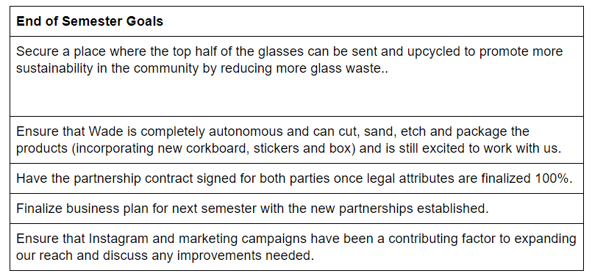
The project will directly fund:
- Candle making tools
- Soy wax and fragrance oils
- Tools to improve precision of glass cutting
- Etching machine rental
- Marketing materials (packaging design, boxes, labels)

Project Name: Stay Glassy—Illinois Enactus

Date of Report Submission: 18/11/2020

Project Purpose:
Stay Glassy is a project seeking to recycle used glass bottles, an abundant and unused resource in the Champaign-Urbana community, to create drinking, decorative, and miscellaneous glasses that will benefit the community. Glass can take up to one million years to completely decompose. By taking old glass bottles produced from university and waste, our mission is to prevent large amounts of glass from ending up in landfills through upcycling. Currently, Stay Glassy continues to improve sustainability in the Champaign-Urbana community and beyond by upcycling glass bottles into reusable drinking glasses and candle glasses, while partnering with local organizations who share similar beliefs. Stay Glassy also supports economic opportunities for people with disabilities by training and working with Wade, an individual from the Developmental Services Center who aims to take on the business to earn income in the future.

Detailed Accounting of Expenditures to Date:
Stay Glassy works to purchase items that will ultimately align with our mission of reducing glass waste as well as assist us in purchasing supplies that will make our workshops possible. Up to Fall 2018, our largest purchases include our Wet Tile Saw ($297) and Diamond Blade ($184). The purpose of purchasing these items is to ensure the cuts of each glass occur in a timely and consistent manner. Our smaller purchases include safety masks, gloves, sandpaper and acrylic enamel paints ($100).

In Spring 2019 to Fall 2019, we have purchased a dremel ($93), a tool that is used to smoothen out cut glass edges in which the wet tile saw does not have enough precision to complete. A website domain to market our products ($218.95), 20 lb of candle wax ($44.8) and product packaging materials and etching machine rental ($181).

In the Spring 2020, we had etching costs and operational goods ($16.94) and candle making materials ($167.15). This current semester (Fall 2020), our expenses are as follows:

Item | Cost ($)
Natural soy wax (with wix and tools) 10lb | 29.99
Krylon Glass Spray Paint | 13.64
Sticker paper | 13.80
Cardboard gift boxes | 21.99
Pumpkin pie candle oil | 14.99

Total | 94.41

Project Progress to Date:
Along with continuously reducing glass waste from the community. We have partnered with Sunsinger, a local restaurant in Champaign to have a constant source of glass waste donation from their wine bottles. In addition to promoting environmental sustainability and hosting selling events every semester, we have partnered with Wade, an individual with an intellectual disability from the DSC. This is in hopes of tackling an additional UN Sustainable Development Goal of Decent Work and Economic Growth, since we hope to transfer skills of glass upcycling production to Wade so when we de-link from the project, he could take over the business and earn his own consistent income from producing and selling aesthetic glass products. Over the past few semesters we have incorporated Wade into our glass production process and taught him to become more autonomous with each step so he could be confident in running the business in the future. In Spring of 2020, the team has successfully drafted up an official partnership contract that includes how much profit he would get from each item and the responsibilities of both parties. Currently, due to COVID-19 and the Developmental Services Center going into quarantine, the contract signing has been delayed, but the team has continued to upcycle around 30 glasses and hosted its first online Fall-themed selling event. Our website has also been launched with our background story and will open up as a selling platform later on: https://www.stay-glassy.com/

Student Involvement and Outreach to Date:
This semester, we have 4 Project Associates, 2 Co-Project Managers and 1 Executive Manager. In addition to consistently getting our glass waste from Sunsinger Restaurant we have officially partnered with Just Bee Acai, an environmentally-conscious vendor in the campus area to display our glasses and candles at their food truck stand and plan to draft up a contract stating each other’s responsibilities. Additionally, we are in the process of talking to Bearology, a bubble tea and juice store in Champaign, Caffe Paradiso and Checkered Moon to possibly display our customized products at their store. We also plan to extend our upcycling of glass waste for the top half of our bottles as well, since in making drinking glasses and candles only the bottom half is used. This Winter, we are preparing to send our top halves to an individual in Champaign who is constructing a Christmas tree entirely made from glass waste. In the future, we are prepared to make constant donations of our top halves to the I.D.E.A store, an arts supply store/activities place for young students. We have also hosted an online Fall-themed pumpkin pie candle sale to the UIUC community.

Marketing and Promotion Efforts to Date:
In addition to launching our official website, we have worked closely with the Enactus media team to create more appealing sticker logos, packaging design and story cards. We have also improved our engagement on Instagram by posting production processes, introducing team members, educating the community on glass waste and interacting with followers through a product giveaway. Additionally, our selling event was a collaboration between Facebook and Instagram and was an opportunity to use Facebook to extend our reach.

Additional Comments:

