# *Thank you for your commitment to green initiatives at the University of Illinois. One of the ongoing requirements listed in the terms of the funding agreement for your project is the submission of semesterly reports with key information about your project. In addition to this form, please provide additional financial documentation and/or progress photos if available.*

# *Please be as accurate as possible in describing the project (including possible setbacks or challenges in meeting the initial goals of the project). Not fully meeting your project's goals will not disqualify you from making future funding requests as long as your reports are as complete and accurate as possible. If you have any questions, please contact the Student Sustainability Committee, at* [*sustainability-committee@illinois.edu*](mailto:sustainability-committee@illinois.edu)*.*

**Project Name:** Pollinator Awareness Signage

**Date of Report Submission:** 1/22/2021

**Project Purpose:**

Original description from student proposal to SSC: “The goal of my project is to provide awareness about pollinators around the University of Illinois (UC) campus. I intend to do so with signage inside and outside of campus buildings, giving facts about native plants and pollinators. This signage will be approved by the University Board.” Since the initial fund request, we have added 4 small signs at, LAR, Wassaja, Natural Resources Building, and Burrill Hall. The larger sign will be installed at the corner of Florida Avenue and Orchard Street, by the Florida-Orchard prairie, near Orchard Downs and the Presidents’ House.”

Revised per scope change:

Originally, there were no signs at all on campus showing how pollinator friendly the campus is. Now there are four; and the University is now considered part of Bee Campus USA. Now we want to add a bigger sign outlining the bee campus student organization, progress the campus has made, and changes the university implemented to be more pollinator friendly. This sign will include an acknowledgement of the SSC funding for the signs and for several of the pollinator friendly plantings around campus.

The funding does not need to be increased, but we are requesting a schedule extension of one year, through May 2021. The design of the sign is anticipated to take at least one month, so that students can assist with the content development, then the sign will be ordered, and since it may be winter –time when the sign is ready for installation, we may not be able to install it until the spring thaw.

**Detailed Accounting of Expenditures to Date:**

We spent $618.40 to install the four small signs. The larger cost is for the large-size sign, which will hit the account in the spring.

**Project Progress to Date:**

The basic design and layout of the sign has been designed and designated information has been identified. The only thing left to do is finalize informational stats for the given categories. Those categories and sign layouts can be found in the image below.

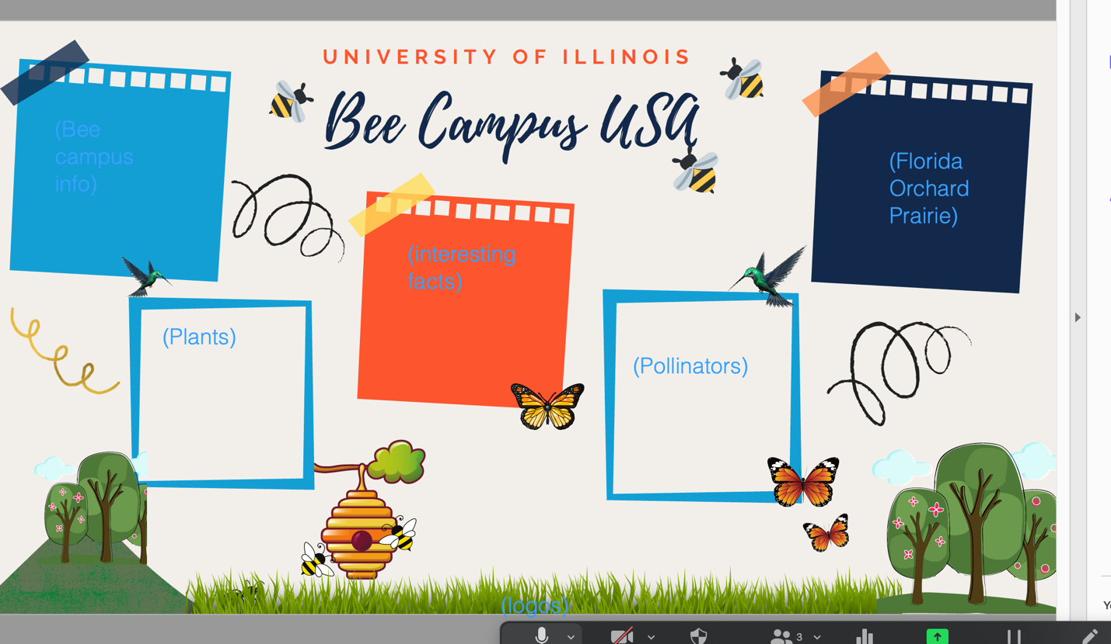

The small scale signs are installed around campus already, and the large scale sign is going to be ordered and installed this spring.

**Student Involvement and Outreach to Date:**

Around 6 student members from the Bee Campus Committee are assisting in completion of this project. They will help with placement and designing the signage.

The small signs were designed by F&S with student review, and the large sign has an initial draft by F&S student intern, Chantelle Hicks, and it will have content developed with the Bee Campus students and F&S.

**Marketing and Promotion Efforts to Date:**

N/A

**Additional Comments:**

Any additional comments/relevant information for the semesterly report