May 2023

The continuous pilot-scale plastic-to-fuel (PTF) reactor system has been overhauled and is currently operational.
Improvements Carried Out
As planned in our previous report, we carried out the following improvements to improve safety and operability:
- Many threaded joints were converted to welded ones to minimize leak points.
- Relocated catalyst addition pipe.
- Added a gas sampling port.
- Remounted motors on adjustable legs for better alignment.
- Improved access to remove residue.
Testing
The equipment was tested over several days. A barrel of polypropylene was processed to recover several liters of fuel. At the current settings, we can process 1-2 lb/hour. We plan on increasing the capacity gradually as we gain more operational experience.

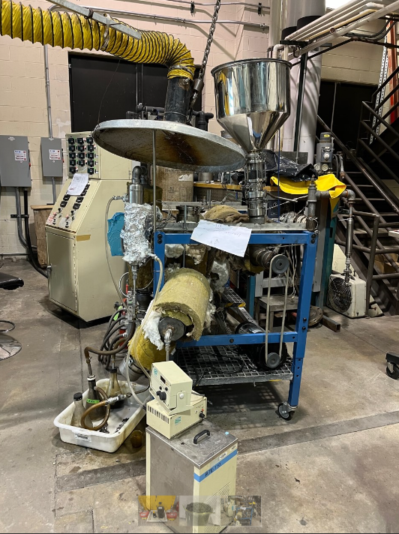  Reactor | 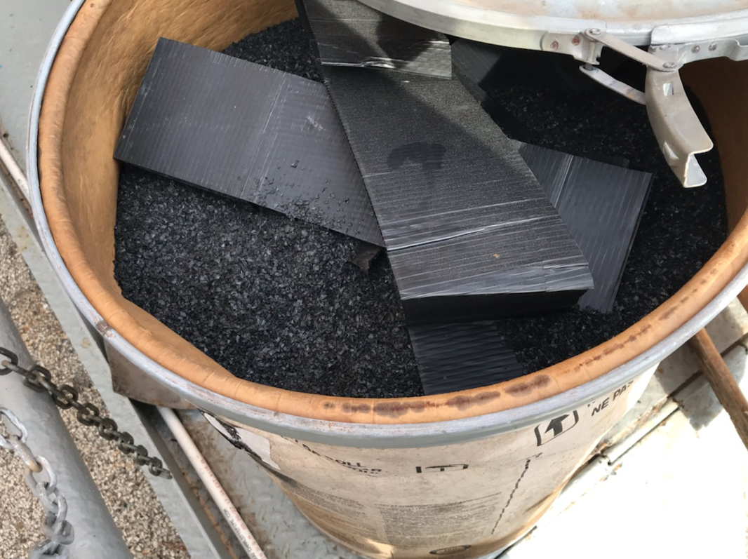  Polypropylene flakes
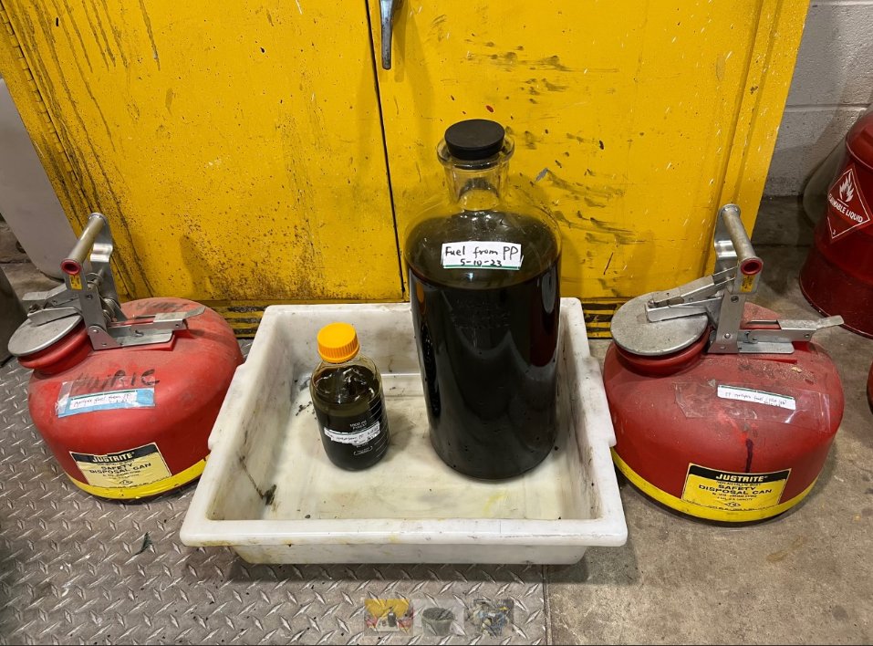  Crude Fuel, 12 liters | 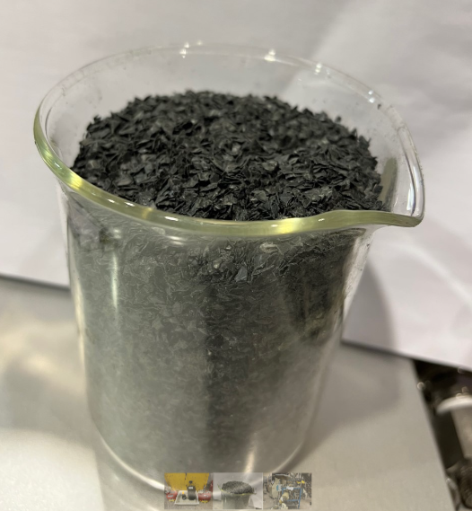  Char (Residue)

Catalyst Screening
Currently, the PP is being depolymerized thermally at 450 °C. We have screened several catalysts to lower the operating temperature using thermogravimetric analysis and small scale (100 g) pyrolysis experiments. SiAl, a relatively inexpensive catalyst, was found quite suitable. We are currently trying to identify a commercial source for testing.

Vet Med Plastic Collection
We are coordinating with the Zero Waste campus Coordinator, Ms. Hulse, and Vet Med student Varun Seth to collect PP waste material destined for the landfill. We have picked up our first 95 gallon tote for characterization and processing.
Anticipated Activity (June-December 2023)
- Collect PP from Vet Med.
- Continue to operate the reactor and gain further operational experience.
- Identify reliability issues and resolve them.
- Characterize the crude product.
- Conduct bench scale hydrogenation and characterize the product.

Student Involvement

We have hired one student over the summer to help with the pilot reactor operation.

No Cost Budget Extension

We request a no-cost extension of the project to December 2023 to continue to test the system and utilize different waste plastics on campus to determine suitability.

