# *Thank you for your commitment to green initiatives at the University of Illinois. One of the final steps in completing the terms of the funding agreement for your project is the submission of a Final Report with key information about your project. You will also need to submit a detailed report of expenses (if you don't list it within this document) as well as supporting photos to showcase your project.*

# *Please be as accurate as possible in describing the project (including possible setbacks or challenges in meeting the initial goals of the project). Not fully meeting your project's goals will not disqualify you from making future funding requests as long as your reports are as complete and accurate as possible. If you have any questions, please contact the Student Sustainability Committee, at* [*sustainability-committee@illinois.edu*](mailto:sustainability-committee@illinois.edu)*.*

**Project Name:** An Energy Saving Demonstration for Remolding Old Structures at the ABE Farm-Phase 2

**Date of Report Submission:** 10/5/2020

**Project Purpose:**

**This project aims to help meet the iCAP goal of Energy conservation in buildings and provide a sustainable environment for student research by replacing inefficient, non-sealing and rusted out overhead doors in the ABE Farm Manager and student offices, student learning, design, fabrication and shop facility.**

**Project Summary:**

The development process was actually rather easy as during the winter primarily one could walk around and see snow blowing in under the doors since they were rusted out and feel the cold air blowing through and around the doors. This was observed by faculty, staff and students working in the facility.

**Summary of Project Expenditures:**

There was only one expenditure for this project. It was to Champaign Danville Overhead Door in the amount of $23,838.00

**Problems/Challenges Encountered**

Overall the project went as planned with the exception of the extended time it took to get materials due to the Covid pandemic. Otherwise everything went as planned.

**Problems/Challenges Encountered**

Please describe any challenges or setbacks that may have impacted your project and how they were addressed

**Student Involvement and Outreach to Date:**

There were several students that helped to address the problems and assist in the calculations to determine the effect to the environment. Through this exercise the students also assisted in calculating the anticipated energy savings.

**Marketing and Promotion Efforts to Date:**

We have recognized the project through departmental communications to date. In addition we are advertising it on the monitors in the department and it will be featured in an upcoming departmental newsletter that go out to students and alumni.

**Additional Comments:**

The Agricultural and Biological Engineering Department and Farm cannot begin to thank SSC enough for their willingness to fund this important project. The positive results from this work will last for many, many years to come. This project and many others across campus would not happen without the assistance of SSC. The students of this great university should be proud of the work they are achieving not only for today’s students but the ones yet to come in the years ahead.

In addition to the above fields, please provide a detailed accounting of how the funding was spent as well as pictures of the final project in an email to [sustainability-committee@illinois.edu](mailto:sustainability-committee@illinois.edu). Thank you again for your commitment to sustainability.

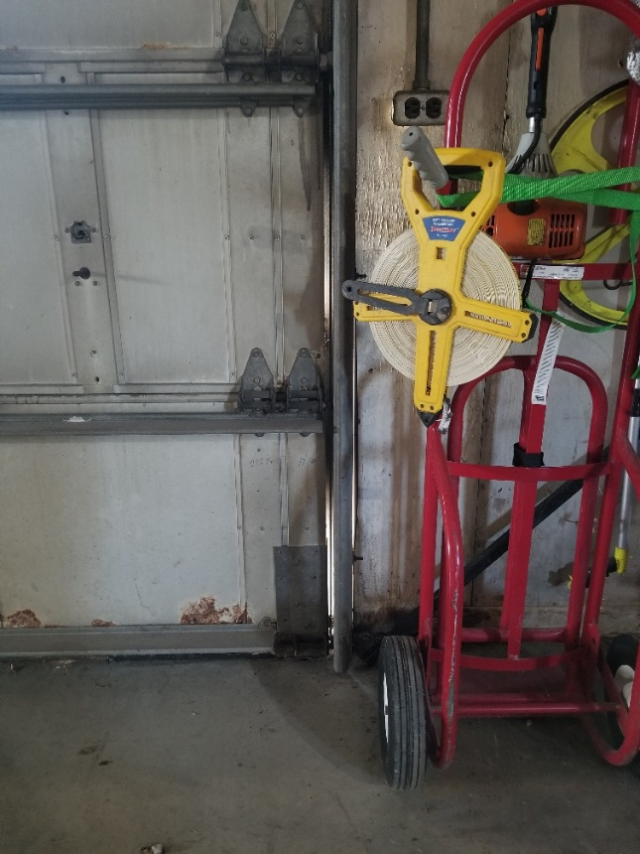

Before: note light coming in around door

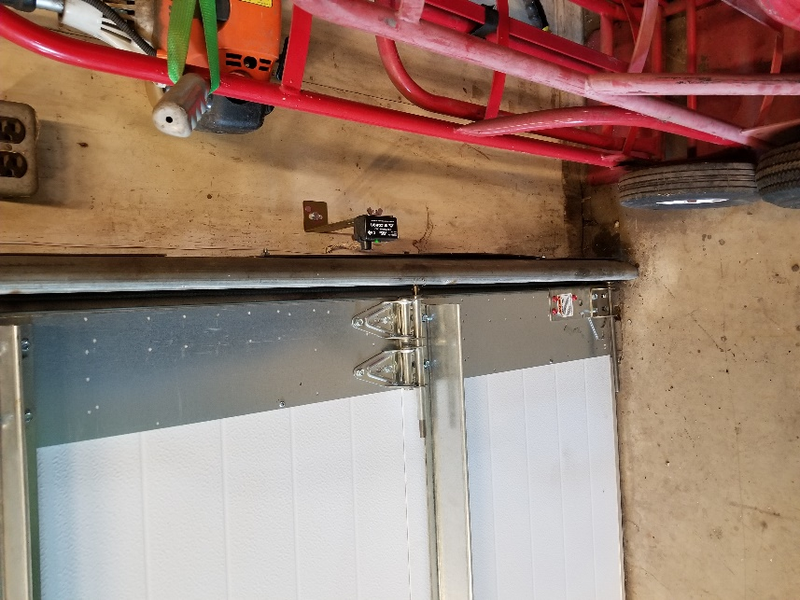

After: no more light and air coming in

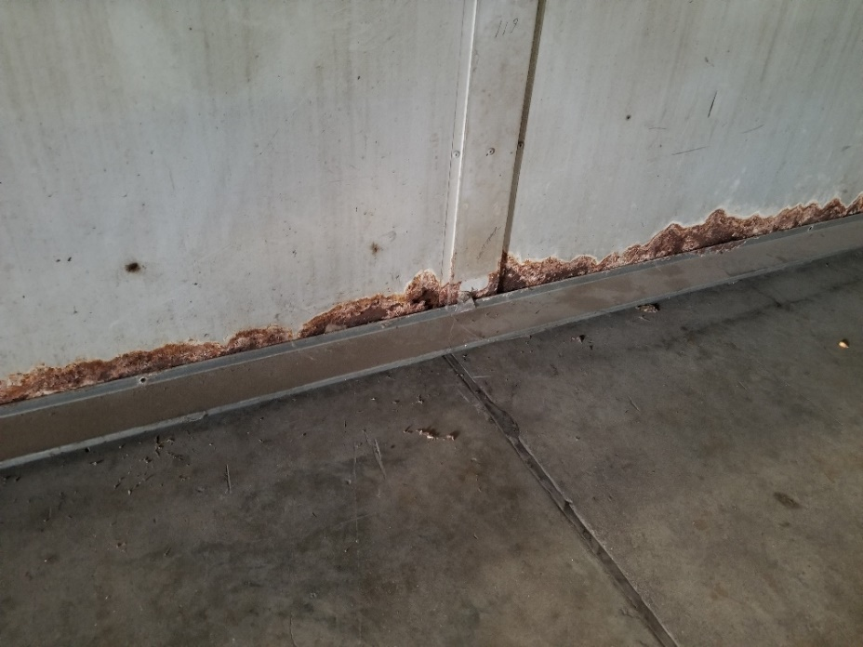

Before: Rotted out bottom of door allowing air to flow through.

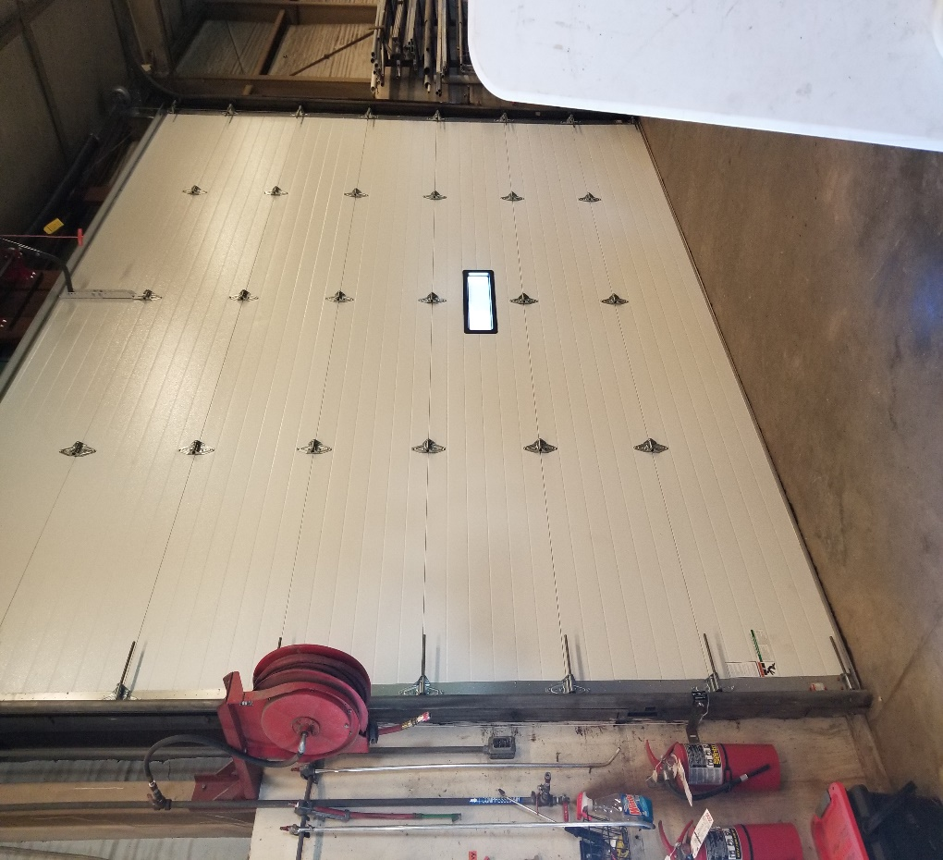

After: door is properly sealed in opening preventing air from passing around and through which will reduce energy costs.