Thank you for your commitment to green initiatives at the University of Illinois. One of the ongoing requirements listed in the terms of the funding agreement for your project is the submission of semesterly reports with key information about your project. In addition to this form, please provide additional financial documentation and/or progress photos if available.

Please be as accurate as possible in describing the project (including possible setbacks or challenges in meeting the initial goals of the project). Not fully meeting your project's goals will not disqualify you from making future funding requests as long as your reports are as complete and accurate as possible. If you have any questions, please contact the Student Sustainability Committee, at sustainability-committee@illinois.edu.
Project Name: A Living-lab Platform Based on the Campus Instructional Facility Geothermal Project

Date of Report Submission: 1/15/2022

Project Purpose:
This project aims at investigating the performance of geothermal HVAC system at CIF and visualizing the data to public, in order to arise their awareness of importance of renewable energy on campus. CIF buildings’ envelopes’ thermal properties, indoor and outdoor environments, weather conditions’ variation over a year, and the geothermal parameters need to be collected. And mathematical models for designing the geothermal HVAC system should be developed and integrated into an open-source, hands-on-easy web-application. In the end, the technical facts and energy savings’ predictions of the CIF project are shown through some digital display located in CIF for educational purpose.

Detailed Accounting of Expenditures to Date:
Research Assistantship for one PHD Student: $4500 (Paid by 07/01/2021).
Temperature sensor installed at the steam tunnel (provided by F&S, free).
Display screen (suspended due to the limit installing space in CIF)

Project Progress to Date:
The building information of CIF has been completely collected. I reached out to Beth Leitz from Facilities & Services and obtained the access to the campus facilities data. The building drawings showed the dimensions and materials of envelopes. Also, an overall energy analysis for the CIF was conducted in Design-Builder software to estimate the heating/cooling loads. To summarize the constructional/technical information of CIF, two slides were created and displayed on one of the screen in CIF. A snapshot was attached below.

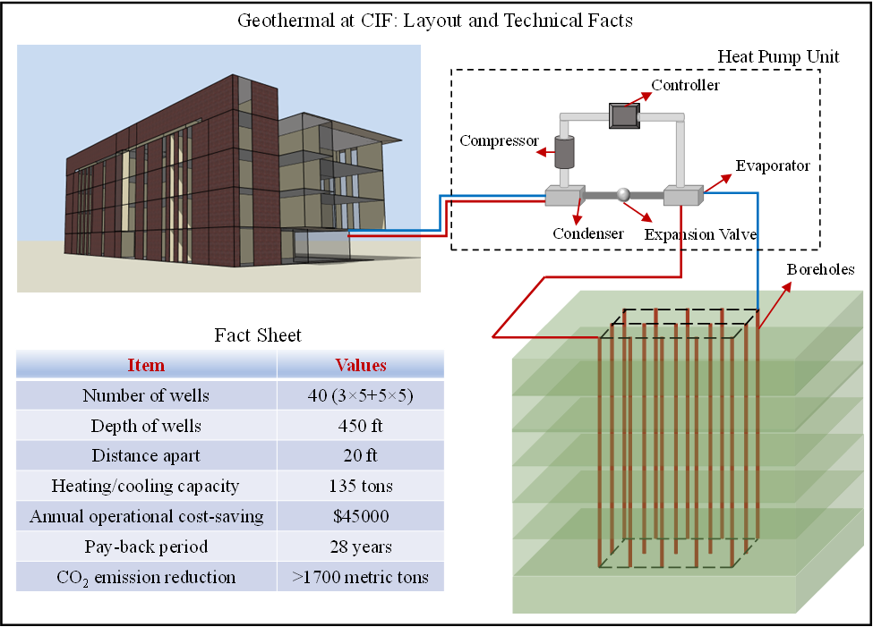

Furthermore, a mathematical model for assessing the geothermal HVAC system is established. The model is primarily consisted of the calculations of subsurface thermal response and GSHP economic benefits. The model has been compiled into a MATLAB Web-app for use of educational purposes for any interested students. The interface of the app and examples of results are shown below.
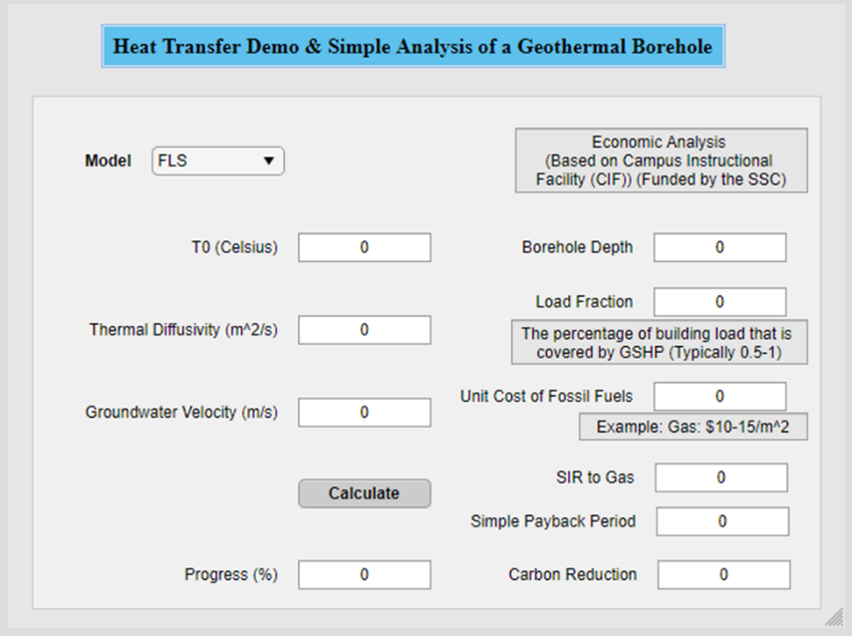
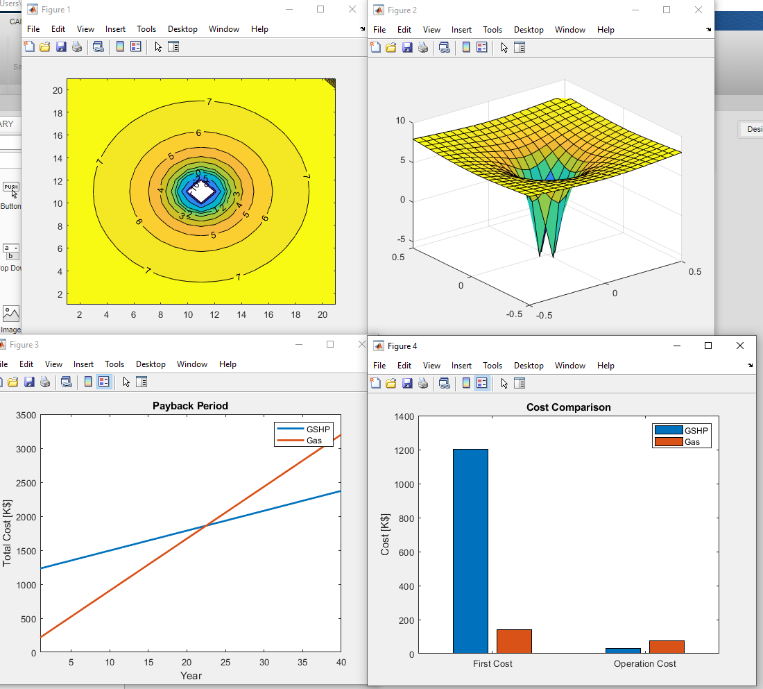

I had talks with Mr. Robbie Bauer (Utilities Distribution Management Engineer) and coordinated with controls electrician Robert J. about installing a temperature sensor at the steam tunnel pipe (that provides heat to the CIF). The sensor has been successfully installed and the thermal data can now be accessed through eDNA APP, as shown below. The other three pictures are the underground site of steam tunnel, temperature sensors on the steam pipe and tunnel wall, respectively. The mathematical model and web-app compiling were completed on 2022.01.09. This can be used by students in class who are interested in the design of ground source heat pump system.
Figure 1 Temperature variations at the steam tunnel
Figure 2 Installation of temperature sensors inside steam tunnel

Student Involvement and Outreach to Date:
In the course ABE 436 (Renewable energy systems) and TSM 438 (Renewable Energy Applications) in Fall 2021, an introduction to geothermal energy and applications has been presented to over 50 students. The system layout, technical facts and environmental-economic benefits of CIF geothermal were explained in detail. The students may have a better understanding and stronger awareness towards geothermal based on the information acquired from CIF project and the SSC. Below presents some pictures taken from the classroom.
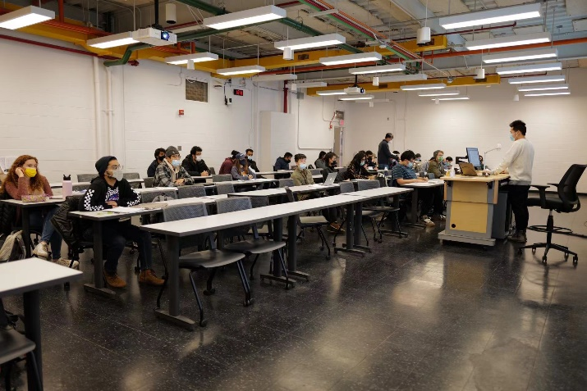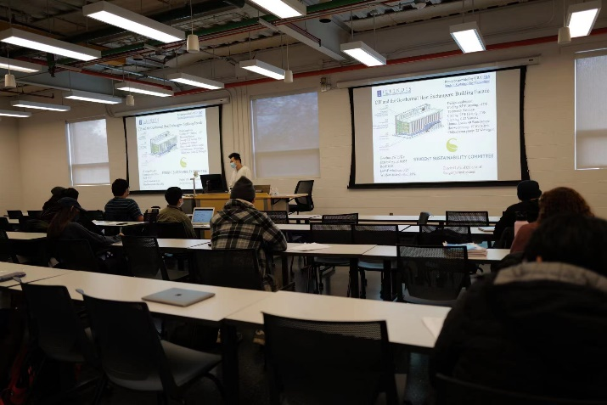

Additional Comments:
Thanks to the funding & technical support from the SSC and F&S, I organized two papers related with geothermal HVAC system. One of them has been published (The link: https://doi.org/10.1016/j.applthermaleng.2021.117341 ) and the other is currently under review. In the Acknowledge parts of both papers, we thanked the SSC of UIUC for your support. These publications are beneficial to improve the public awareness of renewable energy systems, especially geothermal energy systems, which aligns with the SSC’s goals in motivating carbon-reduction acts.

