Thank you for your commitment to green initiatives at the University of Illinois. One of the ongoing requirements listed in the terms of the funding agreement for your project is the submission of semesterly reports with key information about your project. In addition to this form, please provide additional financial documentation and/or progress photos if available.

Please be as accurate as possible in describing the project (including possible setbacks or challenges in meeting the initial goals of the project). Not fully meeting your project's goals will not disqualify you from making future funding requests as long as your reports are as complete and accurate as possible. If you have any questions, please contact the Student Sustainability Committee, at sustainability-committee@illinois.edu.
Project Name: A Living-lab Platform Based on the Campus Instructional Facility Geothermal Project

Date of Report Submission: 9/7/2021

Project Purpose:
This project aims at investigating the performance of geothermal HVAC system at CIF and visualizing the data to public, in order to arise their awareness of importance of renewable energy on campus. CIF buildings’ envelopes’ thermal properties, indoor and outdoor environments, weather conditions’ variation over a year, and the geothermal parameters need to be collected. And mathematical models for designing the geothermal HVAC system should be developed and integrated into an open-source, hands-on-easy web-application. In the end, the real-time energy transfer and energy savings of the CIF project can be shown through this living lab for educational purpose.

Detailed Accounting of Expenditures to Date:
Research Assistantship for one PHD Student: $4500 (Paid by 07/01/2021)

Project Progress to Date:
The building information of CIF has been collected that is close to completion. I reached out to Beth Leitz from Facilities & Services and obtained the access to the campus facilities data. The building drawings showed the dimensions and materials of envelopes. Also, a report for the CIF energy analysis was used to estimate the heating/cooling loads. A snapshot was attached below for illustrating the above-mentioned two files.
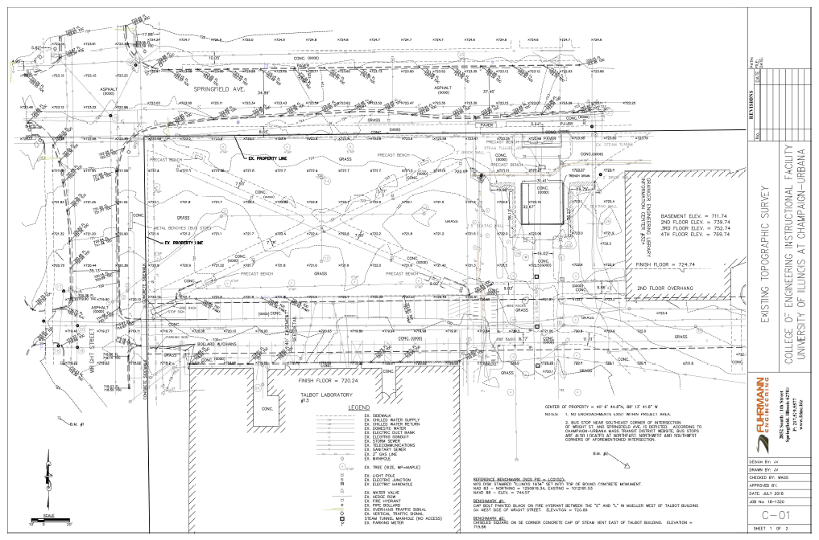
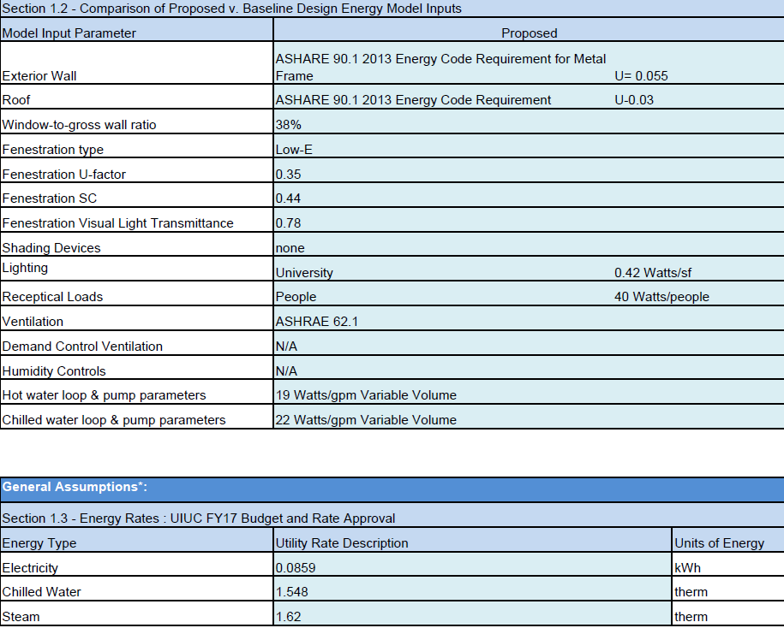

Further, at the modeling side, I have established a mathematical model for designing the geothermal HVAC system (needs to be refined in the future). And the model will then need to be compiled into a MATLAB Web-app for public use. (A fundamental interface is shown below)
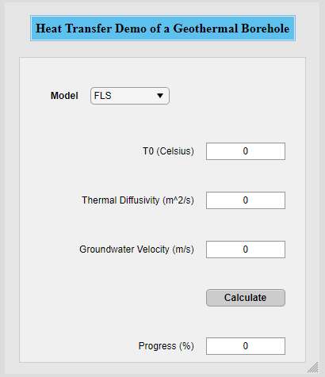
I had talks with Mr. Robbie Bauer (Utilities Distribution Management Engineer) and coordinated with controls electrician Robert J. about installing a temperature sensor at the steam tunnel pipe (that provides heat to the CIF). The sensor has been successfully installed and the thermal data can now be accessed through eDNA APP, as shown below.

The mathematical model and web-app compiling are expected to be completed by the end of 2021. And after that, a digital screen will be ordered and installed at the basement of CIF to show the data.

Student Involvement and Outreach to Date:
In 2021 Fall, I am the TA for the class ABE 436 (Renewable energy systems). In the course materials, introduction to geothermal energy and applications has been included. The students may have a much better understanding based on the data acquired from CIF project.

Additional Comments:
Thanks to the funding & technical support from the SSC and F&S, I organized two papers related with geothermal HVAC system. One of them has been published (The link: https://doi.org/10.1016/j.applthermaleng.2021.117341 ) and the other is ready for submission. In the Acknowledge parts of both papers, we thanked the SSC of UIUC for your support. These publications are beneficial to improve the public awareness of renewable energy systems, especially geothermal energy systems, which aligns with the SSC’s goals in motivating carbon-reduction acts.

