**Funding Criteria**

**A. General Rules**

1. Students, faculty, and staff are encouraged to submit requests for funding. Student-led projects require a faculty or staff sponsor in order to have funds awarded.
2. Funding can only go to university-affiliated projects from students, faculty, staff, and departments.
3. All SSC projects must make a substantial impact on students. All SSC funding is 100% from student green fees, so the projects funded by the students must benefit them.

**B. Things SSC Can Fund, On A Case-By-Case Basis**

1. SSC can fund feasibility studies and design work; however, it must work toward ultimately addressing a sustainability need on campus.
2. SSC can fund staff positions that are related to improving campus sustainability. Strong preference will be given to proposals receiving matching funding from departments and/or plans for maintaining continuity of the position after the end of the initial grant.
3. SSC can fund outreach events with a central theme of sustainability, provided their primary audience is the general campus community.
4. SSC discourages requests for food and prizes but will consider proposals on a case by case basis.
5. SSC can fund repairs and improvements to existing building systems as long as it works toward the goal of improving campus sustainability.
6. SSC can provide departments with loans for projects with a distinct payback. Loans will require a separate memorandum of understanding between SSC and departmental leadership pledging to repay the award in full and detailing the payback plan.

**C. Things SSC Will Not Fund:**

1. SSC will not fund projects with a primary end goal of generating revenue for non-University entities.
2. SSC will not fund personal lodging, food, beverage, and other travel expenses.
3. SSC will not fund any travel expenses.
4. SSC will not fund tuition or other forms of personal financial assistance.

**Instructions**

*Submit this completed application and one map, graphic, or picture to* [*Sustainability-Committee@Illinois.edu*](mailto:Sustainability-Committee@Illinois.edu)*. Please adhere to the session word counts. The committee holds the right to decline applications over the designated word counts. If you have any questions about the application process, please contact the Student Sustainability Committee Coordinator at* [*sustainability-committee@illinois.edu.*](mailto:sustainability-committee@illinois.edu.)

**Project Name:**

**Total Amount Requested from SSC:** $50,000

**Primary Project Leader Name & Email:** Dr. Samantha Lindgren, salindgr@illinois.edu

|  |
| --- |
| **Project Abstract:** In less than 100 words, briefly describe your project. |
| Green walls are increasingly common in educational spaces for the improved health, well-being, and academic outcomes they afford, and for improved indoor environmental quality via reduced noise pollution, thermal stabilization, and air filtration. The wall will be designed by students and installed in the College of Education’s (COE) south atrium, an existing meeting and study space. The green wall will serve as an innovative teaching and learning space for COE courses including those for teachers, increasing sustainability education on campus. All students will be welcomed into the space where informal learning (exhibit signage and associated COE webpage) will be available. |

|  |  |  |  |  |  |
| --- | --- | --- | --- | --- | --- |
|  | Education | Energy | Food & Waste | Land & Water | Transportation |
| Project Category | X |  |  |  |  |

**Project Team Member List** (student projects must include their faculty/staff advisor’s information)

|  |  |  |
| --- | --- | --- |
| Name | RSO/Department | Email Address |
| Jon Hale | Education Policy, Organization & Leadership (EPOL) and Curriculum & Instruction (C&I) | jonhale2@illinois.edu |
| Jeffry Royce | College of Education Facilities | jroyce@illinois.edu |
| Presley Fee | EPOL, Graduate Student | [psfee2@illinois.edu](mailto:psfee2@illinois.edu) |
|  |  |  |
|  |  |  |
|  |  |  |

|  |  |  |
| --- | --- | --- |
| Questions | Yes | No |
| Is this a student-led project? |  | X |
| If applicable, have you received approval from Facilities & Services and/or site manager? | X |  |
| Do you have a plan for ongoing funding beyond SSC? (SSC cannot guarantee ongoing financial support) | X |  |
| Beyond SSC, do you have sources contributing funding or support (ex. staff time, external grants, etc.) to this project? | X |  |
| Have you applied for SSC funding previously? |  | X |

|  |
| --- |
| **Project Timeline** |
| SSC funding agreements remain active for two years. Please list your project’s timeline and/or milestones. |
| **Fall 2023:** Obtain estimates from green wall companies in Illinois  **Spring 2024:** Convene student working group (undergrad and graduate students) to work with green wall company on design  **Summer 2024:** Order supplies for wall system: wall framing, filtration system, planting medium, plants  **Fall 2024:** Hire UIUC contractors to move existing artwork and install green wall; EPOL 421 students develop signage and teaching guides for utilizing the space with visitors and students  **Fall 2024-Spring 2025:** Monitoring and evaluation of green wall uses within COE and student experiences |

|  |
| --- |
| **Project Description** |
| In 250 words or less, describe your project. What does your project hope to accomplish? What are your project’s deliverables? Bullet points welcome. |
| The aim of our project is to build a “green wall” - a vertically built structure covered with plants and vegetation and a water filtration system - in the College of Education (COE) to create an environmental learning space that promotes and advances the merits of Environmental and Sustainability Education (ESE). This space is additionally designed to improve the overall aesthetic and learning experience by providing a unique space that uses plant life to create a green environment to study, learn, and cultivate a grounded sense of well-being. Additionally, the wall itself is educational in its use of green technology and architecture that provides natural air filtration, thermal stability, and noise absorption to meet green climate standards set in the iCAP. The COE is a fitting place to build an innovative space intended for ESE.  Built in 1964, the building was designed as an experimental, open-space concept that mirrored the progressive social and political trends of the time. This period brought renewed research in experiential learning, collaboration, and centering students to advance democratic ideals - but not ESE. A green space reinvigorates the historic mission of the COE by providing innovative learning opportunities to advance ESE for on-campus students, engage students from across campus through informal learning, draw visitors, and make a visual commitment to the progressive social and climate goals advanced by the COE, embedded in the iCAP, and championed by current and future Illini. |

|  |
| --- |
| **Environmental Impact** |
| In 200 words or less, how does your project increase environmental stewardship at UIUC? If applicable, what is the carbon, water, waste, and/or energy savings? Does your project relate to the iCAP? Bullet points welcome. |
| Increasing environmental stewardship is inextricably linked with education. The field of ESE strengthens the connections between knowledge, action, and responsible decision-making.  This project supports the iCAP goal of **Doubling Green Infrastructure Installations (4.2.3)**. Green walls provide indoor environmental benefits including:   * Better air quality * Reduced noise pollution * Thermal stability   This proposal **Broadens Sustainability Education (6.1)** by creating a new and innovative teaching and learning space as COE increases its ESE offerings. This wall will be used with COE students (future teachers and policy makers) to:   * Explore novel ways of teaching ESE within formal PK-16 classrooms (e.g., nature- and place-based pedagogies, hydroponics, food security, energy efficiency) thereby increasing ESE and stewardship for K-12 students in Illinois and nationwide * Explore environmental justice issues (e.g., access to greenspaces, including green walls, during the school day is associated with better academic outcomes/attention, schools in impoverished or urban areas lack the greenspaces available to predominantly white schools) * Connect students more deeply to nature * Provide informal ESE learning opportunities to the broader campus community through signage and a website   Goal **Support Youth Sustainability (7.5)** is advanced by involving COE and campus students in the design and development of the green wall (below). |

|  |
| --- |
| **Student Impact** |
| In 200 words or less, how will this project benefit students? How will students be involved with this project? What educational components are in your project? Bullet points welcome. |
| In addition to the benefits and opportunities for students listed above, the green wall supports student well-being by providing an indoor greenspace. The improved mental health benefits of being in nature are many, unfortunately more than half of the academic year in Illinois occurs during months when access to outdoor greenspace is limited. Green walls have been called “restorative spaces” in the academic literature for their emotional and psychological benefits. Supporting the mental health of our students is a current campus priority. The south atrium in the COE building is already a meeting and study space with sofas, tables, and chairs, providing students from across campus with a restorative space year-round.  Philosophically, Sustainability Education is a community-based and participatory field. As such, the design of the green wall will be a community endeavor and will be led by students. COE undergrads and grad students, as well as those interested across campus, will be invited to join a working group, facilitated by COE faculty and staff, to work with a green wall company on the design. Students in EPOL 421, a course created with iSEE’s support, will develop the text for signage and an associated COE webpage. |

**College of Education South Atrium**

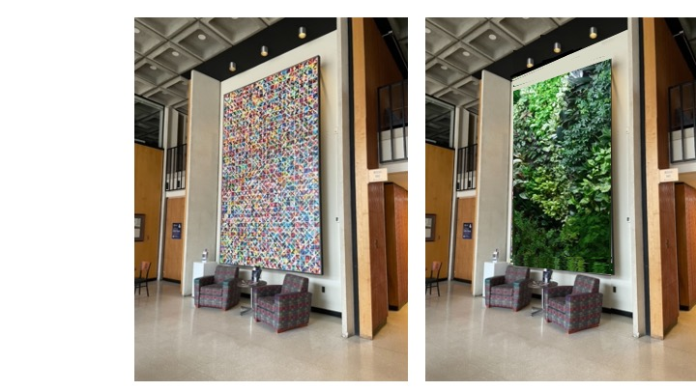

This image shows the space as it currently exists, and with a mock-up example of a green wall to demonstrate the potential of the space.