CEE 449: Environmental Engineering Lab

May 10th, 2024

**Testing the Lead and Copper Levels of Drinking Water on Campus**

Final Report

Team 4: Aaron Leshuk-Morita, Matt Wingen, Issa Fouani, Jackson Moore

Team 5: Isabelle Newsom, Noemi Carrasco, Dominika Szal, Hailey Grubich, Abbey Fields

Team 6: Aaron Marszewski, Izabela Dimevska, Alexis Ferraren, Siari Rodriguez-Ayala

**EXECUTIVE SUMMARY**

Concerns over water quality within the campus population have led to widespread use of plastic water bottles, thus creating a large amount of waste. To address these concerns, we conducted research projects over the semester focusing on the type of filtration, stagnation, and age of building to determine if there are any significant changes to the water quality based on these factors. This research will be used to determine what type of filter should be utilized considering both safety and economics. This paper outlines the selection criteria that each group used for determining the building and site locations. The hydration stations that were tested included stations found in the Union, Campus Instructional Facility (CIF), Florida Avenue Residence (FAR) dormitory, and Illinois Street Residence (ISR) dormitory, with specific stations and dates outlined later in this paper. Initially, we conducted preliminary free chlorine tests on each of the hydration stations to determine and compare the filtration status of the stations with the list from Facilities and Services. Each group collected water samples and brought them back to the Hydrosystems Laboratory where samples were prepared for inductively coupled plasma mass spectrometry (ICP-MS) analysis. From our results, we noted that the concentrations for total lead and total copper were well below the United States Environmental Protection Agency’s (EPA) action levels regardless of filtration status or age of the building, as pictured in Figure 1. Our groups identified that there were no significant differences between types of filters; however, we would like to suggest that the University choose to go with a filtered hydration station if they are concerned about taste, or an unfiltered hydration station if they are concerned about price. Using this information along with an economic analysis of providing every two students in the dormitories with a Brita filter and installing a filtered or unfiltered hydration station, we determined a recommendation for the University. Due to the price of the Brita filters, which amounts to $2.8 million for ten class years, and the overall water quality that the campus has, it was determined that the Brita filter option was not economically viable.

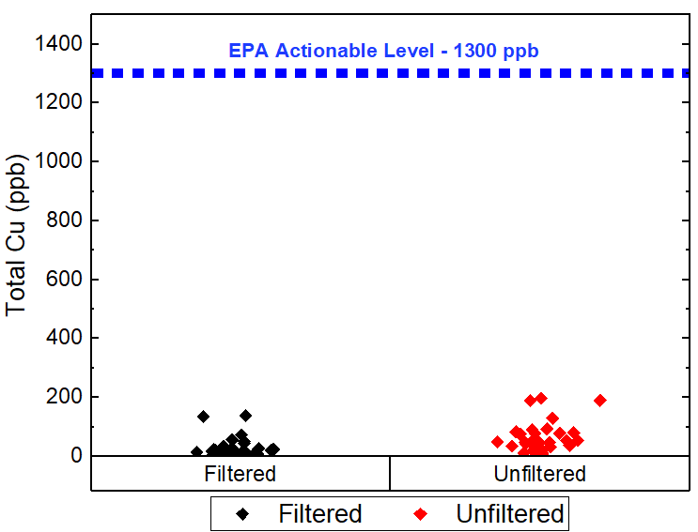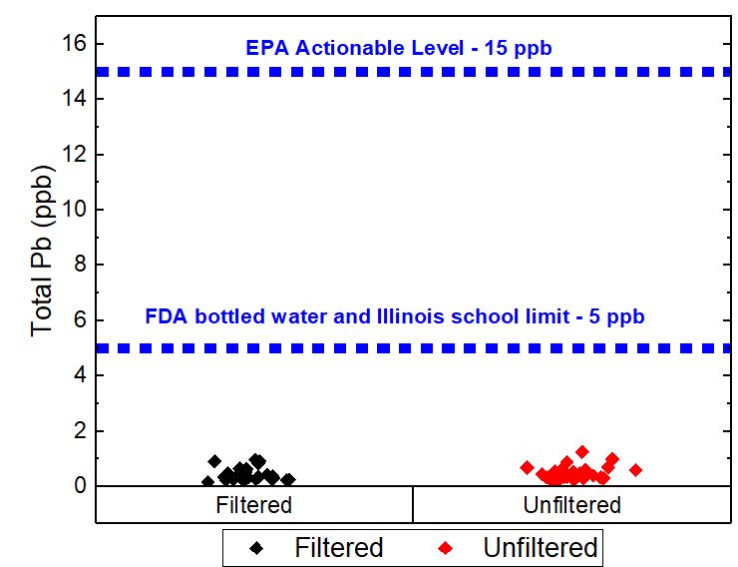

**Figure 1. Total Lead and Total Copper Concentration Diagrams with Regulation Standards**

**INTRODUCTION**

According to the non-profit organization *Plastic Oceans International*, it is estimated that 10 million tons of plastic get into our oceans each year, and roughly half of those plastics are single use.[6] The rest are disposed of in landfills where they can leach into rivers, lakes, drains, aquifers, and other drinking water sources. The majority of bottled water is made from a plastic called polyethylene terephthalate (PET), which can take over 400 years to fully decompose.[8] Other plastics share similar lifetimes and can partially degrade into toxic microplastics and nanoplastics. They also bioaccumulate in marine and land animals which not only kills over a million of them annually, but also threatens the safety of our food chain. On average, 28 gallons of water are needed to produce one pound of plastic.[7] In the U.S., plastics manufacturing is also energy and carbon intensive as well, requiring 54 million barrels of oil annually for burning and refining; a process that emits over 23 million tons of ${CO}_{2}$ per year just in our country.[1] Burning crude oil creates toxic hydrocarbons for use in plastics, including antimony, benzene, polyethylene, and more. Ultimately, the life cycle effects of plastics are detrimental to our health and the health of our planet. Eliminating the demand for bottled water in return for increased use of filling stations will significantly improve our health, environment, and ecosystems. We believe this initiative can start on our University of Illinois campus.

According to a 2022 Drinking Water Behavior Survey conducted by the Institute for Sustainability, Energy, and Environment (iSEE), the average percentage of students surveyed who said they preferred bottled water over tap water was 53%.[2] What’s more interesting is the majority of all students surveyed said they preferred filtered over tap water.[2] The UIUC campus receives its drinking water from the Mahomet Aquifer, which provides drinking water supply for over half a million Illinois residents. As of 2018, 18 PFAS were tested and were non-detect;[10] its high alkalinity water makes it PH resilient, and it has a history of overall excellent water quality. We are blessed to have such a clean source of drinking water and must preserve it for future students and generations. Decreasing plastic use on our campus will ensure that less plastic makes it to landfills in neighboring communities - a great way to preserve the cleanliness of the aquifer.

The goal of our research projects is to quantitatively prove to our community that UIUC drinking water is extremely safe, to persuade the other half of students to make the switch from purchasing bottled water to using bottle filling stations. Since most students prefer the filter, we will also test the difference between filtered and unfiltered filling stations across different aged buildings, residence halls, and examine the effects of stagnation on each. The primary metrics we will use to assess drinking water quality are lead and copper concentrations. Lead is a neurotoxin and is not good to ingest in any amounts, meaning its maximum contaminant level goal (MCLG) is 0, as it has a multitude of consequences on our health. Copper isn’t nearly as bad and is actually beneficial for us in small amounts, but has a maximum contaminant level (MCL) of 1.3 ppm. Consuming water with copper levels above this threshold can cause nausea, liver, and kidney damage. We did not test for microplastic concentrations, as we know bottled water contains significantly higher amounts of microplastics than tap water. By switching from bottled water to filling stations, students will significantly reduce their exposure to microplastics and the toxic effects it has on them.

**RESEARCH QUESTIONS**

The primary goal of this project was to investigate the variations in water quality in different age campus buildings and if the filtration systems in place improve drinking water quality. In the context of this research, water quality was judged by the presence of heavy metals and chlorine. This information was ultimately used to determine whether filters in drinking fountains are worth the cost. The end goals of the project were to inform the campus community if they should be mindful of the variation of water quality between different aged buildings and if this is affected by the presence of a filter.

**VARIABLES**

Each group considered whether filtered or unfiltered bottle filling stations had an effect on the water quality. Beyond this, the age of the building, the type of filling station, and how stagnate the water was were different variables to be investigated.

When sampling, each team had to consider: time of day, sampling volume, and pollutant concentrations.

**SAMPLING METHODOLOGY**

*Water Chemistry*

Building age is one aspect that may further affect the water chemistry servicing the bottle filling stations. The older a building is, the more likely it is to have aged plumbing systems, which may or may not include outdated lead service lines. Aged drinking water pipes pose a threat to drinking water quality, as they can be corroded. Corrosion is caused by a mixture of oxygen, water, and metals and in turn causes the pipe’s metal to break down. Broken down metals can then be carried by water and increase the level of metals in drinking water.

Filters, specifically activated carbon filters, work by adsorption. The granular activated carbon has a large surface area for contaminants, like heavy metals or chlorine, to adsorb onto. The water passes through the filter, and the filtered water comes out the other end. The granular activated carbon filters meet their max capacity when all the surface area of the carbon is filled. At UIUC, Elkay filters are used at filling stations, which claim to reduce chlorine and lead levels.

Stagnation occurs when treated water sits in the service line pipe for an extended period of time. Due to the added chlorine residuals in the water to meet disinfection requirements, the chlorine can interact with the metals in the pipes and the organic matter, along with scale, found in the pipes as well. Under normal conditions and usage of the water, or constant “flushing,” the chlorine does not have time to interact with the metals or organic matter. However, if stagnant conditions occur, chlorine levels would decrease due to such chlorine oxidizing the metals, therefore indicating the metals dissolved in the water would increase. For our research, we hypothesized that lower chlorine levels would indicate higher lead and copper concentrations.

*Varied-Age Building Sampling*

Samples were collected from filtered and unfiltered water sources from two different aged buildings, the CIF and the Illini Union. The CIF was completed in 2021 and represented the new building, whereas the Illini Union was completed in 1941 and represented the old building.[1,13] Samples were collected in high traffic areas in each respective building, in between the times 11-4 pm to ensure the buildings had been occupied for the morning to avoid effects of overnight stagnation. Unfiltered samples were taken at each building from either a faucet or unfiltered drinking water fountain. Then filtered samples were taken at each building from a filtered bottle filling station. The age of each filter used was recorded from the Facilities & Services (F&S) records. In total, 48 samples were collected. 24 samples were taken at the CIF, and the remaining 24 were collected at the Union. Blanks were incorporated into the ICP-MS process with DI water and 5 ppb control vials placed into the rack of sample vials. The individual sampling events involved collecting 1st and 2nd flushes, each 1 L in volume, taken consecutively from the same station. This took into account different flushes having different lead concentrations. Unfortunately, 24 of 48 sample measurements were performed on an ICP-MS instrument that lacked the sensitivity to measure samples at such low concentrations, so we had to discard half of the samples.

For the CIF, 3 filtered and 3 unfiltered locations were sampled. 2 sampling events were conducted at each location. During the sampling events, 2 flushes, each 1 L in volume, were collected. A total of 12 1L samples of filtered CIF and 12 1L samples of unfiltered CIF water were collected. Maps of all CIF sampling locations can be seen in Figure 2.

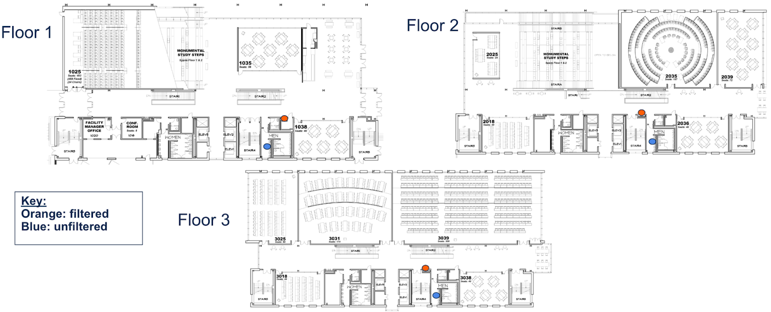

**Figure 2. CIF sampling plan map.[12]**

For the Union, 2 filtered and 3 unfiltered locations were sampled from. There are only 2 bottle filling stations designated as having filters on the F&S spreadsheet for the Union. 3 sampling events were conducted at each filtered station while 2 sampling events were conducted at each unfiltered location. A total of 12 1L samples of filtered Union and 12 1L samples of unfiltered Union water were collected. Maps of all Union sampling locations can be seen in Figure 3.

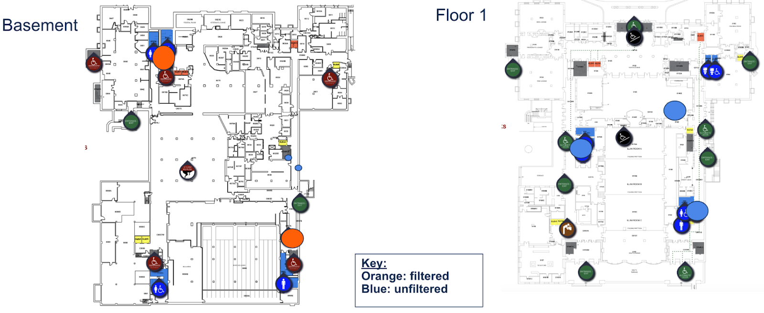

**Figure 3. Union sampling plan map.[12]**

The filtered locations in both buildings are noted in a filter change log, where rate of filter change and a record of previous changes is kept. The two filtered Union locations are changed semi-annually, as it states, and were last changed August 21, 2023. CIF filters are changed less often, being annually, and were last changed nearly a year ago on April 17, 2023. Considering our last samples were taken on April 16th of this year, the CIF samples are likely filtered through nearly-expired filters that may not be as effective as otherwise. The filters are still technically within the recommended safe range, however, and we made the assumption that this will not have a significant effect on our data. A summary of the filter change log of our filtered locations can be found below in Table 1.

**Table 1. Summary of filter change log of filtered locations.**

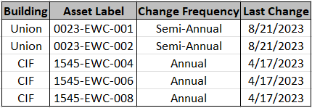

*Varied Hydro Station Sampling*

There are three different types of water bottle refilling stations that can be found on campus –– glass fillers, filtered water fountains, and unfiltered water fountains. Glass fillers also produce unfiltered drinking water. Samples were collected from four water filling stations at the Florida Avenue Residence Hall (FAR) to investigate the copper and lead levels at the three different types of water filling stations. This specific residence hall was selected as it was believed to contain all three types of water fountain and it has a large student population which consists primarily of first-year students. Furthermore, our team wanted to ensure that all the samples that we collected came from the same plumbing system.

The specific locations and types of the hydro stations in FAR, based on initial chlorine sampling, are as follows: 1 glass filler on the second floor, 1 unfiltered bottle filler on the first floor, 1 unfiltered bottle filler in the basement, and 1 filtered bottle filler in the basement. The highlighted locations can be seen in the figures below, and the basement locations can be found in the Appendix.

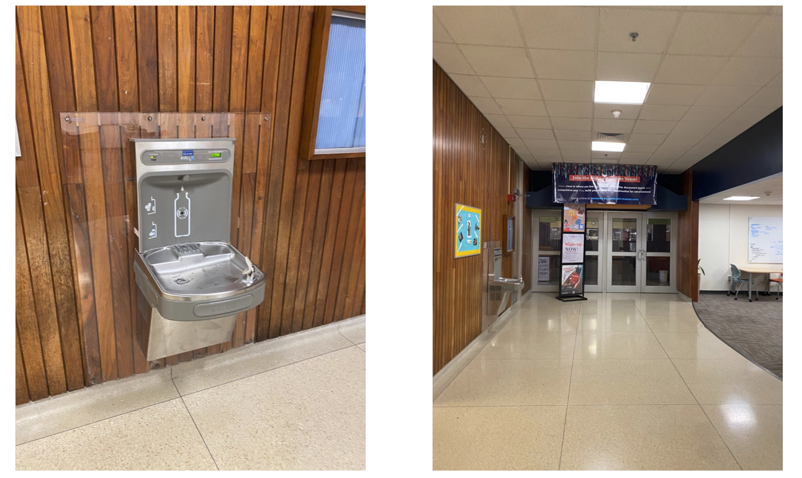

**Figure 4. Water fountain in the first floor lobby of FAR, located near the closed dining hall**

**Figure 5. Location of glass filler on the second floor of FAR [12]**

​​Forty nine samples were collected in total. Twelve samples were collected from each of the four FAR hydro stations, and one sample from a plastic water bottle. When collecting the samples, two duplicates of the first flush and two duplicates of the second flush were taken. The samples from FAR were collected on three different days, with four samples being collected each day from each hydro station. The samplings took place on April 11th, April 16th, and April 18th at approximately 12 P.M.

According to data provided by Facilities and Services, the first floor and basement fountains were labeled as filtered. In order to verify this, we conducted chlorine tests on all four fountains during the first two days of sampling to determine whether the water fountains were filtered and unfiltered. If the water fountains were indeed filtered, then there would be very little to no chlorine in the sample. After the chlorine tests were done, we prepared all forty nine samples for ICP-MS testing by inserting nitric acid into 10 mL samples. These samples will then undergo testing for lead and copper concentrations.

*Varied-Age Building Sampling: Stagnation*

The second group of varied-age building locations was Florida Avenue Residence Hall (FAR) and Illinois Street Residence Hall (ISR). ISR is a new residence hall where piping is expected to be more up to date as the building underwent major renovations in 2021, representing the new building. On the contrary, FAR, built in 1964, represents the older building where there are no known updates to the drinking water pipes since. Stations of filtered and unfiltered status were chosen between both locations. The sampling locations for ISR can be seen in Figure 6.



**Figure 6. ISR Floor 00 Sampling Locations (Blue as Unfiltered and Orange as Filtered)[12]**

For FAR, the unfiltered was a bottle filler station in the basement gym, and the filtered was a bottle filler station in the basement hallway, shown in Figure 7. For ISR, the unfiltered station was a bathroom tap on the ground floor of ISR, since there were no unfiltered stations to our knowledge. The filtered for ISR was a bottle filler on the ground floor next to the bathrooms.

To best accommodate for the overnight stagnation period, each sampling event began at 7 am. For each building, a team of two people collected samples from each filling station for a total volume of 3L collected in twelve 250 mL samples. A volume of 3L was needed to investigate the effects and falloff of stagnation. This sampling routine will be replicated three times a week on Wednesday, Thursday, and Friday for two weeks to have consistent results. We first tested the stations for their chlorine levels the first four sampling days at ISR only due to pending building access to FAR. The chlorine tests were used to determine if the filling stations were actually filtered or not. On the last three days of sampling, we began to collect samples for lead and copper testing. For the stations that we determine were filtered, we would flush–let the water run–for some of the 3L volume, keeping the 1st, 4th, 8th, and 12th 250mL samples; or volumes 0-250mL 750-1000mL, 1750-2000mL, and 2750-3000mL, respectively; we measured these 4 samples for their chlorine levels and kept to prepare for lead and copper testing. Similarly, for the unfiltered samples, we would collect all 12 samples in the 3L and measure the chlorine levels, and discard all but samples 1, 4, 8, and 12 to prepare for lead and copper testing. Over the three days, a total of 48 samples were collected to test for lead and copper, where each sampling station had three replicate samples. Due to issues with one of the lead and copper analysis instruments, 32 of these samples were discarded.



**Figure 7. FAR Basement Unfiltered (left) and Filtered (right) Sampling Locations**

*Preliminary Free Chlorine Samples*

Preliminary free chlorine tests were performed on samples from each of the selected locations to establish the presence or lack of a filter. Filters effectively remove almost all free chlorine from water, so the presence of free chlorine indicated a lack of filtering. This process confirmed that the locations marked “filtered” indeed had filters present. To test the chlorine level, a 10 ml vial of each sample would have a DPD free chlorine pillow added and dissolved into the water. The color of the 10 ml would change depending on the Cl2 concentration. Higher concentrations of Cl2 would turn pink, while lower concentrations of Cl2 would be clear or light pink. Each vial would be placed into a HACH DR890 colorimeter, where the chlorine concentrations are read in mg/L of Cl2. The lower concentrations indicate the presence of a filter due to the amount of chlorine being removed; higher concentrations indicate the lack of a filter.

Regarding the varied building age team, after a flush of 1 liter was done to avoid capturing stagnant water, 10ml samples from each location were introduced to DPD free chlorine powder pillows. The results confirmed filter presence, as locations marked “filtered” had chlorine levels of 0.06-0.21 mg/L while “unfiltered” had 1.69-2.16 mg/L, a stark contrast. In doing this we eliminated a potential unforeseen factor that may otherwise affect our data. Graphs of chlorine concentrations at each filtered and unfiltered sampling location in the CIF and the Union can be seen below in Figure 8.

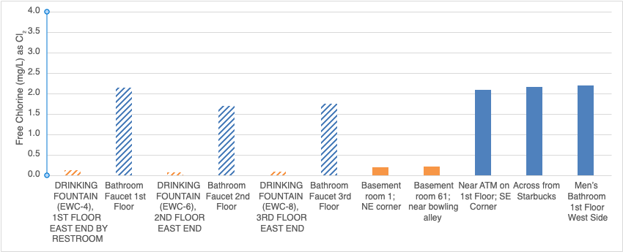

**Figure 8. Preliminary Free Chlorine Sample Results for Varied-Age Building Sampling. Filtered Locations in Orange and Unfiltered in Blue. Hatched Bars are at CIF and Solid Bars are at Union.**

In the case of the filtered and unfiltered water fountains in the FAR residence hall, it was determined that the glass filler, gym water fountain, and the main lobby fountain are unfiltered, and that the only filtered water fountain that was sampled is located in the basement hallway. This result was particularly interesting as the main lobby fountain was marked as filtered according to Facilities and Services. Free chlorine results can be seen below in Table 2.

**Table 2. Free Chlorine Sample Results for Varied Hydro Station Sampling at FAR**

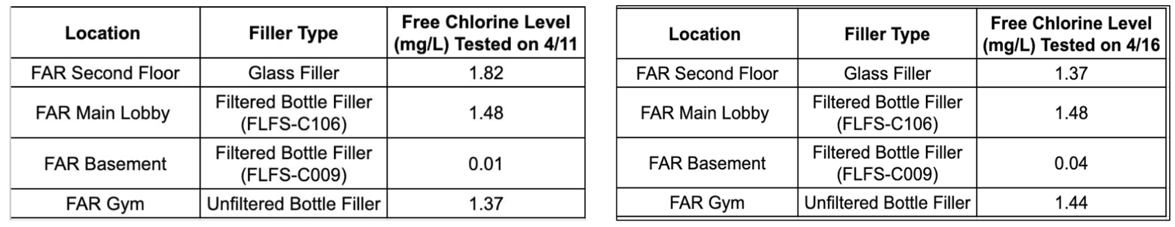

Despite the chlorine results proving the opposite, we continued to include the FAR main lobby fountain results with the filtered group in order to remain consistent with the Facilities and Services’ records.

Preliminary free-Chlorine sample results for the varied-age building sampling involving stagnation of the water are not presented, as there were issues in the validity of concentrations. However, free chlorine concentrations for the samples in which lead and copper were also measured can be found in Figures G and H in the Appendix.

*Lead and Copper*

Lead and copper were the two contaminants tested for each sample. Samples were prepared for ICP-MS testing by adding 100 μL of nitric acid to 10 mL of each water sample. With TA assistance, the samples were put through the ICP-MS testing process, and standards were used to create a calibration curve to calculate concentrations from signal intensities for both lead and copper. Standard curves used for calculations can be found in the Appendix. A sample measurement challenge encountered was the equipment failure of the College of Civil Engineering’s ICP-MS. The vacuum pump gauge of the ICP-MS was broken, preventing the plasma from being turned on. This prevented some of the samples collected from being analyzed for around a week, which in turn held up our overall progress. Thankfully, the School of Chemical Sciences (SCS) graciously agreed to analyze our samples with a quick turnaround time. Unfortunately, the ICP-MS from SCS lacked the sensitivity to record accurate data at low concentrations, so that round of sampling from each group was discarded.

**RESULTS AND DESIGN**

Results illustrating the lead and copper concentrations in the samples tested can be seen in Figures 9-12, where the same 72 samples (36 lead, 36 copper) are analyzed based on different independent variables, including filtered vs. unfiltered, samples taken in the 1st liter of water vs. subsequent samples, and newly constructed buildings (CIF, ISR) vs. older buildings (FAR, Union).

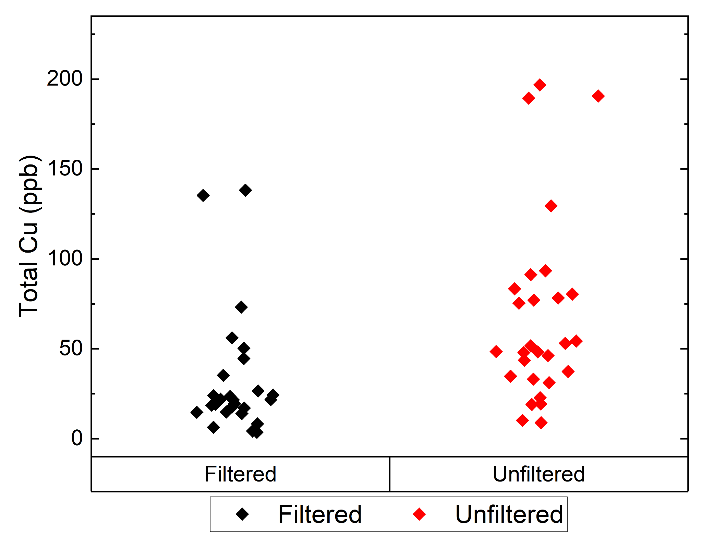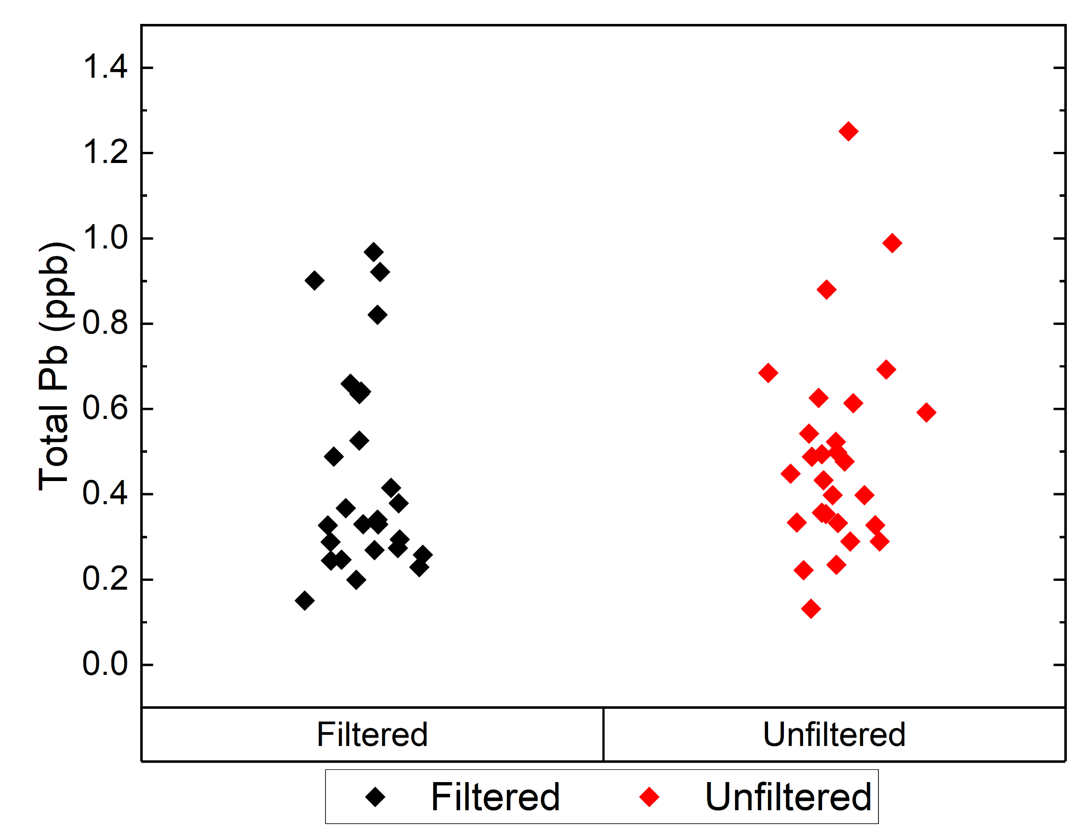

**Figure 9. Lead and Copper Concentration Diagrams for filtered vs. unfiltered samples.**

[Space intentionally left blank]

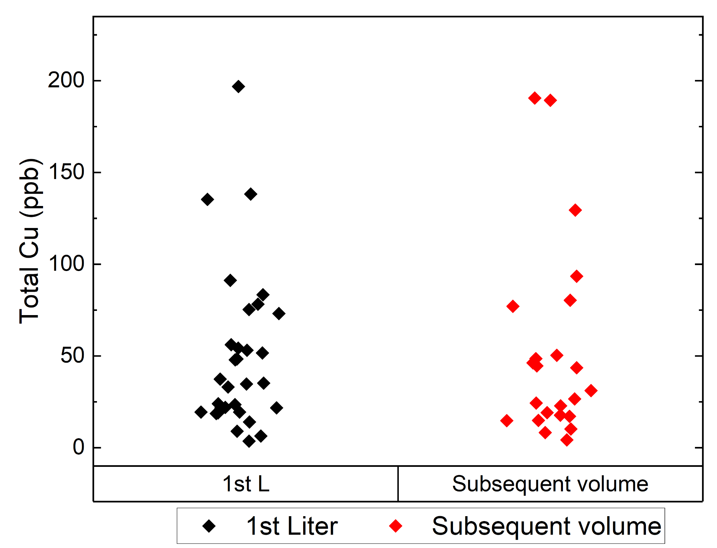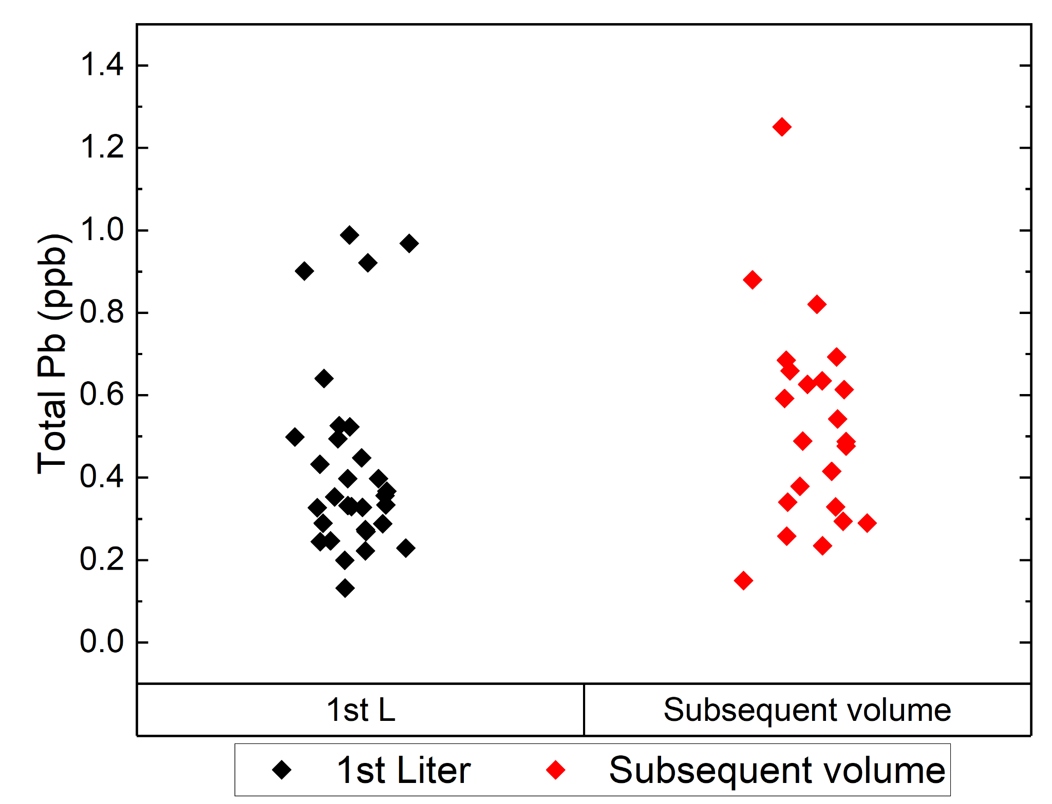

**Figure 10. Lead and Copper Concentration Diagrams flushing and stagnation level.**

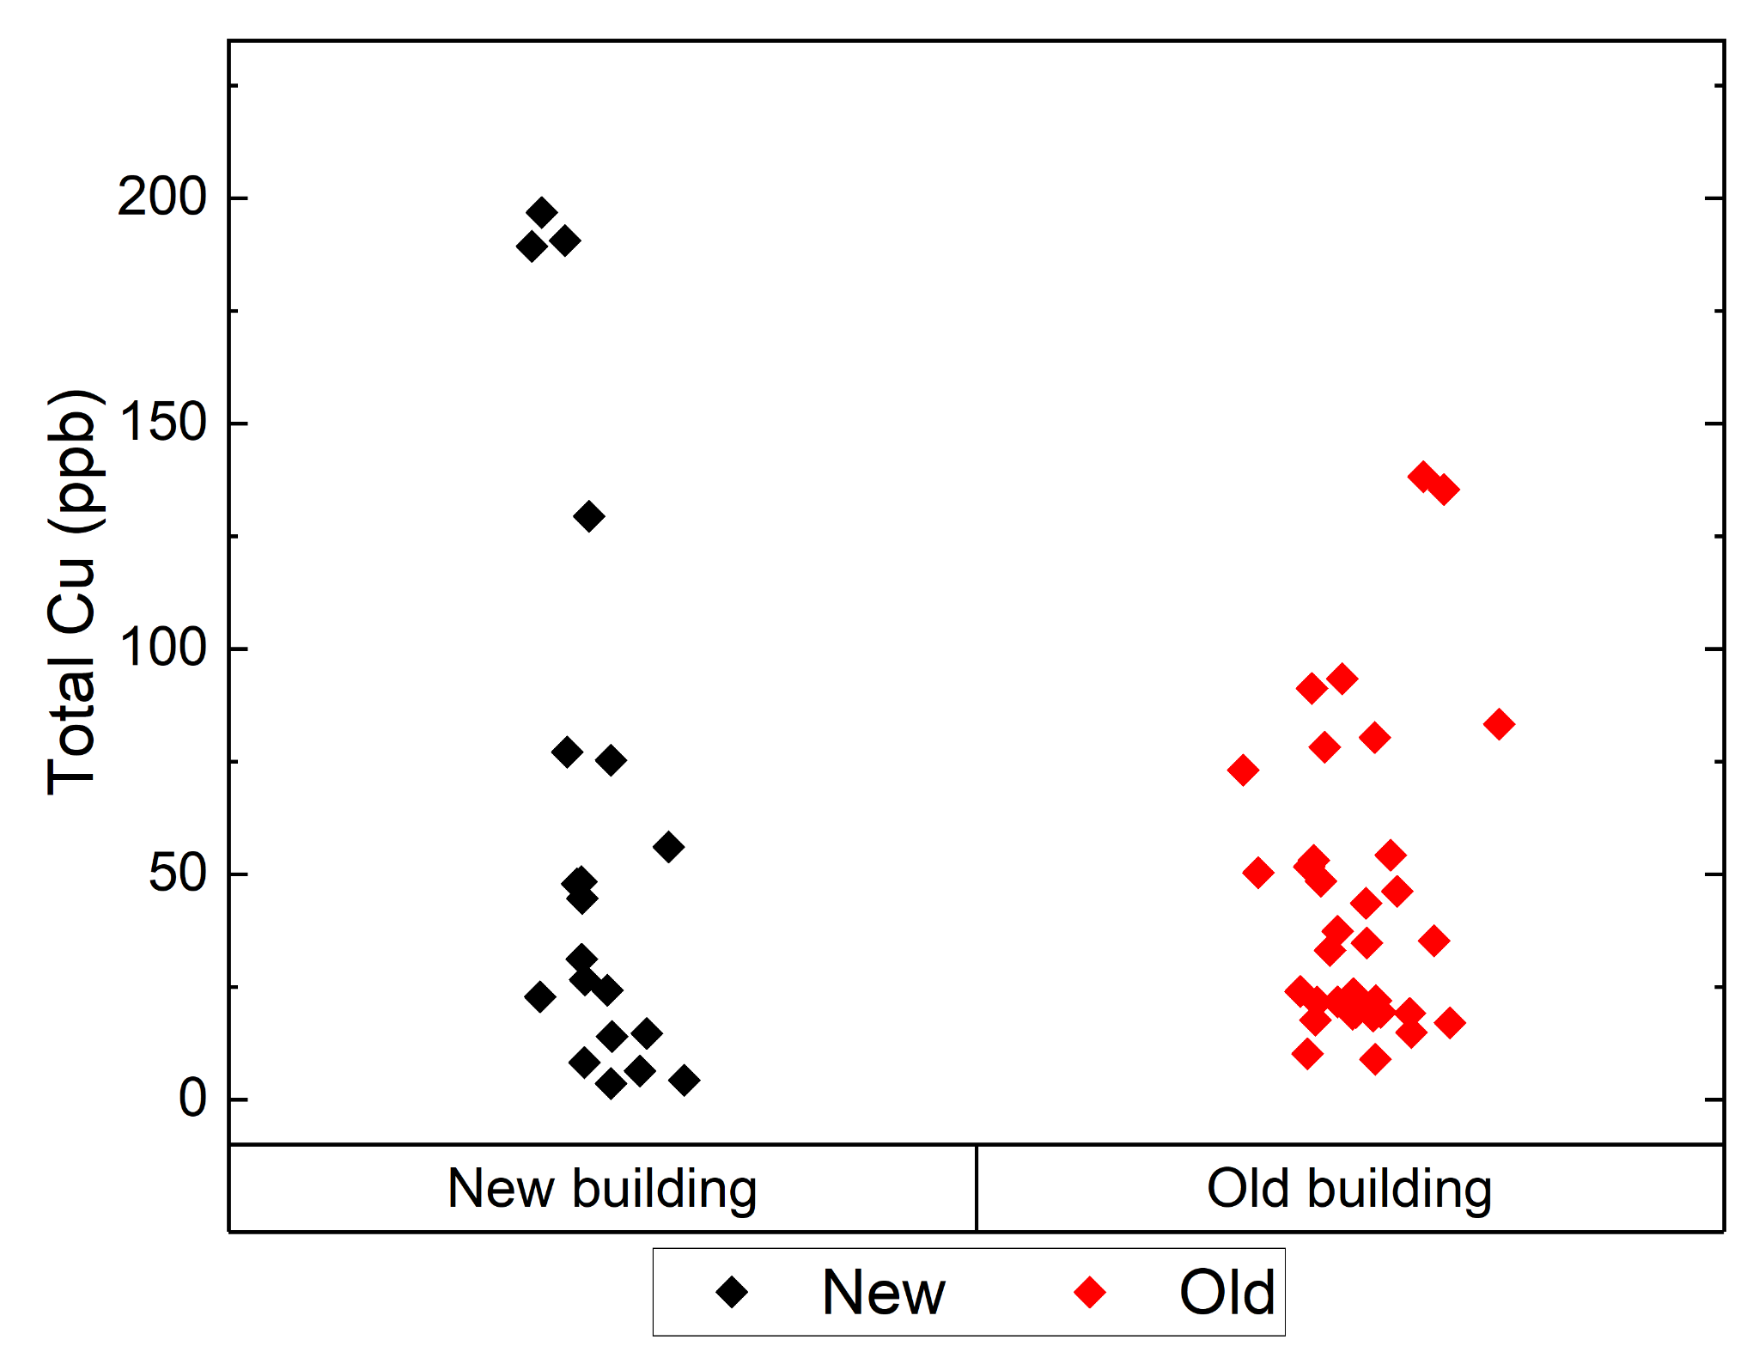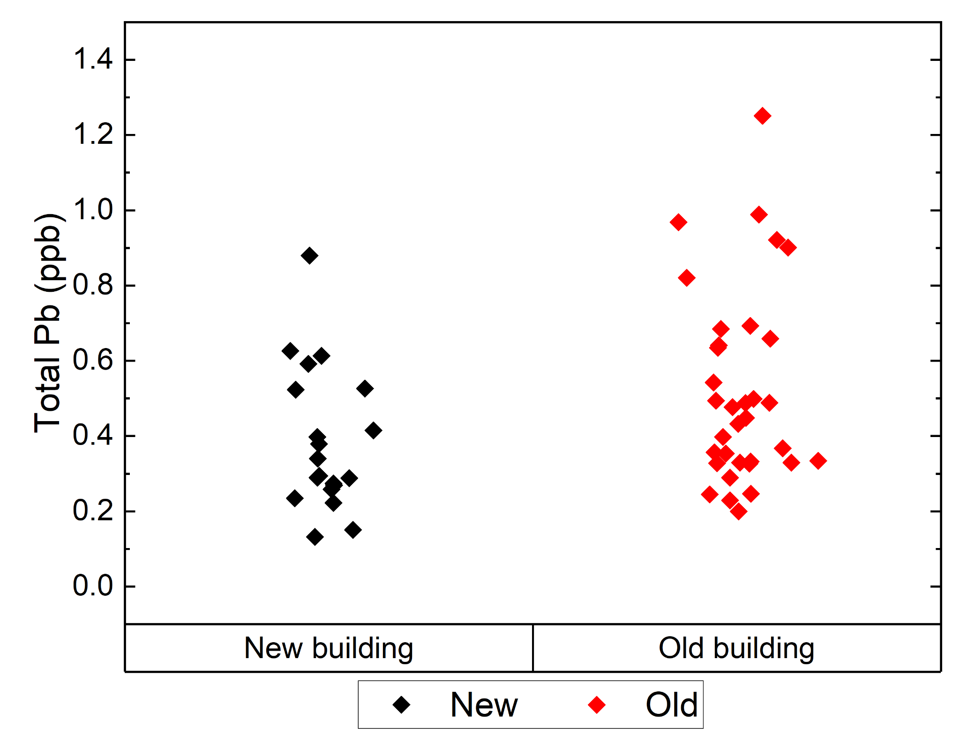

**Figure 11. Lead and Copper Concentration Diagrams by Building**

*Hypotheses*

**Table 3. Hypotheses for the Results of Lead Testing**

|  |  |
| --- | --- |
| $H_{01}$ | No significant difference in lead concentration between filtered and unfiltered stations |
| $$H_{A1}$$ | There is a significant difference in lead concentration between filtered and unfiltered stations |
| $$H_{02}$$ | No significant difference in lead concentration between new and old buildings |
| $$H_{A2}$$ | There is a significant difference in lead concentration between new and old buildings |
| $$H_{03}$$ | No significant difference in lead concentration between 1st L and remaining flush |
| $$H_{A3}$$ | There is a significant difference in lead concentration between 1st L and remaining flush |

**Table 4. Hypotheses for the Results of Copper Testing**

|  |  |
| --- | --- |
| $H_{04}$ | No significant difference in copper concentration between filtered and unfiltered stations |
| $$H_{A4}$$ | There is a significant difference in copper concentration between filtered and unfiltered stations |
| $$H_{05}$$ | No significant difference in copper concentration between new and old buildings |
| $$H_{A5}$$ | There is a significant difference in copper concentration between new and old buildings |
| $$H_{06}$$ | No significant difference in copper concentration between 1st L and remaining flush |
| $$H_{A6}$$ | There is a significant difference in copper concentration between 1st L and remaining flush |

*Statistical Tests and Requirements*

The goals of our projects are to examine the difference in heavy metal concentration based on presence of a filter, stagnation, and building age. Mainly, we are concerned if there is a statistically significant difference between lead and copper levels based on those three discrete independent variables. Combining results from all of our groups, we conducted six (3 for lead, 3 for copper) two-sample two-tailed t-tests to help us determine with 95% confidence interval and t-critical value of 2.07 if there is a statistically significant difference based on our independent variables.

The t-test has some prerequisites before it can be conducted: Each sampling event must be independent of the next, the samples collected must be done randomly, the sample data must follow a normal distribution, and the standard deviations must be close between two data sets of samples.

*Filtered vs. Unfiltered*

Each flush taken from a filter or unfiltered station did not affect the concentrations of the next flush, so the independence criteria is met. The sampling locations were chosen randomly, so the simple random samples criteria is also met. The samples follow a roughly normal distribution, and the standard deviations are close.

*1st L vs. subsequent volume (Stagnation)*

The first liter of sample taken at 7am does not affect the concentration of lead/copper of the next days’ first liter taken at 7am. Likewise, the remaining 3L taken as subsequent volume will not affect the next days’ concentrations in that respective remaining 3L. Hence, the independence condition is satisfied. Additionally, the two sampling locations were chosen randomly in ISR and FAR. The samples followed a roughly normal distribution and standard deviations and variances were similar between the two sample sets.

*New vs. Old Buildings*

Each flush taken regardless of the type of filling station did not affect the concentrations of the next flush, so the independence criteria is met. The sampling locations were chosen randomly within each building, so the simple random samples criteria is also met. The samples follow a roughly normal distribution, and the standard deviations are close.

Since all criteria are met for all groups, the t-tests may be conducted and evaluated for rejection or acceptance of the null hypotheses.

*Combined Statistical Test Results*

Below is a table summarizing our statistical test results from running the 2 sample 2 tailed t-test six times for our 3 independent variables and 2 parameters being measured - lead and copper. We used 95% confidence interval and t critical value of 2.07 as a basis to reject or accept our six null hypotheses.

[Space intentionally left blank]

**Table 5. Lead Statistical Test Results**

|  |  |  |  |  |  |
| --- | --- | --- | --- | --- | --- |
| Parameter: Lead (ppb) | | | | | |
| Independent variable | $$\underline{x}$$ | | $$s$$ | | *n* |
| Filtered | .442 | | .241 | | 26 |
| Unfiltered | .496 | | .242 | | 28 |
| **Result** | | | | | |
| $$t=-.82$$ | | $$p=.42$$ | | $$Fail to reject H_{0}$$ | |
| Independent variable | $$\underline{x}$$ | | $$s$$ | | *n* |
| New buildings | .385 | | .189 | | 20 |
| Old buildings | .521 | | .257 | | 34 |
| **Result** | | | | | |
| $$t=-2.2$$ | | $$p=.03$$ | | $$Reject H_{0}$$ | |
| Independent variable | $$\underline{x}$$ | | $$s$$ | | *n* |
| 1st L flush | .428 | | .230 | | 31 |
| Subsequent Volume | .528 | | .249 | | 23 |
| **Result** | | | | | |
| $$t=-1.5$$ | | $$p=.14$$ | | $Fail to reject H_{0}$ | |

[Space intentionally left blank]

**Table 6. Copper Statistical Test Results**

|  |  |  |  |  |  |
| --- | --- | --- | --- | --- | --- |
| Parameter: Copper (ppb) | | | | | |
| Independent variable | $$\underline{x}$$ | | $$s$$ | | *n* |
| Filtered | 32.9 | | 34.6 | | 26 |
| Unfiltered | 67.7 | | 52.0 | | 28 |
| **Result** | | | | | |
| $$t=-2.9$$ | | $$p=.0054$$ | | $$Reject H_{0}$$ | |
| Independent variable | $$\underline{x}$$ | | $$s$$ | | *n* |
| New buildings | 60.6 | | 64.5 | | 20 |
| Old buildings | 45.2 | | 33.7 | | 34 |
| **Result** | | | | | |
| $$t=.99$$ | | $$p=.33$$ | | $$Fail to reject H_{0}$$ | |
| Independent variable | $$\underline{x}$$ | | $$s$$ | | *n* |
| 1st L flush | 49.9 | | 43.6 | | 31 |
| Subsequent Volume | 52.4 | | 53.2 | | 23 |
| **Result** | | | | | |
| $$t=-.18$$ | | $$p=.85$$ | | $Fail to reject H_{0}$ | |

According to the results of our lead tests, there is no statistically significant difference in lead concentration between filtered and unfiltered stations and the 1st L flush vs subsequent volume. This suggests that the filtration process and effects of stagnation did not significantly impact the levels of these contaminants in the water. It's noteworthy that none of the samples exceeded the MCLs set by the EPA. This highlights the overall quality of the water, regardless of filtration status. However, there is a statistically significant difference in lead concentration between new and old buildings.

Taking a look at the results from our copper tests, there is no statistically significant difference in copper concentration based on the 1st flush vs subsequent volume, like we saw with lead. However, this time there is a significant difference in concentration between filtered and unfiltered stations; the negative t-value indicates that there tends to be higher copper in unfiltered vs filtered stations. Apart from lead, there seems to be no significant difference in copper concentration between the new and old buildings.

Regardless of these differences, the water from both buildings is safe, as all samples were below the EPA action level of 15 ppb for lead,[14] and limit of 5 ppb for Illinois schools.[11] It is also important to note that bottled water is allowed to have up to 5 ppb of lead,[15] while the average CIF and Union concentrations were much lower than this. All copper samples and averages were well below the MCL of 1300 ppb.[14]

To summarize, below are our sets of data compared to certain health requirements set by various agencies.



**Figure 12. Lead and Copper Concentration Diagrams with relevant regulation standards from the EPA, FDA, and Illinois Department of Health**

*Economic Analysis*

For one part of the economic analysis, we wanted to discuss the possibility of distributing Brita Filters and Pitchers. We have a life-cycle analysis (LCA) for Brita filters below:

Pitcher Filters Distribution LCA: Pitcher Cost = $36,[16] Filter cost = $20,[17] Change 2x per year = $40/yr, Maintenance Cost = $0: University housing accommodates 8,550 students, Assume one pitcher per 2 students: 4,275 pitchers.[18]

4275 ($36 𝑝𝑖𝑡𝑐ℎ𝑒𝑟 + $40 𝑓𝑖𝑙𝑡𝑒𝑟𝑠)= Total Cost for One Class Year: $325,000

Total Cost for 10 Class Years: $3.3 million

We decided that it would not be economically feasible to distribute Brita filters, and also unnecessary due to the already high water quality of both unfiltered and filtered water.

A life-cycle analysis was also completed for filtered and unfiltered hydrostations. We used costs provided to us by Jennifer Fratterigo. These were as follows:

* $1,500 initial investment for filtered hydrostations
* $1,000 initial investment for unfiltered hydrostations
* $250-$500 for installation
* $65-$75 for filters
* $500 annual labor costs

Using a 10-year design life, 6% interest rate, and assuming filters are replaced twice a year, it was found that one unfiltered hydrostation would cost **$5,055** over 10 years, and one filtered hydrostation would cost **$6,596** over 10 years.

*Recommendations to the University*

Upgrading to filtered fountains requires an initial investment of $1,500 with recurring filter costs, but offers potential taste improvements and psychological benefits despite no significant impact on lead or copper levels. On the other hand, unfiltered fountains cost $1,000 to install with no ongoing filter costs, providing a more economical option while still meeting EPA safety standards. And finally, while older buildings may have slightly higher lead concentrations compared to newer ones, both still deliver water that is safe and well within EPA safety standards. The results of this study show that the University of Illinois provides safe drinking water options from both its filtered and unfiltered fountains, in buildings of all ages, so students can hopefully reduce their single use plastic bottle consumption and opt to utilize the water supplied by the University.

*Recommendations to Individual Users*

Based on the results from our analysis, the quality of water from filtered and unfiltered bottle filling stations are within safe consumption limits. We also did not notice any significant change in the water quality between stagnant and flushed samples. As such, we fully endorse using drinking water fountains as much as possible to avoid unnecessary plastic waste and do not see the need for any additional precautions such as pitcher filters or manually flushing water. It should be noted that this may only be true when classes are in session, and additional precautions can be taken when buildings and fountains are experiencing less user traffic, potentially resulting in a higher risk from stagnation.While our study did not find a clear health benefit from installing filtered stations, it's essential to consider other factors. For example, individuals may prefer the taste of water from chlorine-filtered stations or have psychological peace of mind from using filters, even though these benefits may be challenging to quantify. These additional benefits may be significant enough to warrant the additional costs of upgrading to filtered filling stations.

**FINAL DELIVERABLE**

In our final deliverable, we have created graphs of our findings. These graphs include results from preliminary free chlorine sampling, lead and copper levels for both filtered and unfiltered hydrostations, and also lead and copper levels from first and second flush hydrostation samples. Along with these graphs, we also include a cost and benefit analysis which includes the potential benefits of adding more hydrostations to higher traffic areas of the university as well as a cost analysis of providing brita filters to students living in the dorm. This analysis also investigates whether the new hydrostations should be filtered or not filtered based on the concentrations of lead and copper found in our samples. To encourage the use of hydrostations around campus, posters including a QR code to the combined data along with plain english descriptions, such as Figure 13 below, will be provided to post near hydrostations Graphs, a poster, and a report is being submitted to iSEE.

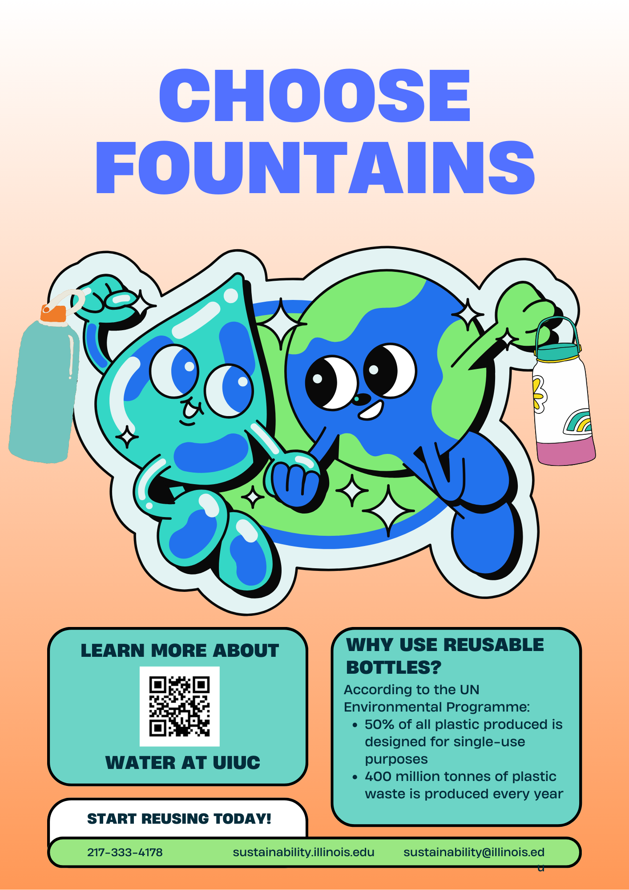

**Figure 13. Sample Poster for iSEE**

**CONCLUSIONS**

In conclusion, this study did not find any concerning levels of lead or copper at the specified sampling sites: FAR, ISR, CIF, and the Union. At least from these three data sets, we can say that filtered drinking water stations are not a necessary addition at this time as there was little increase in drinking water quality when comparing filtered vs. unfiltered stations. Interestingly, there is also no stagnation effect in the dorms, although it would be important to complete more sampling in off-times such as spring break, summer break, and perhaps weekends, where there is less water flow throughout the buildings and a higher risk of stagnation buildup.

In the future, we recommend obtaining pipe system schematics from American Water and shifting sampling focus to buildings that may still have lead piping systems. Priority for testing should go to buildings that are both highly populated and are very old compared to the rest of campus buildings. We suggest starting with the Armory, Engineering Hall, and Altgeld. We also recommend ordering several newer models of the Elkay ezH20 filter (71300C), and testing their removal efficiency of lead in these older buildings compared to the existing filter found in campus filling stations (51300C).

**ACKNOWLEDGEMENTS**

We are deeply grateful to iSEE and Professor Jennifer Fraterrigo for their guidance, to the School of Chemical Sciences and Ashley Blystone for diligently measuring the final Pb and Cu samples, and to Professor Cusick, Professor Verma, Gemma Clark, and Tahsina Alam who have supported our research journey.

**REFERENCES**

1. *The dirty truth: How much plastic water bottles really contribute to P*. SWOP - shop withoutplastic.https://www.shop-without-plastic.com/blogs/how-much-do-contribute-to-pollution/how-much-do-plastic-water-bottles-really-contribute-to-pollution
2. *ICAP Portal*. Reduce Single-Use Plastics (In Progress) | iCAP Portal | University of Illinois. https://icap.sustainability.illinois.edu/project/reduce-single-use-plastics
3. *Microplastics in our waters, an unquestionable concern*. Penn State Extension. https://extension.psu.edu/microplastics-in-our-waters-an-unquestionable-concern
4. *Packaging*. Bottled Water | IBWA | Bottled Water. https://bottledwater.org/packaging/#:~:text=Plastic%20bottled%20water%20containers%20are,and%20HDPE%20for%209.2%20percent.
5. *How does plastic end up in the ocean?*. WWF. https://www.wwf.org.uk/updates/how-does-plastic-end-ocean#:~:text=Rainwater%20and%20wind%20carries%20plastic,plastic%20surge%20in%20our%20seas.
6. *Plastic pollution facts: Plasticoceans.org/the-facts*. Plastic Oceans International. (2021, July 21). https://plasticoceans.org/the-facts/
7. *Your plastic has a water footprint*. Water Footprint Calculator. (2022, July 11). https://watercalculator.org/news/news-briefs/your-plastic-water-footprint/#:~:text=The%20water%20footprint%20of%20plastic,staggering%20when%20viewed%20in%20total.
8. *How long does it take for plastic to decompose?*. Chariot Energy. (2024, February 13). https://chariotenergy.com/blog/how-long-until-plastic-decomposes/#:~:text=For%20example%2C%20single%2Duse%20plastic,years%20to%20fully%20break%20down.
9. Heather. (2024, January 16). *Which is safer, tap water or bottled water? Nanoplastics found.* One Green Bottle - Sustainable Stainless Steel Water Bottles Lunchboxes and cups. https://www.onegreenbottle.com/which-is-safer-tap-water-or-bottled-water-nanoplastics-found/#:~:text=On%20average%2C%20a%20plastic%201L,birth%20defects%20and%20fertility%20issues.
10. *2022 consumer confidence report reported in 2023*. Village of Mahomet, Illinois. https://www.mahomet-il.gov/ccreport
11. *Testing at schools and Child Care Facilities*. Illinois Department of Public Health. https://dph.illinois.gov/topics-services/environmental-health-protection/lead-in-water/testing-schools-child-care-facilities.html
12. University of Illinois Urbana-Champaign. (n.d.). *Facility Access Maps*. <https://facilityaccessmaps.fs.illinois.edu/archibus/schema/ab-products/essential/workplace/index.html>
13. Elkay. (n.d.). *Elkay WaterSentry® Lead + Microplastics NSF/ANSI Certified Filter (Bottle Fillers)*. <https://www.elkay.com/products/details/51300c>
14. Environmental Protection Agency. (2022). *Lead and Copper Rule.* [*https://www.epa.gov/dwreginfo/lead-and-copper-rule*](https://www.epa.gov/dwreginfo/lead-and-copper-rule)
15. Food and Drug Administration. “Lead in Food and Foodwares”, *Regulatory Informatio*n (2024).​​<https://www.fda.gov/food/environmental-contaminants-food/lead-food-and-foodwares#:~:text=Bottled%20Water%3A%20The%20FDA%20limits,parts%20per%20billion%20(ppb)>.
16. *Denali Water Pitcher with Elite Filter.* (n.d.). Brita. <https://www.brita.com/products/denali-pitcher-elite/>
17. *Elite Replacement Filters.* (n.d.). Brita. <https://www.brita.com/products/elite-replacement-filters/>
18. University of Illinois. (n.d) *Campus Facts*.<https://illinois.edu/about/facts.html>

**Appendix**

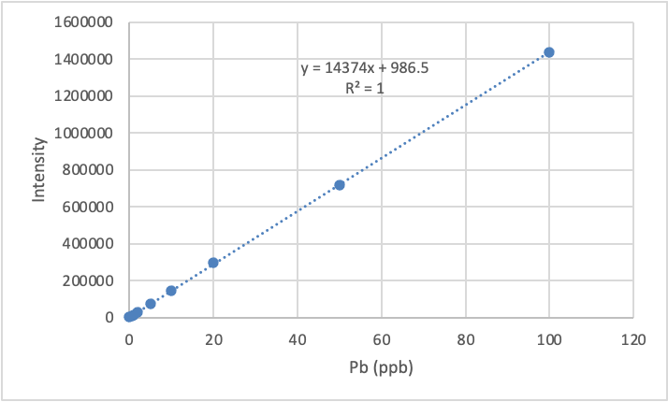

**Figure A. CEE ICP-MS lead calibration curve.**

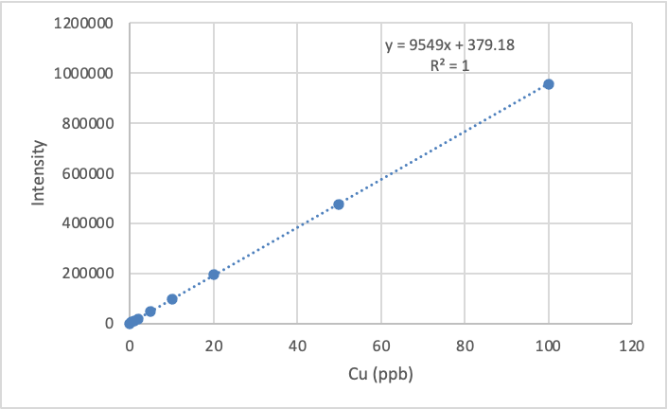

**Figure B. CEE ICP-MS copper calibration curve.**

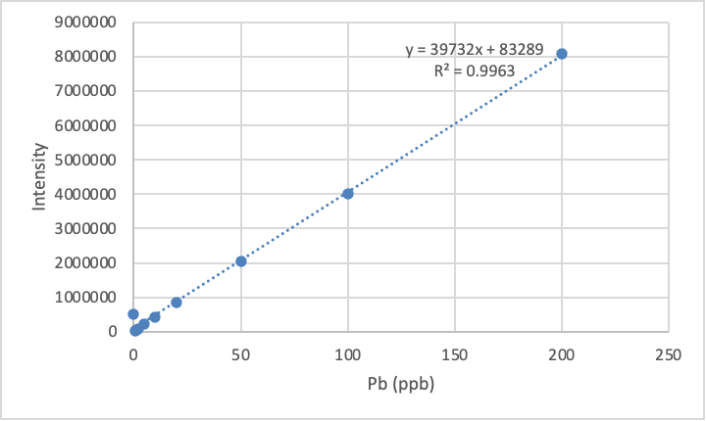

**Figure C. SCS ICP-MS lead calibration curve.**

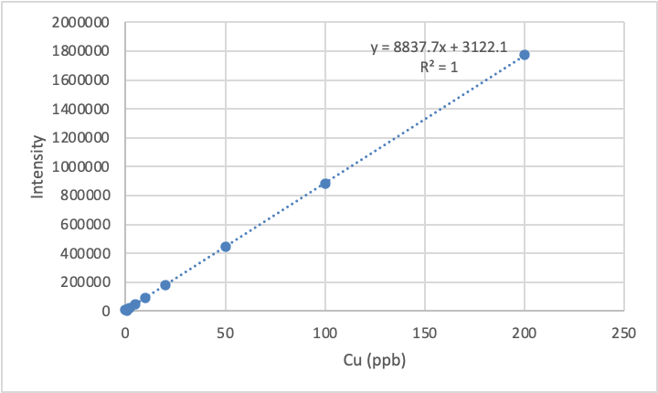

**Figure D. SCS ICP-MS copper calibration curve.**

**Figure E: Unfiltered water fountain near the gym in the basement of FAR**

**Figure F. Filtered water fountain in the basement hallway of FAR**

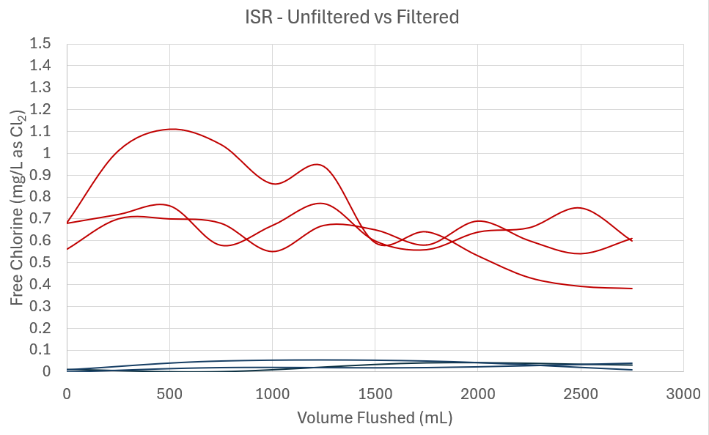

**Figure G: Free Chlorine Data from ISR: Red lines are unfiltered, Blue lines are filtered**

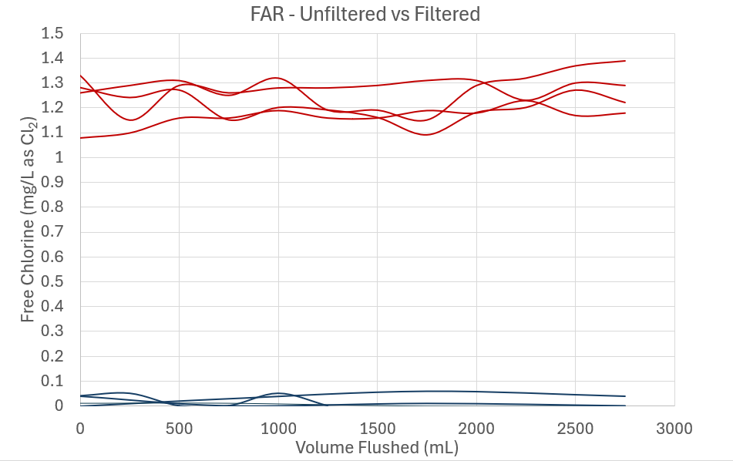

**Figure H: Free Chlorine Data from FAR: Red lines are unfiltered, Blue lines are filtered**