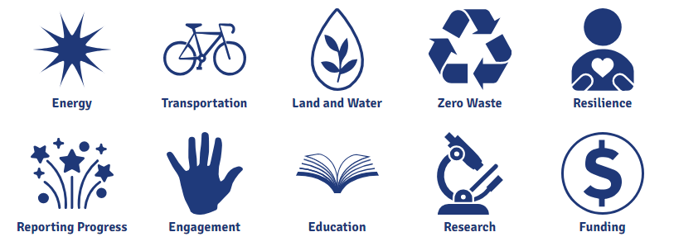


iCAP Portal

Illinois Climate Action Plan (iCAP)
University of Illinois Urbana-Champaign

Tour Stop | Address | Time | iCAP Goal(s) | Contact | Phone | Email | Confirmed
Illini Union: START v | 1401 W. Green St.  Urbana, IL | 1:00PM-1:05PM | Energy,  Zero Waste,  Engagement | David Guth, Sr. Associate Director of Facilities & Operations | +1 (217) 244-1505 | dcguth@illinois.edu | Driving tour talking points only
MCORE Street Project t | Champaign-Urbana | 1:05PM-1:07PM | Transportation | Stacey DeLorenzo | +1 (217) 300-1750 | sdeloren@illinois.edu | Driving tour talking points only
Boneyard Creek Reclamation Project t | Champaign-Urbana | 1:07PM-1:08PM | Land & Water, Resilience | Brent Lewis | +1 (217) 300-3164 | bcl@illinois.edu | Driving tour talking points only
Geothermal at CIF t | 1405 W. Springfield Ave. Urbana, IL | 1:08PM-1:10PM | Energy | Qu Kim | +1 (217) 300-0178 | qkim@illinois.edu | Driving tour talking points only
Campus Bike Center t | 51 E Gregory Dr.  Champaign, IL | 1:10PM-1:12PM | Transportation | Morgan White | +1 (217) 333-0241 | mbwhite@illinois.edu  dcr-bikecenter@illinois.edu | Driving tour talking points only
Abbott Power & Energy Production t | 1117 S Oak St.  Champaign, IL | 1:12PM-1:15PM | Energy | Robert Roman, Director Utility Operations | +1 (217) 300-5810 | roman@illinois.edu | Driving tour talking points only
Solar Farm 1.0 v | Windsor & 1st St.  Champaign, IL 61822 | 1:15PM-1:35PM | Energy | Mike Larson, Associate Director of Utility Production | +1 (217) 333 5139 | mjlarso1@illinois.edu | Confirmed
Student Sustainability Farm v | 2711 South Race St.  Urbana, IL, 61802 | 1:40PM-2:00PM | Land & Water,  Resilience | Matt Turino, Manager | +1 (217) 333-3554  +1 (217) 722-3316 | turino@illinois.edu  illinois-ssf@illinois.edu | Confirmed
Illinois Solar Decathlon Houses:  Gable House & Biomass Generatorv | 4110 S Race St.  Urbana, IL 61802 | 2:05PM-2:30PM | Energy,  Zero Waste,  Land & Water | Prof. Mark Taylor, Arch./ISDH Advisor  Tim Mies, Director of Energy Farm Operations | +1 (217) 244-2853  +1 (217) 244-8610 | mstaylor@illinois.edu  tmies@illinois.edu | Confirmed
Digester t | 1010 W. Illinois St.  Urbana, IL | 1:00PM-1:05PM | Zero Waste, Land & Water | Thurman Etchison | +1 (217) 300-4551 | etchisn@illinois.edu | Driving tour talking points only
Red Oak Rain Garden t | S. Dorner Dr.  Urbana, IL | 2:50PM-2:55PM | Land & Water,  Resilience | Layne Knoche | +1 (217) 244-8160 | lknoch2@illinois.edu | Driving tour talking points only
Illini Union: END v | 1401 W. Green St.  Urbana, IL | 2:55PM-3:00PM | Energy,  Zero Waste,  Engagement | David Guth, Sr. Associate Director of Facilities & Operations | +1 (217) 244-1505 | dcguth@illinois.edu | Driving tour talking points only

t Locations mentioned in talking points during driving portion of Sustainability Tour.
v Stops where the group will disembark on Sustainability Tour.

Tour Stop | Address | Time | iCAP Goal(s)
Illini Union: START v | 1401 W. Green St.  Urbana, IL | 1:00PM-1:05PM | Energy,  Zero Waste,  Engagement | Welcome, my name is Brent Lewis, I am the Campus Landscape Architect. Today we will provide an overview of the University of Illinois I-CAP plan, which is the sustainability road map for our campus to migrate toward carbon neutrality by 2035. The plan is part of an alliance of higher ed institutions committed to the same goal of creating a sustainable, carbon neutral future which ensures our collective ability to educate the current and future generations of students.
MCORE Street Project t | Campus Town  Champaign-Urbana | 1:05PM-1:07PM | Transportation | As we leave the Union, some of you may remember a different approach to the building and a different look to the building street frontage. These changes were due to a four phase federally funded street infrastructure project with the overall goal of promoting multi-modal transportation, with the intent to promote mass transit, bicycles, and pedestrian traffic in lieu of automobiles within the Campus Town area and adjoining connector streets to the larger C-U community. In addition to this, significant money was spent on beautifying street frontage with new trees and landscaping. Another critical goal was replacing the utilities infrastructure, including lighting/power, sewers, and water mains, much of which was over a century old. While the construction and transition to the new street system was challenging at times to navigate, we now have a much more efficient means of moving people in/out of the core campus area. MTD, the local mass transit district, uses an increasingly sustainable fleet of buses utilizing both hybrid and hydrogen power to minimize the carbon footprint.
Boneyard Creek Reclamation Project t | Champaign-Urbana | 1:07PM-1:08PM | Land & Water, Resilience
Geothermal at CIF t | 1405 W. Springfield Ave. Urbana, IL | 1:08PM-1:10PM | Energy
Campus Bike Center t | 51 E Gregory Dr.  Champaign, IL | 1:10PM-1:12PM | Transportation
Abbott Power & Energy Production t | 1117 S Oak St.  Champaign, IL | 1:12PM-1:15PM | Energy
Solar Farm 1.0 v | Windsor & 1st St.  Champaign, IL 61822 | 1:15PM-1:35PM | Energy
Student Sustainability Farm v | 2711 South Race St.  Urbana, IL, 61802 | 1:40PM-2:00PM | Land & Water,  Resilience
Illinois Solar Decathlon Houses:  Gable House & Biomass Generatorv | 4110 S Race St.  Urbana, IL 61802 | 2:05PM-2:30PM | Energy,  Zero Waste,  Land & Water
Red Oak Rain Garden t | S. Dorner Dr.  Urbana, IL | 2:50PM-2:55PM | Land & Water,  Resilience
Illini Union: END v | 1401 W. Green St.  Urbana, IL | 2:55PM-3:00PM | Energy,  Zero Waste,  Engagement

