Resilience iCAP Team April Meeting Agenda

Friday, April 14th
1:00 – 2:00 PM

Zoom link: https://illinois.zoom.us/j/81258275048?pwd=VjZ0TTZENkZndU9GY0cya2E1eGR4UT09

Attendees: Asli Topuzlu, Warren Lavey, Stacy Gloss, Constance Brown, Cheryl Bicknell, Scott Tess, Jennifer Fraterrigo, Annie Cebulski

Absentees: Morgan White, Lisa Merrifield, Ella Zervakis, Linda Derhak, Helen Anil, Caitlin Kelly, Nichole Millage, Katie Simpson

Agenda
- Welcome! – 5 minutes (Asli)
- Discussion on Carbon Credit Sales and Purchasing – everyone
- Goals for next year
  - What was accomplished this academic year?
  - What should the team focus on next year?

Meeting Notes
- Annie Cebulski – worked on campus carbon offsets with Warren Lavey
- Carbon Offset Planning Guide
  - Goal: Purchase carbon offsets in 2023 calendar year in accordance with Second Nature’s MOU with UIUC
    - Second Nature – a group that helps facilitate buying and selling of carbon credits especially with universities
  - Amount: 249,304 Carbon Credits
    - We are under obligation to purchase this amount to replace the carbon offsets that we sold
  - Funding total: $1.4 million from UIUC carbon credit sales
  - Priorities: Maximize impact with achievable purchases and projects
  - Target price: < $5.00 per carbon credit
    - Carbon credits are being purchased up to $20 (for verifiable, good carbon credits) – out of our budget
  - Prior purchase details:
    - Date: June 8, 2017
    - Seller: EcoAct Inc.
    - Price: $45,200
    - Purchase Order: 113,000 tonnes
    - Price Per Credit: $0.40
      - Extremely low!
    - New Purchase Threshold: $100,000 (2023)
- Recommended Standards
  - University of Illinois’ Proposed Standards: Justify its offset purchases to all stakeholders
    - Additional (they enable reductions beyond business-as-usual), measurable, conservative (to ensure reductions are not overstated), permanent, independently verified, trackable, and transparent
- Three Approaches to Meet UIUC’s Offsetting Goals
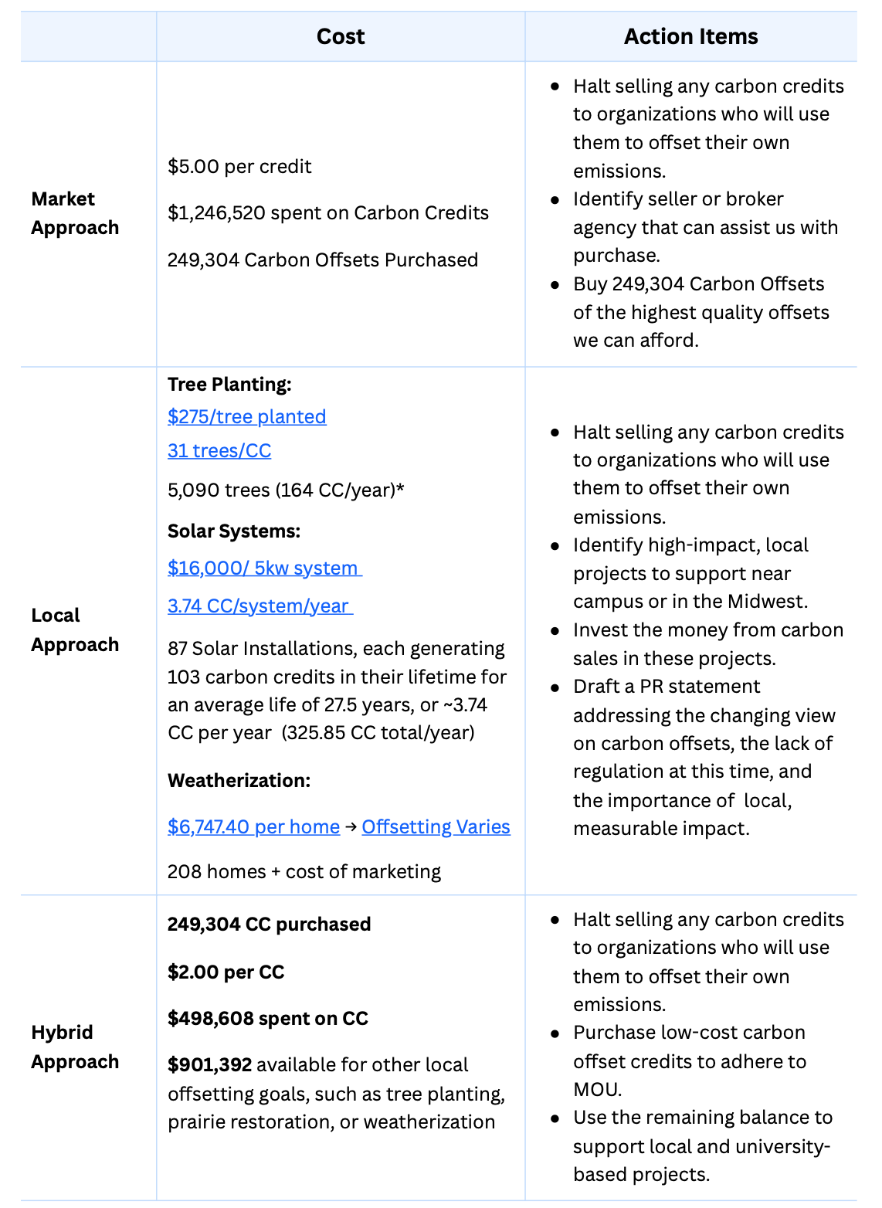
  - Market approach – only buy carbon offsets from the market (expensive as we can which is $5 per credit) and spend our budget on carbon credits
  - Local approach – big impact on the surrounding community, most direct impact
    - The amount of carbon credits we are looking to replace is huge, we can’t reach this through local projects (need to draft a PR statement, can’t necessarily follow MOU)
  - Hybrid approach – purchasing less expensive credits
    - Lower cost means less verifiability
    - Purchasing low-cost carbon credits, but also making local direct impact on the communities with the $901,392 profit
- Considerations for post-purchase (after deciding on the approach):
  - What should the carbon offset program look like?
  - Can we set up a fund by selling our carbon credits to university donors, and channel that money to that supports local or campus-based projects?
  - Can we more proactively sell our carbon credits to other parts of the university to offset their emissions for travel, banquets, festivals, and utilities?

- Many universities have purchased carbon credits but generally have their own offsetting goals that are different than ours, making purchases around 80,000 credits
- There have been three ways that people have been purchasing carbon credits
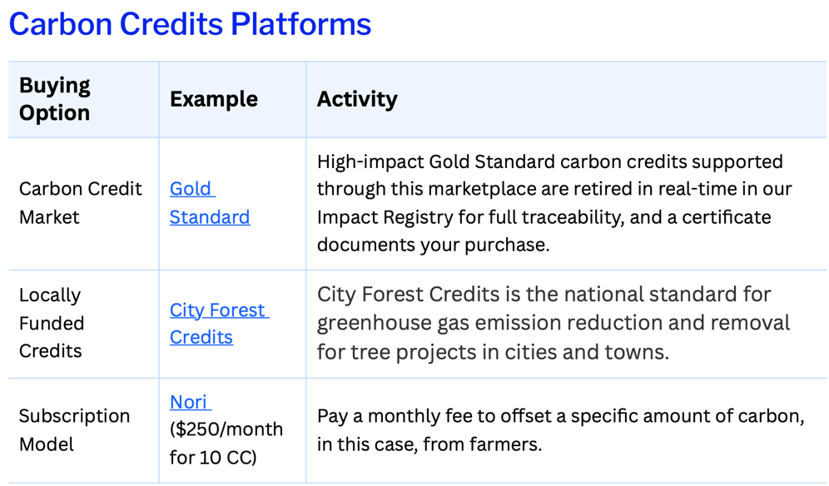
$15-$20 carbon credits

- Some other universities have been investing in local projects
  - Including investing in sustainable farming practices, making carbon sinks to provide a lab where students can learn about carbon offsetting, weatherization with the community, tree planting…
- Most of the universities’ carbon offset purchasing standards are very similar to ours

- UN’s guide to universities buying carbon credits - has a lot of important considerations when buying offsets
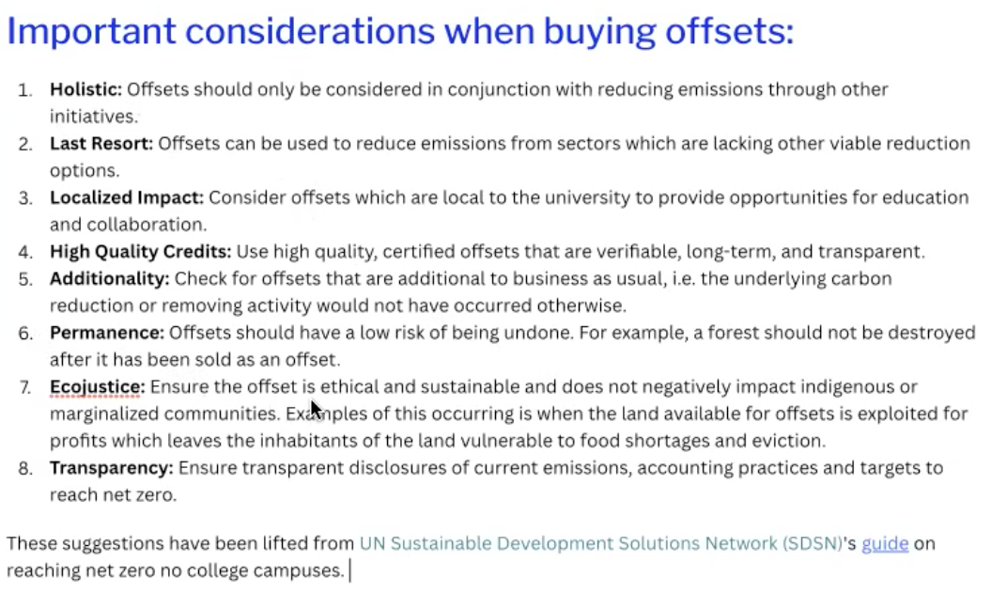

- When we are using carbon purchases as a tool for meeting university emission goals, buying carbon credits is a last resort!
  - Something you should be doing in addition to reducing emissions, but not a viable option for buying our way to carbon neutral

Discussion
- Resilience committee has a charge under the iCAP to look at a carbon offsetting program with local benefits
  - How can we use this opportunity of carbon credit purchase to further the university’s goals in making a local community-based carbon project? Is there a way to match some of these funds to what iCAP is doing and what F&S needs to do?
- Focusing on local projects and having more legitimate carbon credit purchase would be ideal
  - Way more time consuming and hard to find different projects
  - Still helpful for the community
- Good to get different perspectives on this and see if this would be helpful for the iCAP objectives
- Is there a timeline over which the university needs to acquire these carbon credits?
  - Not a specific timeframe, but should start purchasing soon
- Constance’s idea: Purchasing carbon offsets is an easy way out, we might lose track on decreasing our emissions
  - As a resilience team, we should really put all this effort and resource to support the local community
- Are there community projects that we can leverage to increase their impact in the community?
  - Going on projects: Weatherizing homes, solar instillations, geothermal instillations, tree planting
    - Funding and support (federal grants are enormous!) to these projects mean more need of recruiting staff because no one has time to do these projects
- Even if we put together a recommendation as a team that says we are ready to move forward with doing something on carbon offsets, who catches this? Who is responsible for this?
  - The idea was to first find a law student first (Aimee) who would check the MOU and EcoAct, afterwards Morgan thinks that her group has the capability to do the transaction
    - This should be more of a joint conversation and decision from iSEE
  - Staffing component is crucial if we go to a complex root of carbon credit purchase and transaction (?)
- What is required from iCAP Resilience Team in terms of action?
  - The group should discuss and see if teammates are interested in making a statement about carbon credit purchasing
  - Afterward, the group can make a short recommendation based on what the iCAP Resilience Team would like to see this money go towards
    - Which approach do we recommend (local, hybrid, or market)?
      - Hybrid approach with some local components can work??
    - If local approach, maybe put a short synopsis of Cheryl’s community project for homeless people which can be an option
  - Not really going through the regular iCAP Recommendation process

