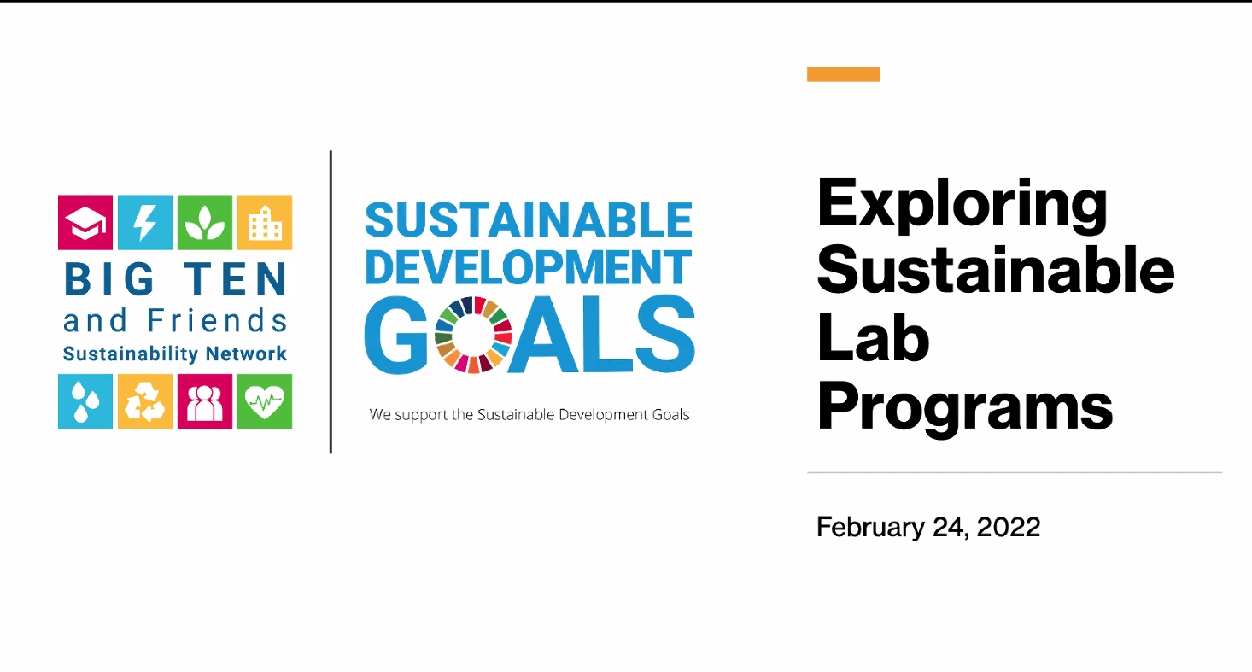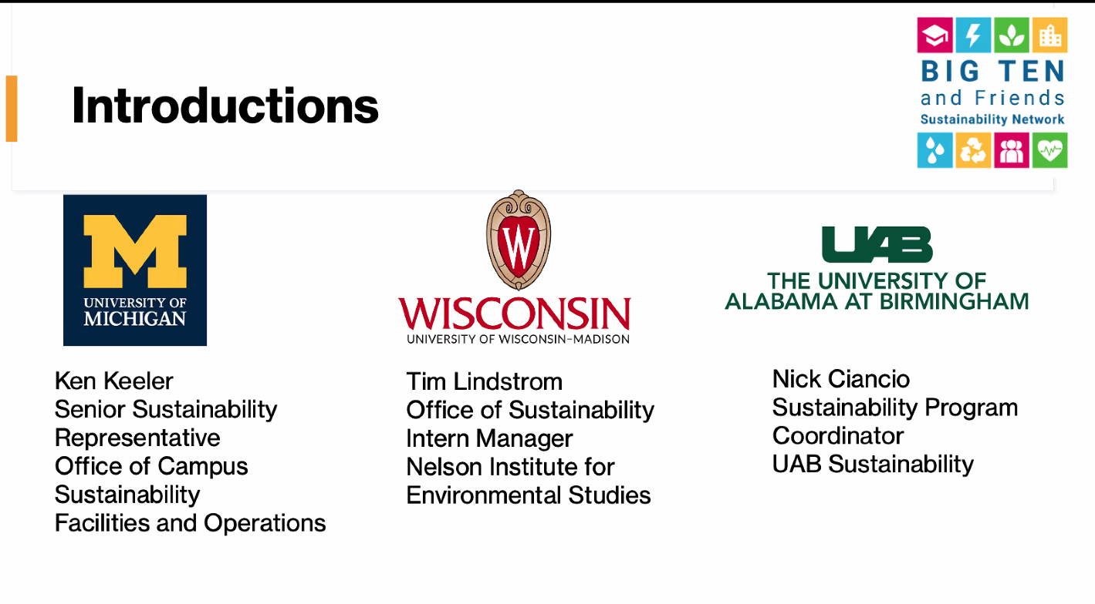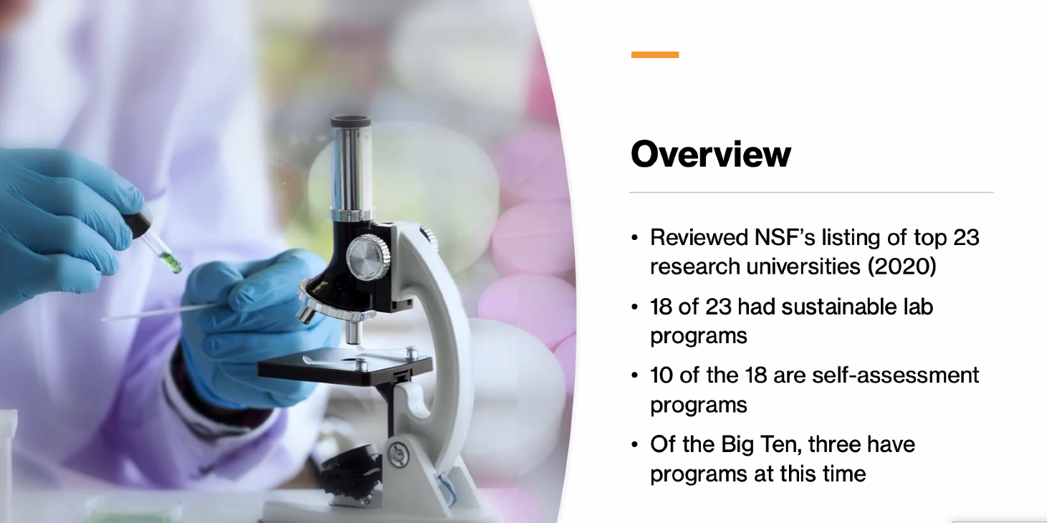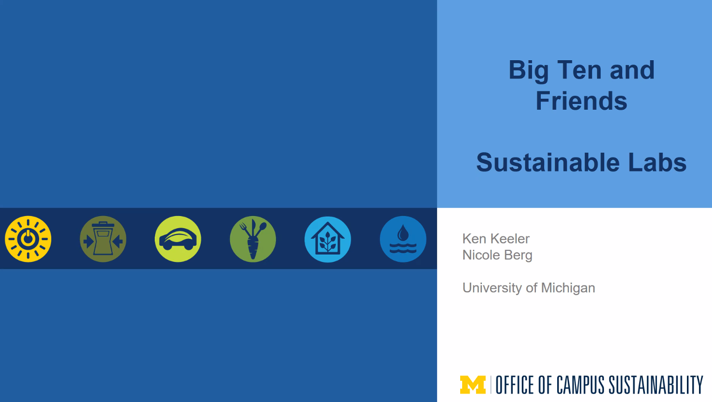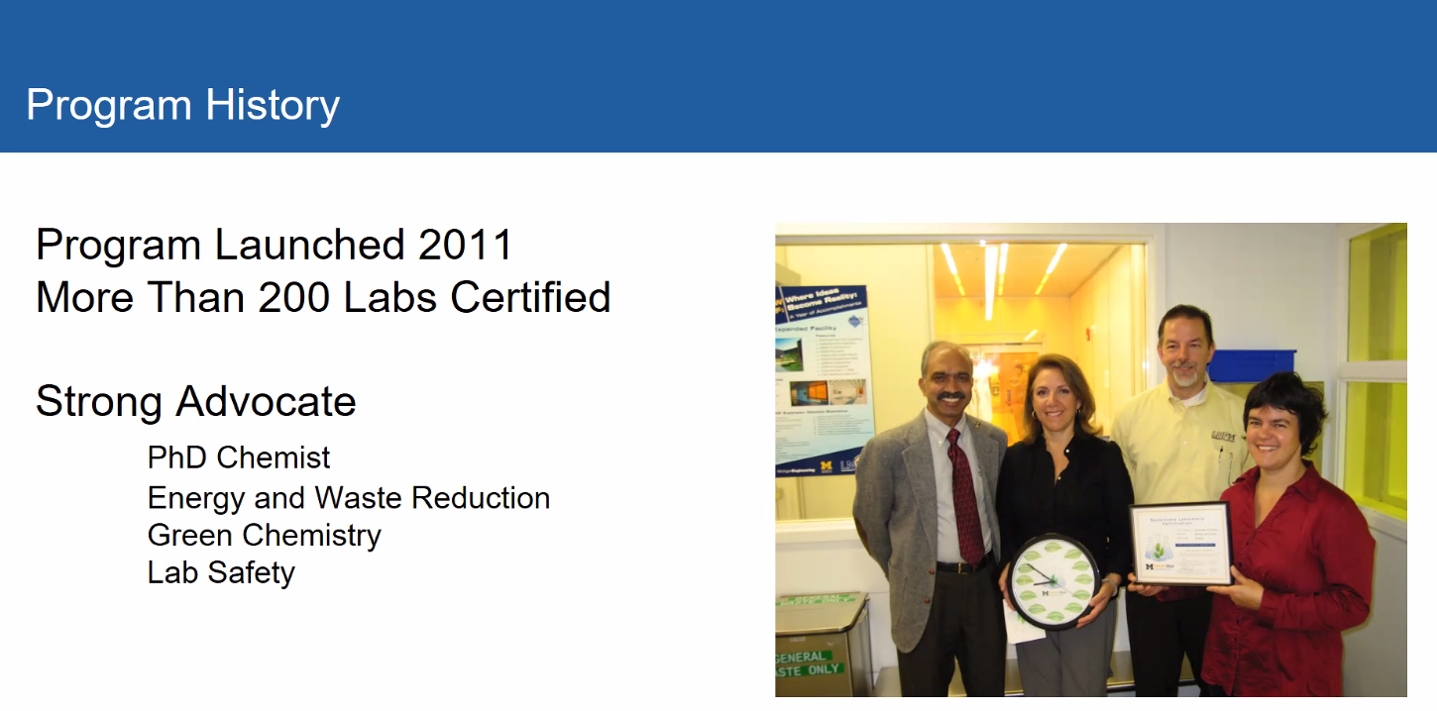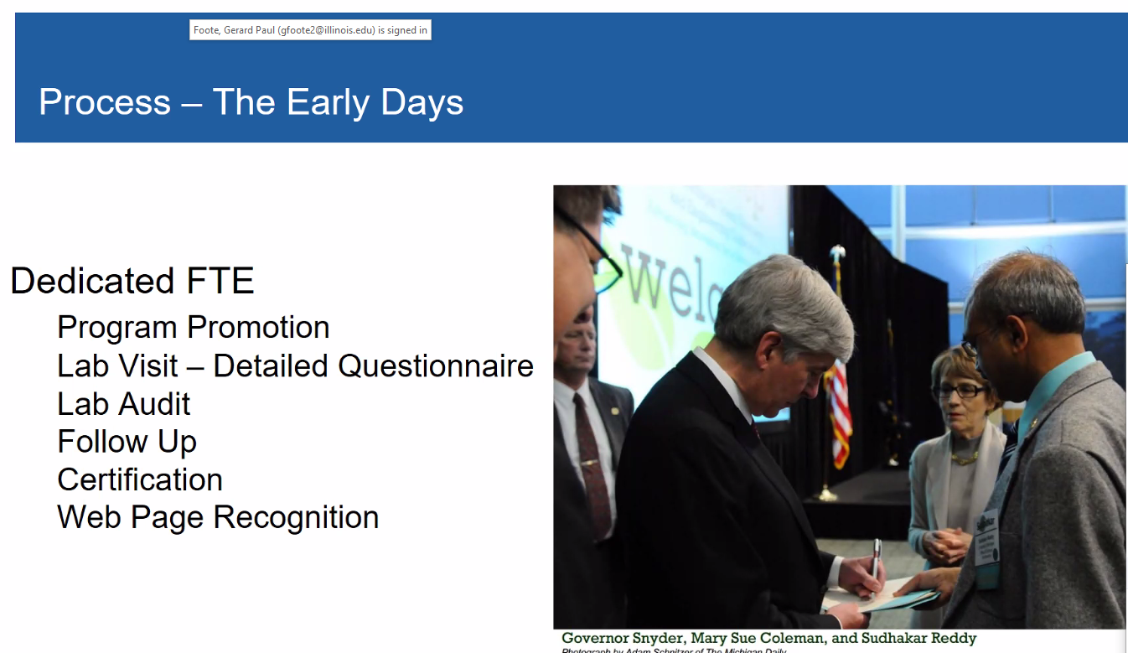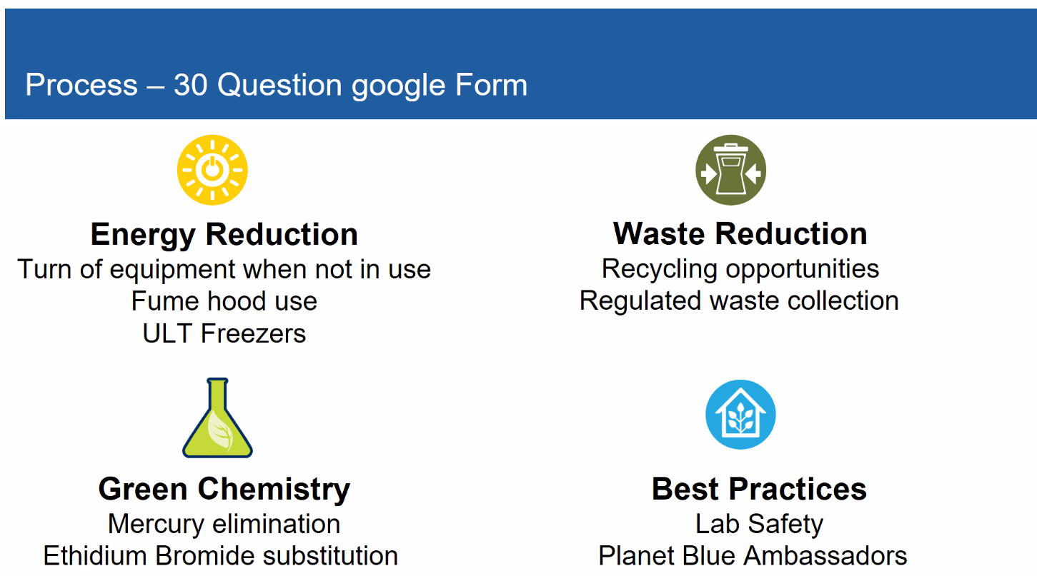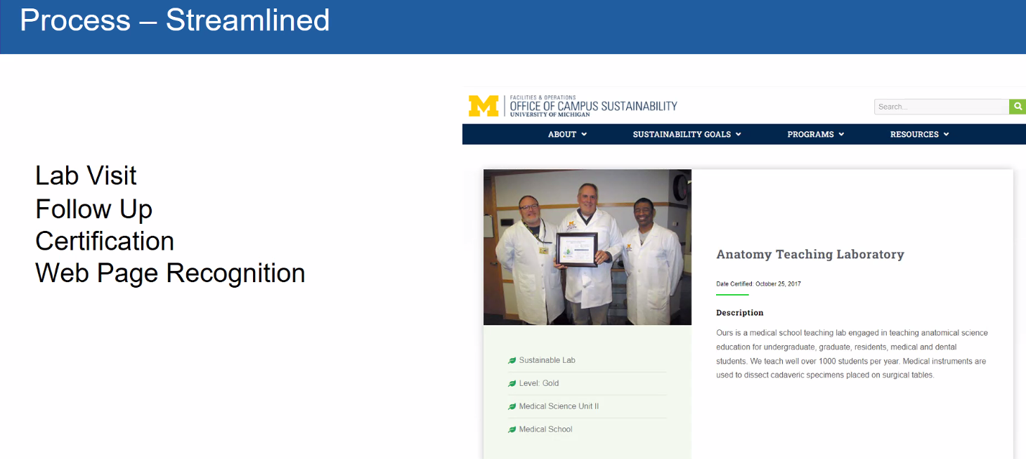
No real points system, have to demonstrate action item to gain platinum status 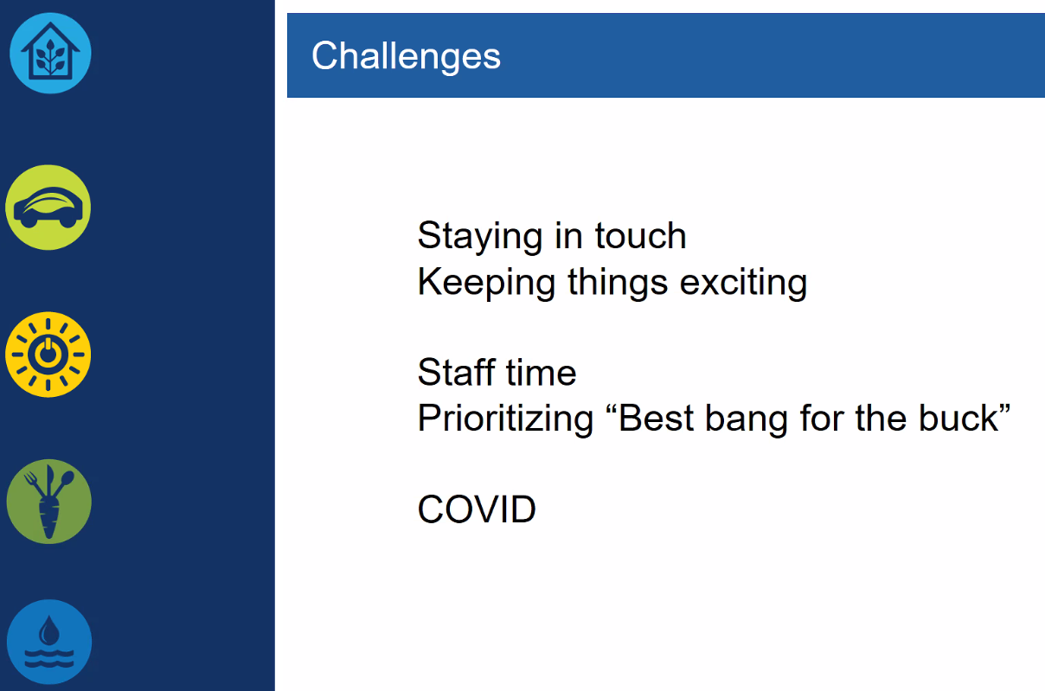
Really a public awareness tool, not a way to verify any impacts
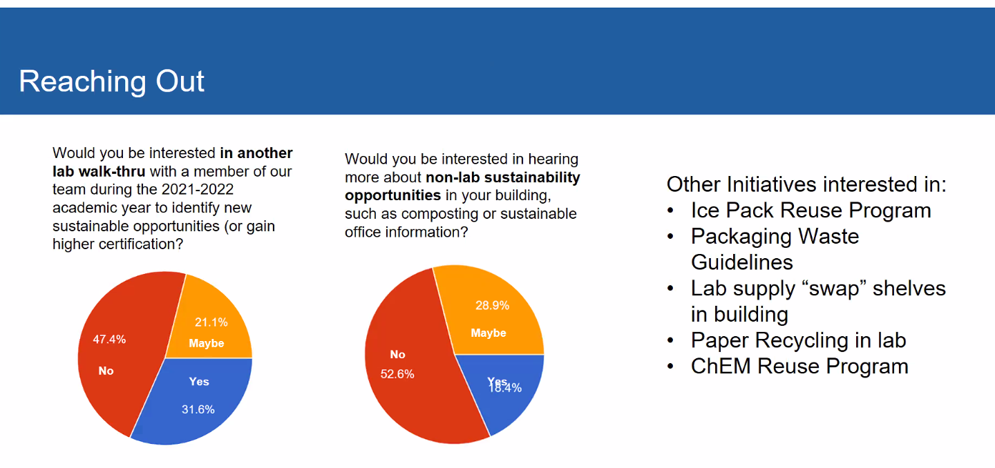
certification is indefinitely, researchers do not want multiple visits or walk throughs nor wanted to hear about other items on campus, I have found this is not necessarily accurate.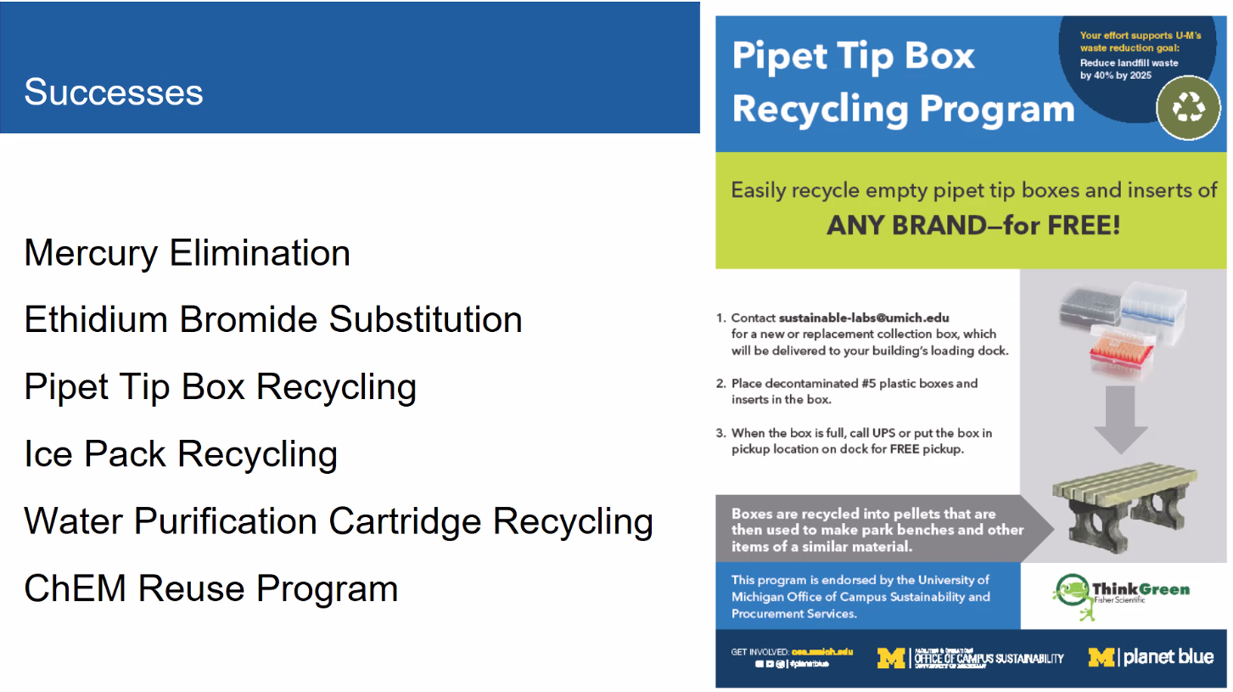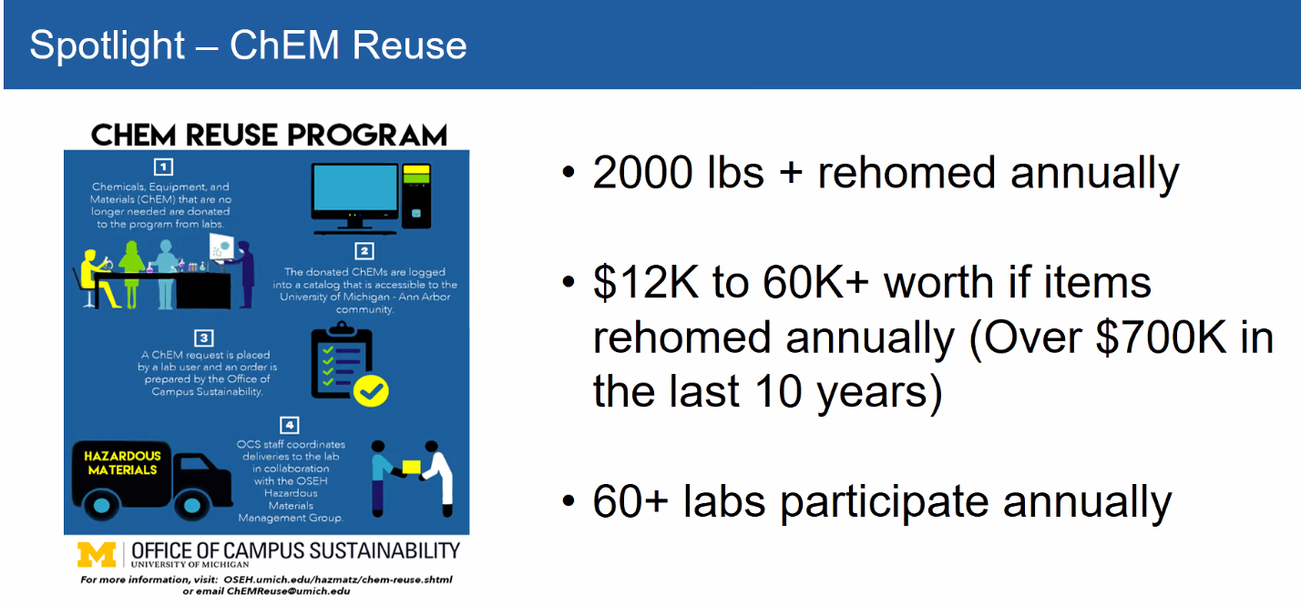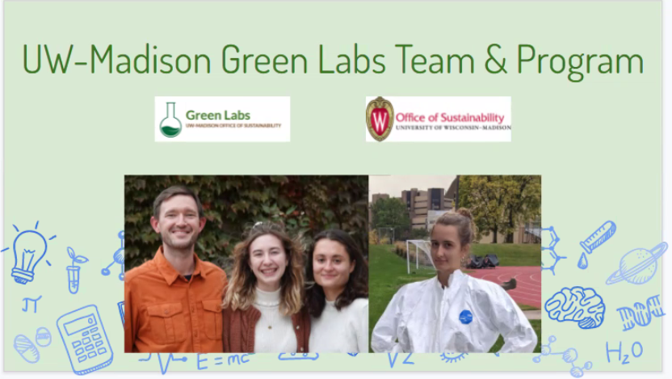grass roots student driven program, not much support from the top down
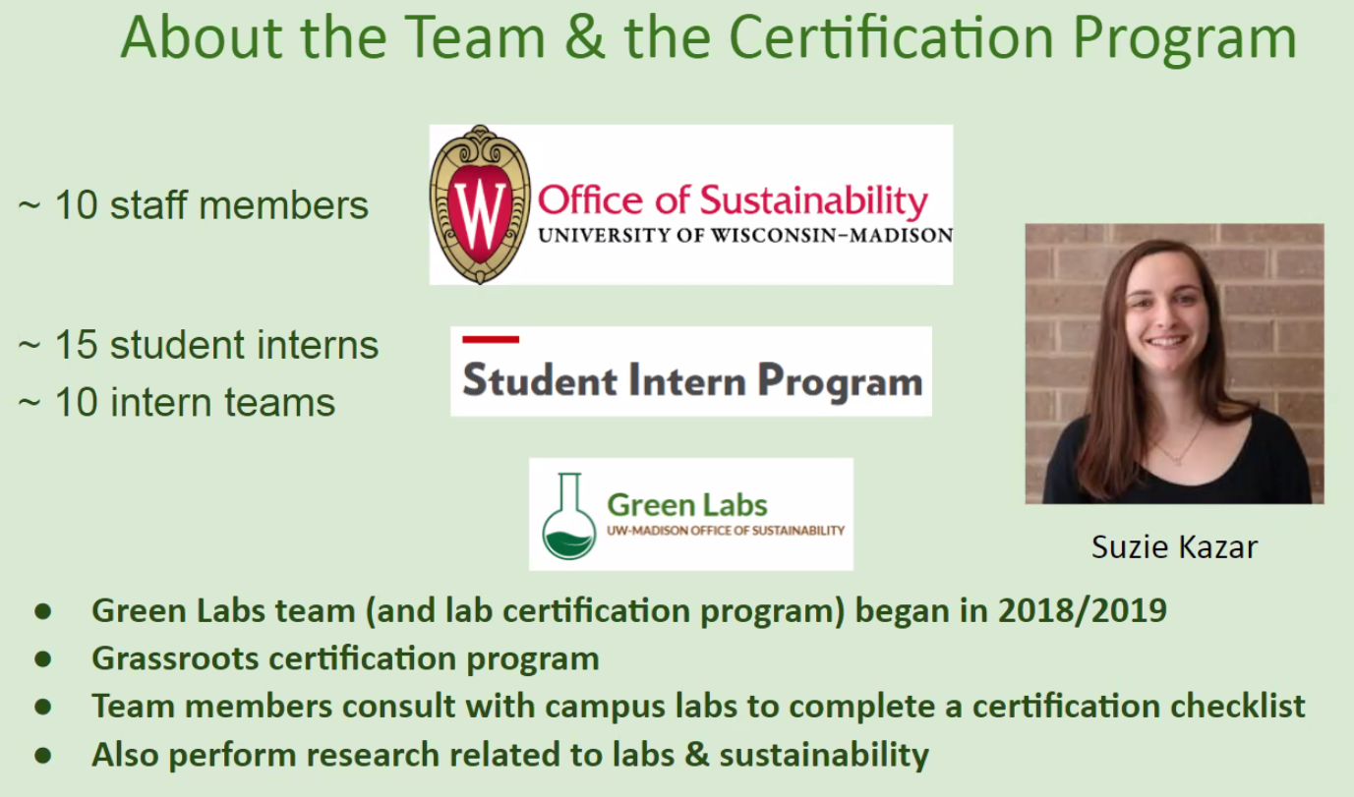undergraduate student passionate about sustainable labs
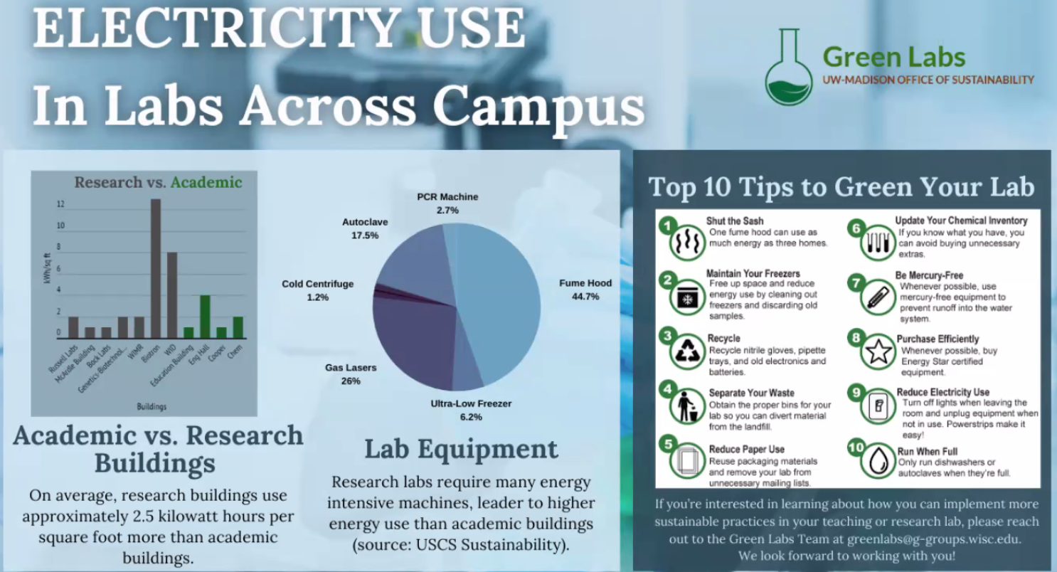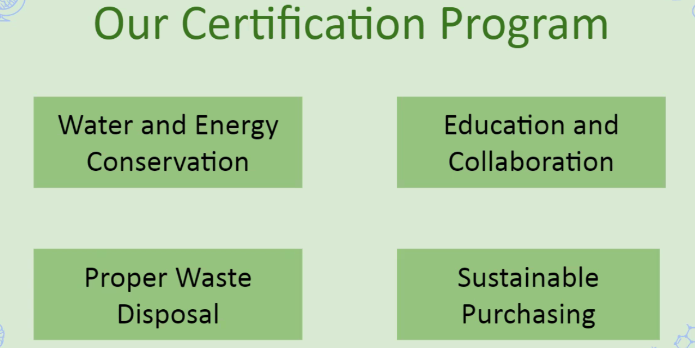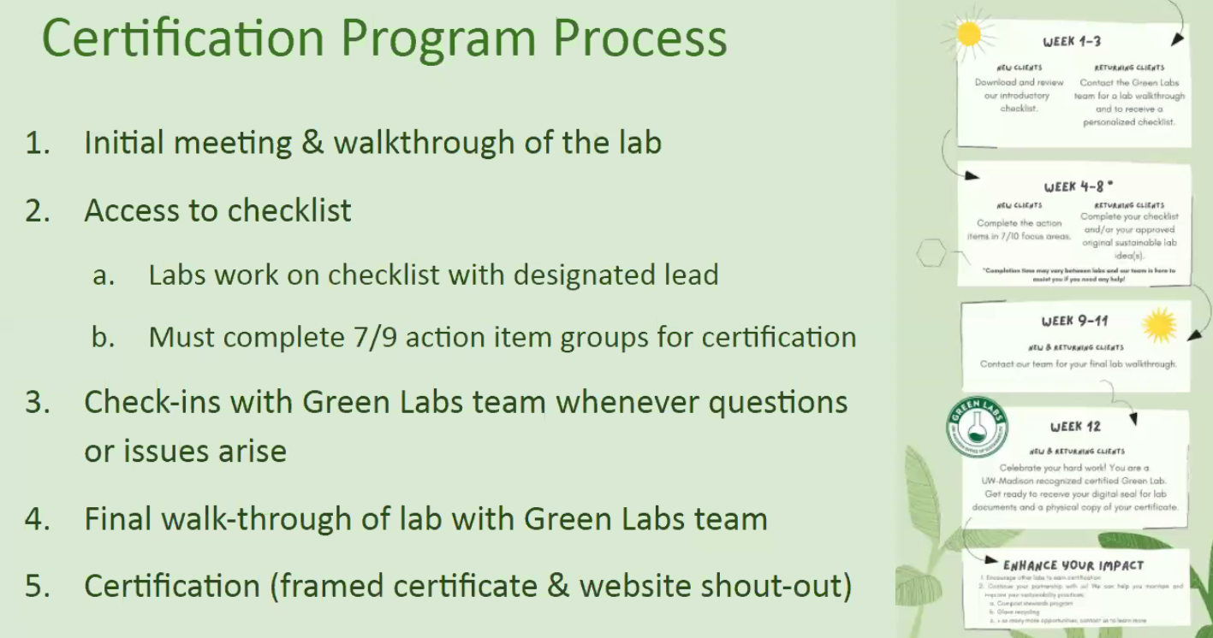
Has sustainability webpage that leads to the labs check list below wet labs, dry labs and various other spaces
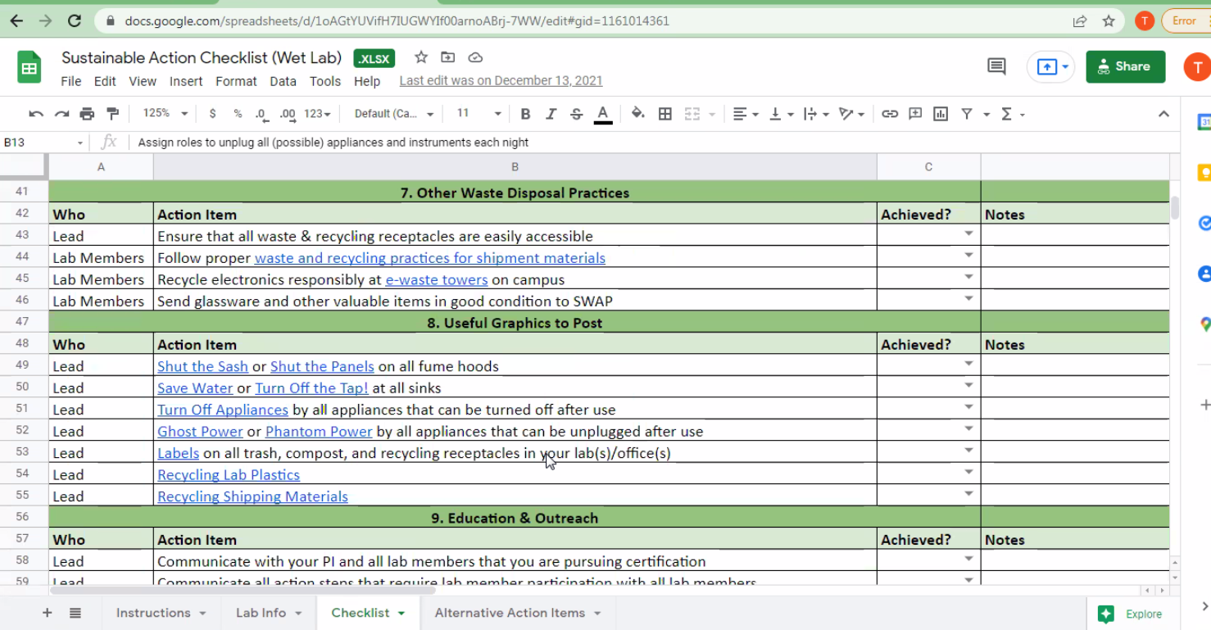
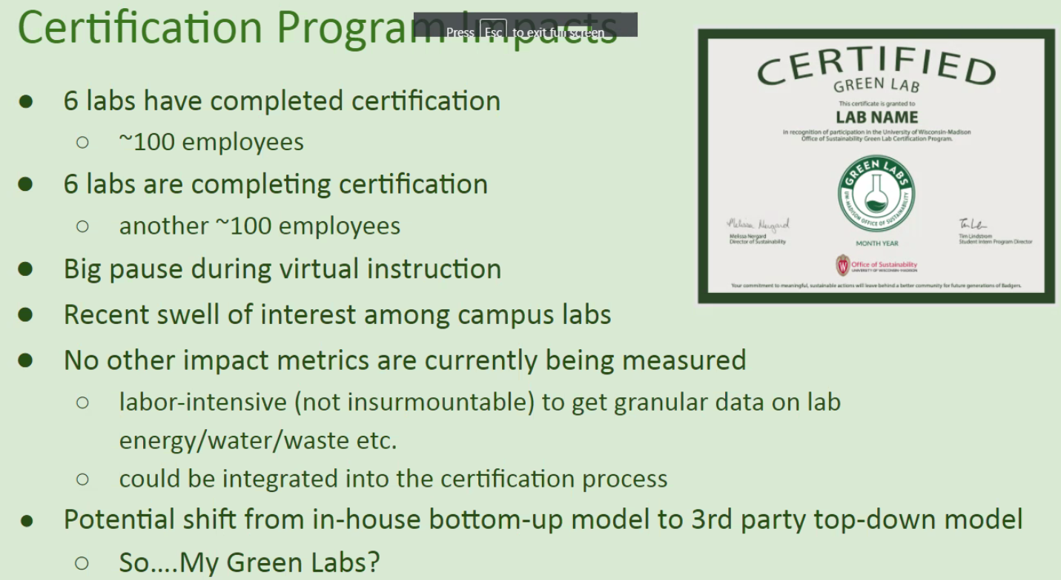
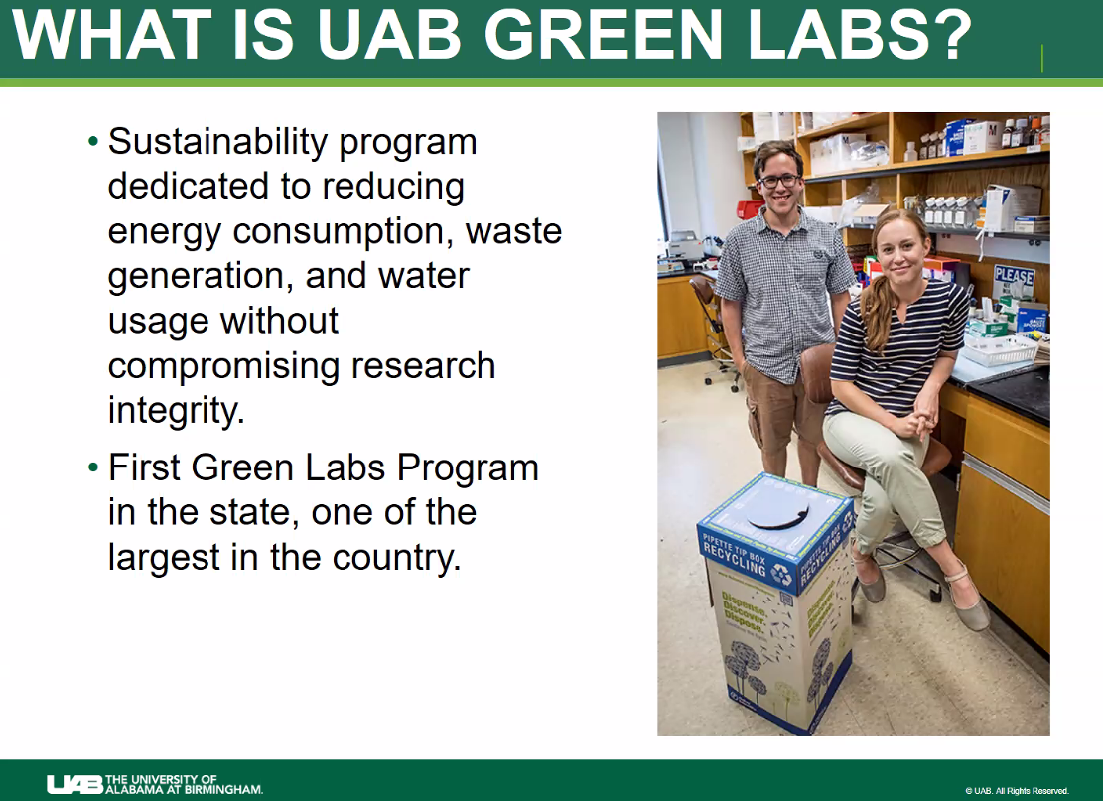
150 certified labs 120 funded PI’s and over 700 researchers out of 3000
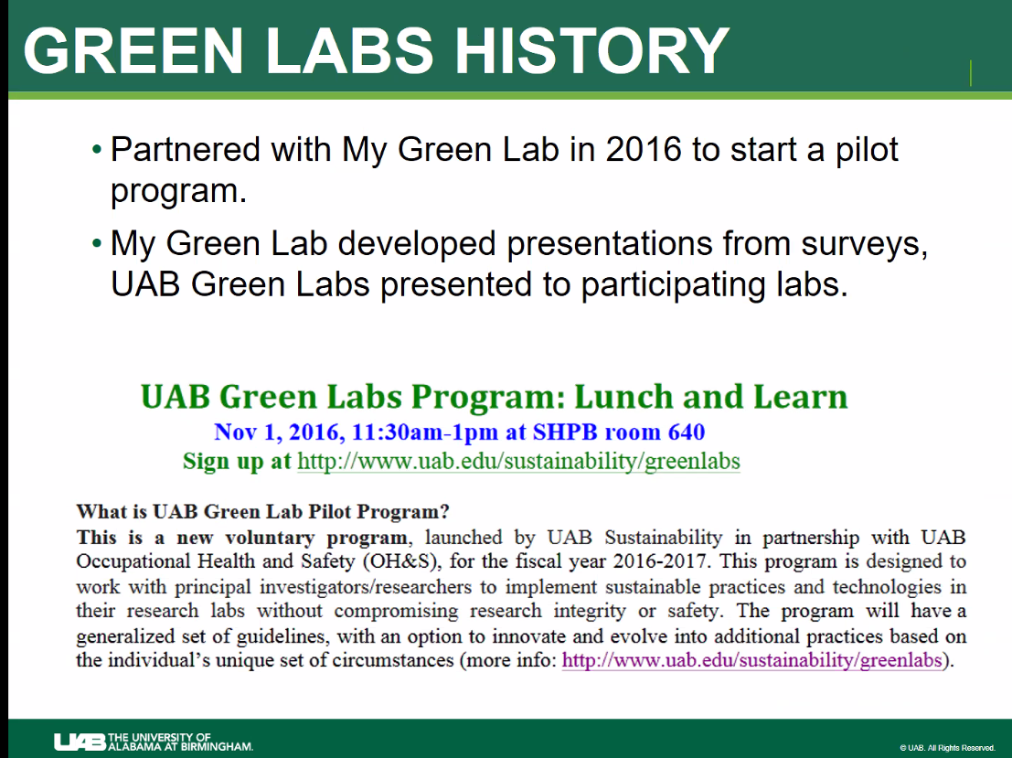
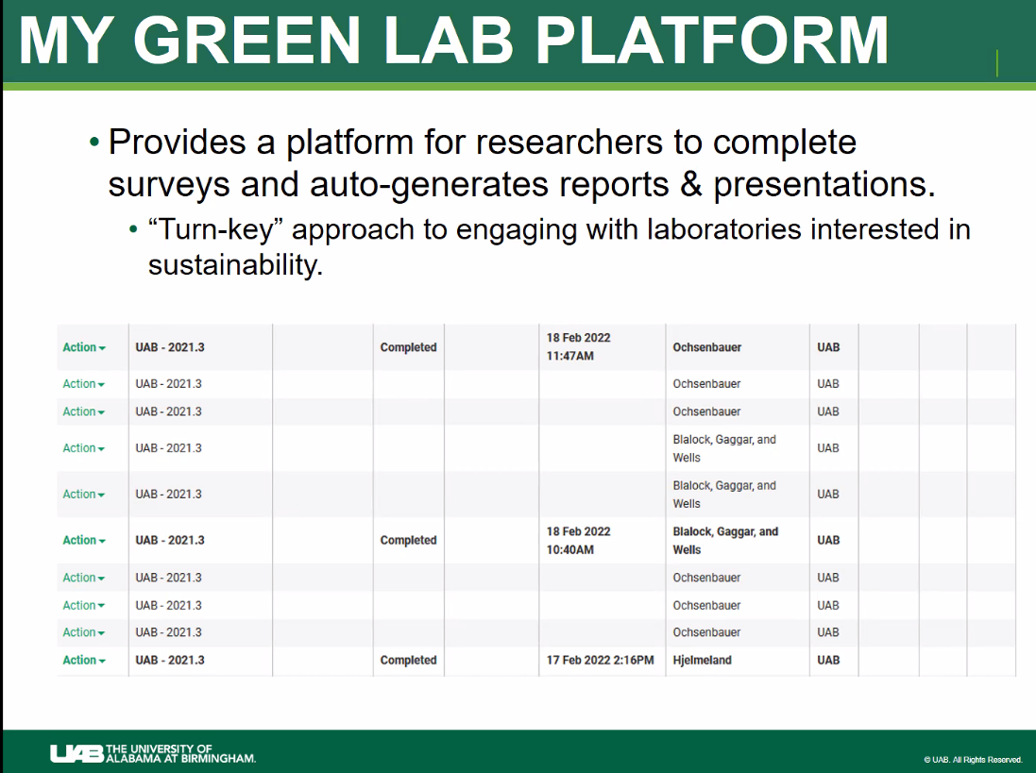
Once 50% threshold reached, survey results generate a report and are shared via a presentation that provides recommended actions and target dates to achieve them by. renew survey every 2 years
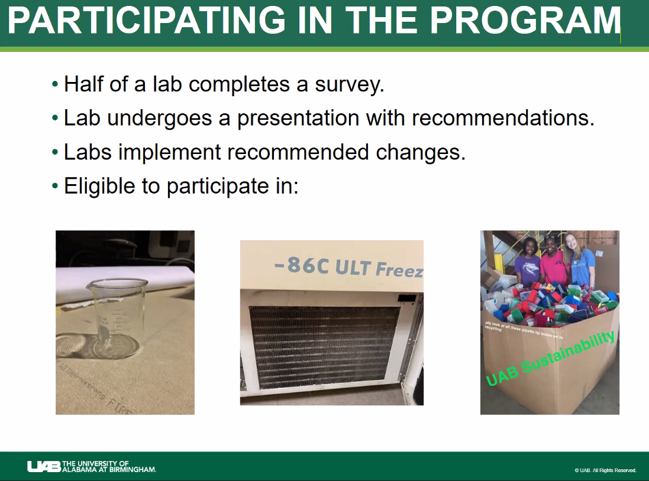
very long survey, incentivize their participation with free glassware free freezer filter cleaning and provide recycling for participation in the survey. Only uses Green as the level to achieve and uses a boiler plate for use with NIH or NSF ??
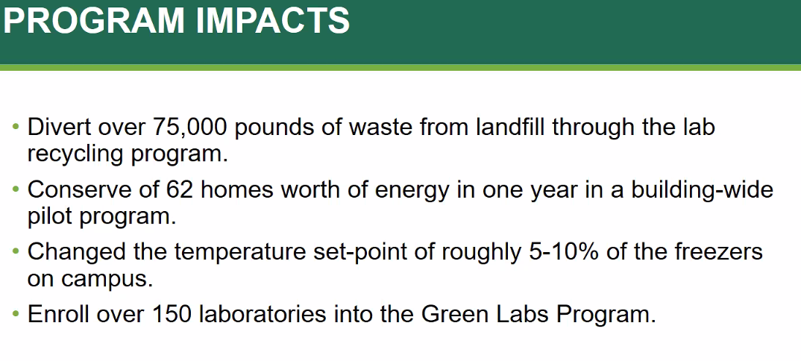

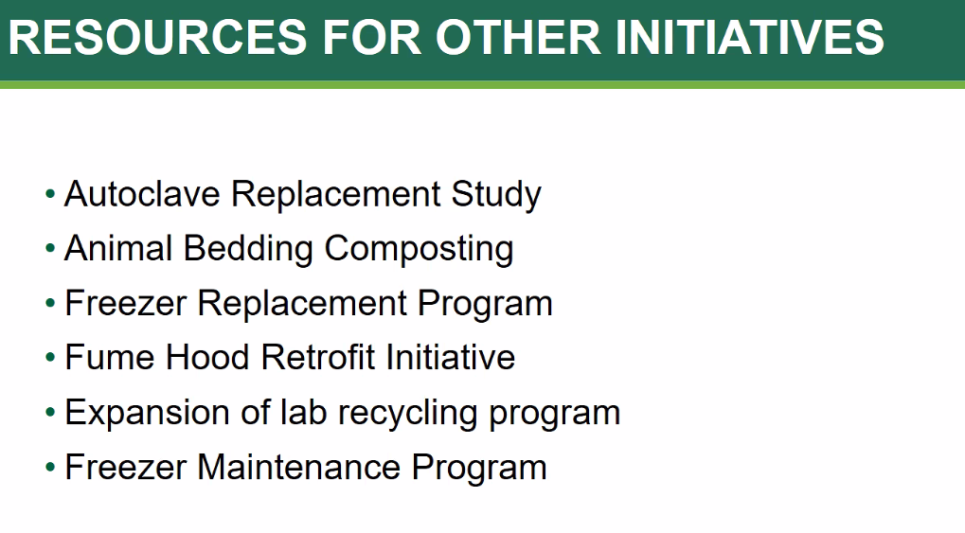
intern does a good amount of the field work so he can tackle other more intensive items like autoclave, freezer replacement, expanding recycling, freezer maintenance program etc….
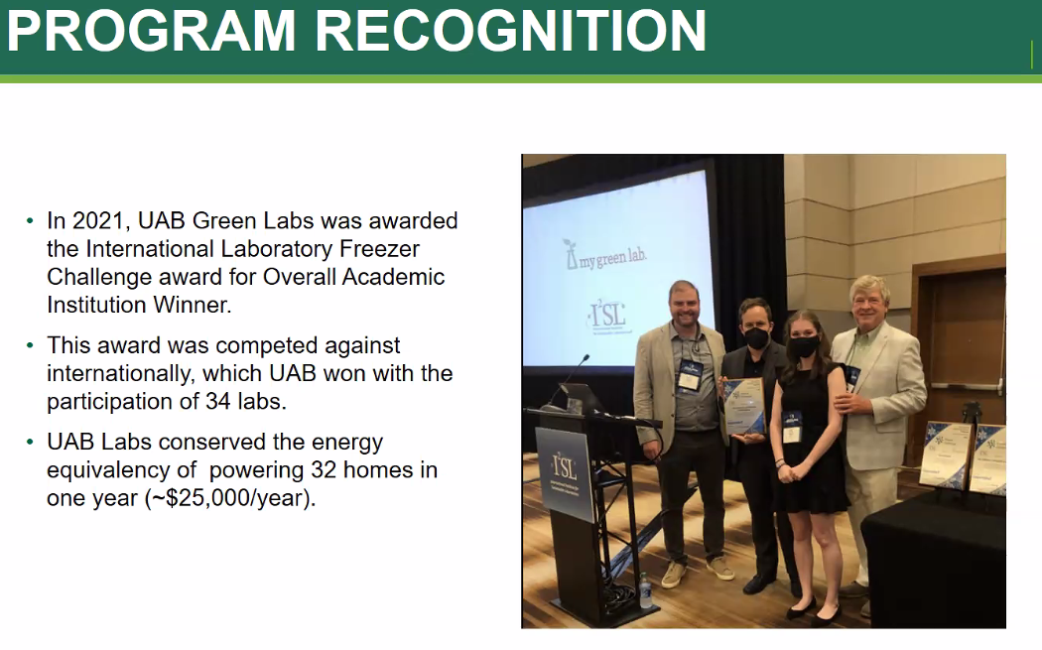
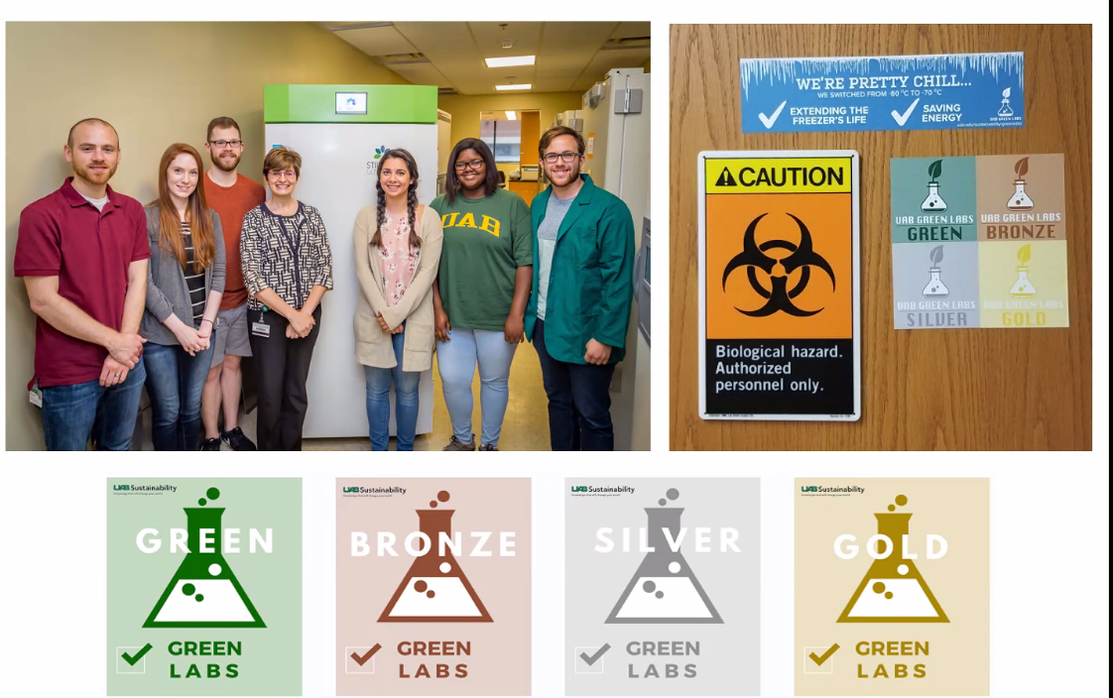

Chat notes:
Me to Nicholas Ciancio (Direct Message) 10:04 AM
Great to see you Nick, look forward to hearing your progress!
From Nicholas Ciancio to Me (Direct Message) 10:06 AM
It's great to see you in the presentation! I've been meaning to reach out to you about I2SL; do you plan on attending this year? If so, perhaps we can give a joint presentation or propose a panel on cold storage energy savings!
Me to Nicholas Ciancio (Direct Message) 10:10 AM
That sounds like a great idea! I have not tackled I2Sl participation yet but should be participating. gfoote2@illinois.edu shoot me a reminder and we can chat further.
From Nicole Berg - U-Michigan to Everyone 10:12 AM
University of Michigan Sustainable Lab Form: https://docs.google.com/forms/d/e/1FAIpQLSffuQeWjB62O4Xcgo6wYqpflBERS_E8WaABFiKARS3CsKhTuA/viewform?c=0&w=1
From Paul Shrivastava to Everyone 10:15 AM
How many labs does U of M have (how many wet labs)?
From Kristin Dreyer to Everyone 10:16 AM
How long does the certification last? (Once certified, always certified?)
From Carley Rice to Everyone 10:17 AM
Have you conducted any energy metering to quantify energy savings in a single lab?
From Sally DeLeon to Everyone 10:18 AM
Have you investigated server use/storage and associated energy impact from research labs? Perhaps this is centralized or on cloud now for Michigan, but just wondering if this is a component of your Green Labs efforts.
From Paul Shrivastava to Everyone 10:19 AM
Have you compiled an inventory of specific “actionable items” on which to provide feedback to Labs being certified?
From Elizabeth Logas-Lindstrom to Everyone 10:20 AM
Is there a sanitization process for lab ice packs before they are reused?
From Me to Everyone 10:21 AM
Are there any measurable and verification methods used to assess impacts?

From Nicholas Ciancio to Me (Direct Message) 10:21 AM
You got it, Paul!
From Nicole Berg - U-Michigan to Everyone 10:23 AM
We do not have metering available at the lab level currently, but our Energy Management Team is currently exploring Smart Labs as a energy management option in the future
From Lydia Bodman Vandenbergh to Everyone 10:23 AM
For Michigan, there is no recertification process at this time.
From Carley Rice to Everyone 10:23 AM
Thanks Nicole!
From Lydia Bodman Vandenbergh to Everyone 10:24 AM
Nicole or Ken - are the ice packs sanitized before reuse?
From Nicole Berg - U-Michigan to Everyone 10:27 AM
The ice packs are limited to ice packs shipped with non-hazardous primers and reagents - no hazardous or biological specimens. We just completed our pilot collection so are currently in the process of sorting through the collected ice packs and assessing all of them. We did work closely with Legal and Environmental, Health, and Safety to get it set-up. A lot of our inspiration came from UC-Boulder's successful program, so I want to give them credit! Program flier: https://drive.google.com/file/d/1DsSDSiwTae1AC7eYIl7QuK_UTDMVEB6j/view?usp=sharing
From Tim Lindstrom to Everyone 10:34 AM
https://sustainability.wisc.edu/student-intern-program/
FYI, in case y'all are interested. :)
From Lydia Bodman Vandenbergh to Everyone 10:35 AM
Keep the questions coming…
From Carley Rice to Everyone 10:36 AM
Has anyone had any success measuring impacts of these certification programs?
From Paul Shrivastava to Everyone 10:37 AM
Has anyone done a Cost/Benefit analysis for establishing a G-Labs program?
From David Jones to Everyone 10:38 AM
Michigan’s Platinum certification level is awarded for going above and beyond. Can you give examples?
From Kenneth Keeler to Everyone 10:41 AM
David, Examples of labs that we awarded platinum to include one lab who purchased a number of energy efficient ULT Freezers. One lab who volunteered to test Gel Red for us and give us an endorsement that we put on our web site. Usually, it is for a lab willing to try out and report back on something new
From David Jones to Everyone 10:42 AM
Thanks!
From Kenneth Keeler to Everyone 10:43 AM
U-Michigan also allows sustainable certified labs to participate in expanded recycling efforts. Like the ice pack program Nicole mentioned
From Me to Everyone 10:46 AM
It's all good fun Nick, Great work!

From Nicholas Ciancio to Me (Direct Message) 10:51 AM
Metering Equipment Data from CU Boulder:
https://docs.google.com/spreadsheets/d/11p8hF9RBkntb1BppNzayC-udLqxTPgg4yEWdmbPO24w/edit#gid=11
From Shane Stennes to Everyone 10:51 AM
You all have existing programs. If you were starting from scratch, what would you do differently (if anything)? How would you recommend approaching development of a new program?
From Nicholas Ciancio to Everyone 10:51 AM
Metering Equipment Data from CU Boulder:
https://docs.google.com/spreadsheets/d/11p8hF9RBkntb1BppNzayC-udLqxTPgg4yEWdmbPO24w/edit#gid=11
From Nicole Berg - U-Michigan to Everyone 10:51 AM
One of the new programs U-M is looking at in the realms of energy savings is: https://www.energy.gov/eere/femp/smart-labs
From David Jones to Everyone 10:51 AM
How is purchasing of shared chemicals handled? Are faculty cooperative with this approach or protective of their own research funds?
From Kristin Dreyer to Everyone 10:52 AM
How are your programs "funded"? Whose budgets pay for the staff and interns? Any suggestions on how to coordinate funding from different university partners/stakeholders?
From Me to Everyone 10:53 AM
Joining the MGL's International Freezer Challenge provides for tracking of valuable metrics that reflects impacts as seen in this article in the green box https://fs.illinois.edu/resources/newsroom/2020/10/01/u-of-i-wins-freezer-challenge-for-a-third-straight-year
From Tim Lindstrom to Everyone 10:53 AM
David, some faculty are more receptive than others, it's really case-by-case. But in general folks are amenable to buying in bulk and shared purchasing as well.
From Me to Everyone 10:55 AM
The poster in this article also reflects impacts https://fs.illinois.edu/resources/newsroom/2021/09/20/u-of-i-wins-the-international-laboratory-freezer-challenge
From Paul Shrivastava to Everyone 10:55 AM
Are the EHS compliance managers in the university engaged with your G-Labs programs
From Kristin Dreyer to Everyone 10:55 AM
Can you talk about these initiatives from an "educational" and "career development" perspective for your interns? Has industry expressed eagerness to hire interns... or grads who participated in the MGL cert program?
From Kristin Dreyer to Everyone 10:59 AM
Can you talk about these initiatives from an "educational" and "career development" perspective for your interns? Has industry expressed eagerness to hire interns... or grads who participated in the MGL cert program?
Do you think having undergrads "helping" a lab with a certification process is an advantageous and less threatening option for lab researchers? (as opposed to having a walk-through / audit that feels more critical)
From David Jones to Everyone 11:00 AM
What are your thoughts about linking UG with Grad students or staff in STEM for mentoring?
From Ritu Jadwani to Everyone 11:00 AM
Do you see cross discipline ideas, for example a textile student giving an idea /working on an idea to reduce waste in the chemistry/physics lab?
From Nicholas Ciancio to Everyone 11:02 AM
If anyone has any additional questions, please don't hesitate to reach out: nciancio@uab.edu
From Tim Lindstrom to Everyone 11:03 AM
timothy.lindstrom@wisc.edu feel free to reach out if y'all have other questions

