Thank you for your commitment to green initiatives at the University of Illinois. One of the final steps in completing the terms of the funding agreement for your project is the submission of a Final Report with key information about your project. You will also need to submit a detailed report of expenses (if you don't list it within this document) as well as supporting photos to showcase your project.

Please be as accurate as possible in describing the project (including possible setbacks or challenges in meeting the initial goals of the project). Not fully meeting your project's goals will not disqualify you from making future funding requests as long as your reports are as complete and accurate as possible. If you have any questions, please contact the Student Sustainability Committee, at sustainability-committee@illinois.edu.
Project Name: Local Grains and Locally Processed Foods for Dining Services

Date of Report Submission: 9/27/2021

Project Purpose:
This project aimed at developing methods that promote the processing of grains produced locally and their consumption by the student body here in Illinois. The project was connected to a larger campus initiative that seeks to promote the development of grain varieties suitable for organic production in this region.
An organic transition project was started in the spring of 2017 at the Vegetable Crop Farm in Illinois, where researchers are investigating plant-soil relationships that influence grain quality. In such a study, various lines of food-grade corn, wheat, and soybean are being evaluated agronomically. This represented an opportunity for us to conduct research & development products that could result from those grains and in partnership with the FSHN Pilot Plant.

Through the field component of this project, we have access to over 12,000, 7,000, and 4,000 lbs. of yellow corn, white corn, and high protein soybean. These grains have been pursued for their quality to produce various products that could be currently used to supplement student meals offered by Dining Services.

Short-term outcomes of this project included:
- Development of new food products from locally produced grains, with evaluated nutrition and sensory characteristics,
- Increasing the use of organic and locally grown foods by Dining Services, and
- Increasing the educational opportunities that raise students’ awareness of the importance of locally produced foods.

Project Summary:
We accomplished most of our goals for this project.
- We purchased the storage containers for the organic cereals and developed test protocols for grain quality determination.
- In Fall 2018, we performed a sensory test called “Consumer Acceptability Testing of Cornbread Muffins” with the participation of 98 UIUC students and 14 UIUC faculty and staff. We asked our participants to taste two cornbread muffins made by organic and conventional cornmeal and evaluate their sensory attributes such as overall liking, appearance, aroma, flavor, and texture. At the end of the test, they were also asked to declare which sample they preferred. The obtained data showed that 60% of the participants chose organic cornbread muffins. Organic samples had higher mean values than conventional samples in all aspects (overall liking, appearance, aroma, flavor, and texture). The participants also noted that there was a significant difference between organic and conventional samples in terms of their flavor. The overall liking scores of the organic corn muffin samples were significantly higher than that of conventional ones. We were also able to gain a deeper understanding of the level of knowledge on organic foods, purchase behaviors, and acceptance measures of UIUC members.
- We completed almost all the nutrient quality analyses of our grain samples. We analyzed their macronutrient composition, color, and contents of minerals, carotenoids, and total phenolic compounds. We also performed the statistical analysis of this collected data to better understand the nutritional composition of organic grain varieties.

Summary of Project Expenditures:
To date, our team has spent $7,251.68 of which $6,657.00 was used in purchasing the large plastic containers to store wheat and corn and $ 594.68 was used to purchase chemicals for nutrient analysis of the corn samples and materials required for the sensory test. There is $2,405.32 available in our budget. Please see the attached spreadsheet for details.

Problems/Challenges Encountered
We had challenges in conducting a sensory test in collaboration with the Maize Mexican Grill restaurant. Last year, we asked for a scope change to conduct another sensory test for which we were planning to use the budget left in our account. We did not ask for additional funding for this activity. Instead, we requested an extension of the deadline. We were hoping to conduct this test by the end of the Fall 2020 semester. With the help of collected nutritional data, we aimed to select a couple of locally produced organic corn varieties to use in this sensory test. We have collaborated with the Maize for a couple of years. Our goal was to conduct a consumer acceptability test using corn tortilla and tortilla chips made from the selected corn varieties with their help and also reach a larger group of participants. However, due to COVID-19 restrictions, it became very challenging to organize such a study. We had to postpone it a couple of times, unfortunately, and eventually had to cancel it.

Student Involvement and Outreach to Date:
Student helpers were involved throughout the project by assisting in developing protocols and testing the quality and acceptability of newly developed products at Dr. Andrade’s lab and the FSHN Pilot Plant. This represented an opportunity for students to link into applied research. Students were also involved in organizing the sensory panels of the developed products. We have trained six undergraduate student and four graduate students on grain quality testing and worked with eight graduate students in the organization of our sensory panels.

Marketing and Promotion Efforts to Date:
To announce our sensory test, we created a flier that included the SSC’s logo. This flier was shared on many different platforms including the SSC’s Facebook page, ACES, and FSHN email groups. It was also forwarded to iSEE and SSC to be put in their respective newsletters. Below, you can find the flier.
We also made a presentation on grain quality at the field day which was held in Wisconsin. We met with local farmers and producers who were interested in organic agriculture. We talked about grain quality and safety parameters, and the tests and tools to assess grain quality. We also introduced them FSHN pilot processing plant and laboratory. One of the most important goals of our project is to support local farmers and locally grown and processed foods. In accordance with this purpose, we offered to help with grain processing and quality testing in FSHN pilot plant facilities to the local producers. Below, you can see the picture poster presentation which also includes the SSC’s logo.
Our findings were also presented at professional meetings including the AACC Cereals and Grains Annual Meeting & Expo 2019, Denver,CO and the Institute of Food Technologies Annual Meeting– Food Sustainability session; July 2021)
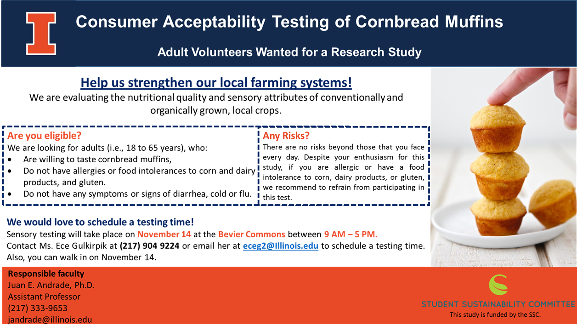

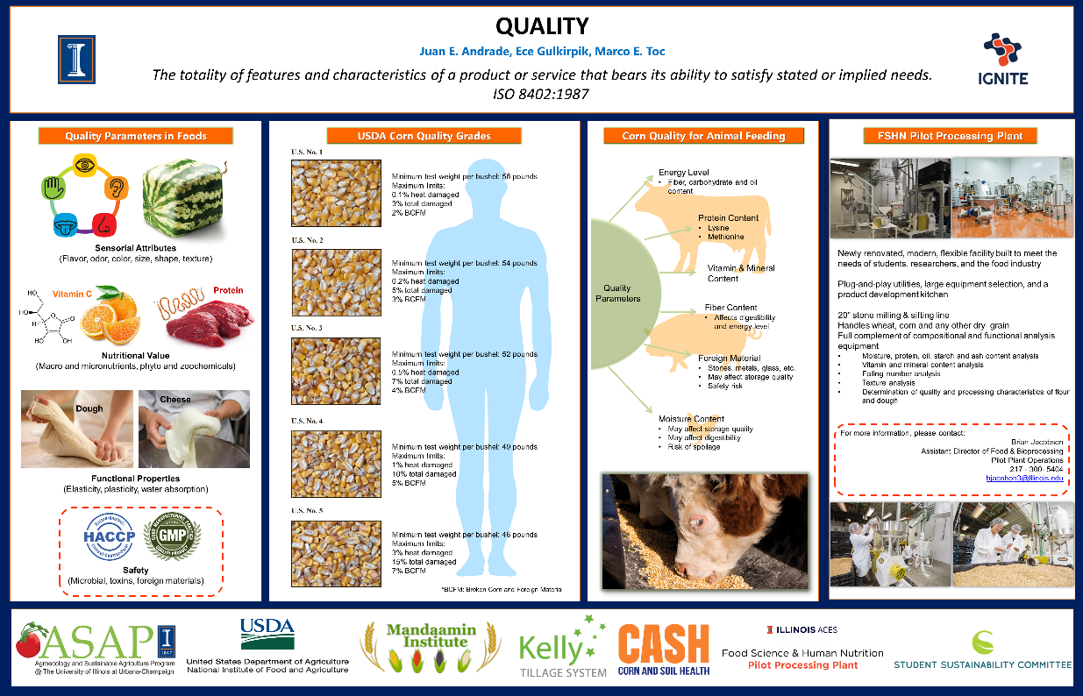
Additional Comments:
Any additional comments/relevant information for this report

In addition to the above fields, please provide a detailed accounting of how the funding was spent as well as pictures of the final project in an email to sustainability-committee@illinois.edu. Thank you again for your commitment to sustainability.

