**The Barn in the American Imagination**

**COLLEGE OF FINE AND APPLIED ARTS | Fall 2017**

University of Illinois at Urbana Champaign

Design Research Fellows

Proposal by Aaron Brakke and Stan Ruecker

Date: October 3, 2017

Location: Conference Room 127B at Facilities and Services

Meeting Participants:

Ted Christy

Sara Simmons

Matthew Andrew Tomaszewski

-

Kevin Hamilton

Stan Ruecker

Aaron Brakke

**Introduction**

From barn raisings to barn dances to enthusiastic teenagers in musicals staging impromptu performances, the American barn has always had a special role to play in American life, and in particular, in the American imagination.

In this project, we hope to reference this iconic form in an art installation designed to meet one of the key objectives of the Design Research Initiative, namely increasing the awareness of design and design research on campus. We will do this by combining reclaimed barn wood with new wood and materials to create a pavilion that includes information on a variety of themes, and that can be used as a venue for a series of different events that engage the university and the larger community. The design and installation of the pavilion will provide a hands-on experience for graduate students in Aaron Brakke’s ARCH 576: Architectural Design Seminar.

In addition, the pavilion’s proposed location which is between the Business Instructional Facility and the Krannert Art Museum will invite people from around campus, and especially from undergraduate engineering, to increase their awareness of the site of the new Siebel Design Center, and to emotionally engage with the construction of the center by using the pavilion as a viewing platform of the construction site.

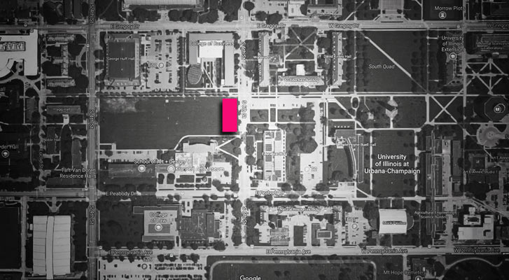**Location**

The site that is being proposed for this project is located in the open area west of 6th Street and south of the Military Axis, between the Business Instructional Facility (BIF) and Krannert Art Museum on the University of Illinois Campus in Champaign, Illinois. Other buildings located in the immediate vicinity include the School of Art + Design, Education, Natural Resources, Architecture, among others.

**Engaging Local History**

In parallel with the founding of the University and its development, the dense forest thicket originally on the site was cleared to make way for development. The university, now home to nearly 50,000 students, faculty and staff is seated in Champaign and Urbana, which together comprise a community of 200,000. At the same time, the agricultural industry is utilizing this region’s fertile soil to harvest nearly 48 million bushels of corn and 13 million bushels of soybeans annually that contribute to the + $15 billion state economy.

South of the university, Frederick Pell purchased hundreds of acres of land upon his return to the region after serving in the Civil War. This land has been farmed, portions of it have served as the U of I apple orchard and others developed into housing. The Uchtmann 120 in Sec. 7, Philo Township is now owned by Don and Nancy Uchtmann who have granted use of the lumber to the Design Research Fellows. This material has been secured from the deconstruction of a barn on their premises which is believed to have been built early in the 20th century.

**Engaging Diversity / Multiple Academic Groups**

The Design Research Fellows actively sought to encourage dialogue within the College of Fine and Applied Arts throughout the 2016-17 academic year. As we move into the 2017-18 academic year we have decided to expand the demographic scope and engage more members of the University community through the pursuit of existing opportunities (150 year symposium / publishing / etc.) and by creating other spaces for this to happen. The Barn Project is one avenue for us to achieve our objectives.

**Engaging the Community**

Several cultural activities (talks, dance, artistic performance) are being planned that will utilize the Barn project as the scenography for the activities. Several of these events will be designed to engage the local community.

**Design Center**

This installation is to be located directly east of the Design Center construction site to serve as a viewing platform that simultaneously puts the viewer in touch with the past as current plans see development and narratives for the future are pondered and dreamed.

**The Design-Build Aspect of the Barn Project:**

Architecture and design students will be tasked with designing, developing and constructing a a pavilion that will serve as a place to gather, converse and view the surroundings. The history of the region will be contemplated as the lumber acquired from the dismantled Frederic Pell Barn will be handled and examined. Students will embark on a process that requires a careful reading of the cultural practices and material culture of a region that gave birth to Lincoln and has promoted an equal, just and inclusive society. As students gain this insight, they will also be asked to envision a small node for other members of the community to gather. This place will provide clues to learn of the past as well as cues to discuss the future.

In addition, techniques of traditional wood construction and of milling will be learned, since the architecture wood shop has received a grant from the student sustainability council to improve our infrastructure to harvest local timber. Students will also be asked to think innovatively and employ computational design thinking and digital fabrication equipment to produce the pavilion.

**Precedents with Architecture Students:**

The Urbana Urban Screen Structure project is currently under development. Students were required to analyze the vernacular structure of a log cabin. Tectonic details were studied and ‘part’ to ‘whole’ relationships were discussed. The class was challenged to address the following questions: How can small scale interventions become place makers that heighten the awareness of the context in which they are constructed? How can urban acupuncture serve as an instrument to facilitate a critical discussion and promote speculation about the future? The class was tasked with designing and building screen structures that responded to the aforementioned questions. We worked closely with the city to develop projects that will enhance the public space when installed in downtown Urbana. Students gained exposure to a myriad of theoretical and practical issues throughout the semester. Important insight was gained into methods, materials and techniques used to imagine, conceive, develop, prototype and produce architecture. Furthermore, I worked with our Fabrication Coordinator Lowell Miller to provide unique opportunities to learn about the lumber industry, details and construction. We are proactively creating new opportunities for local and sustainable development through the use of local trees to create usable lumber.

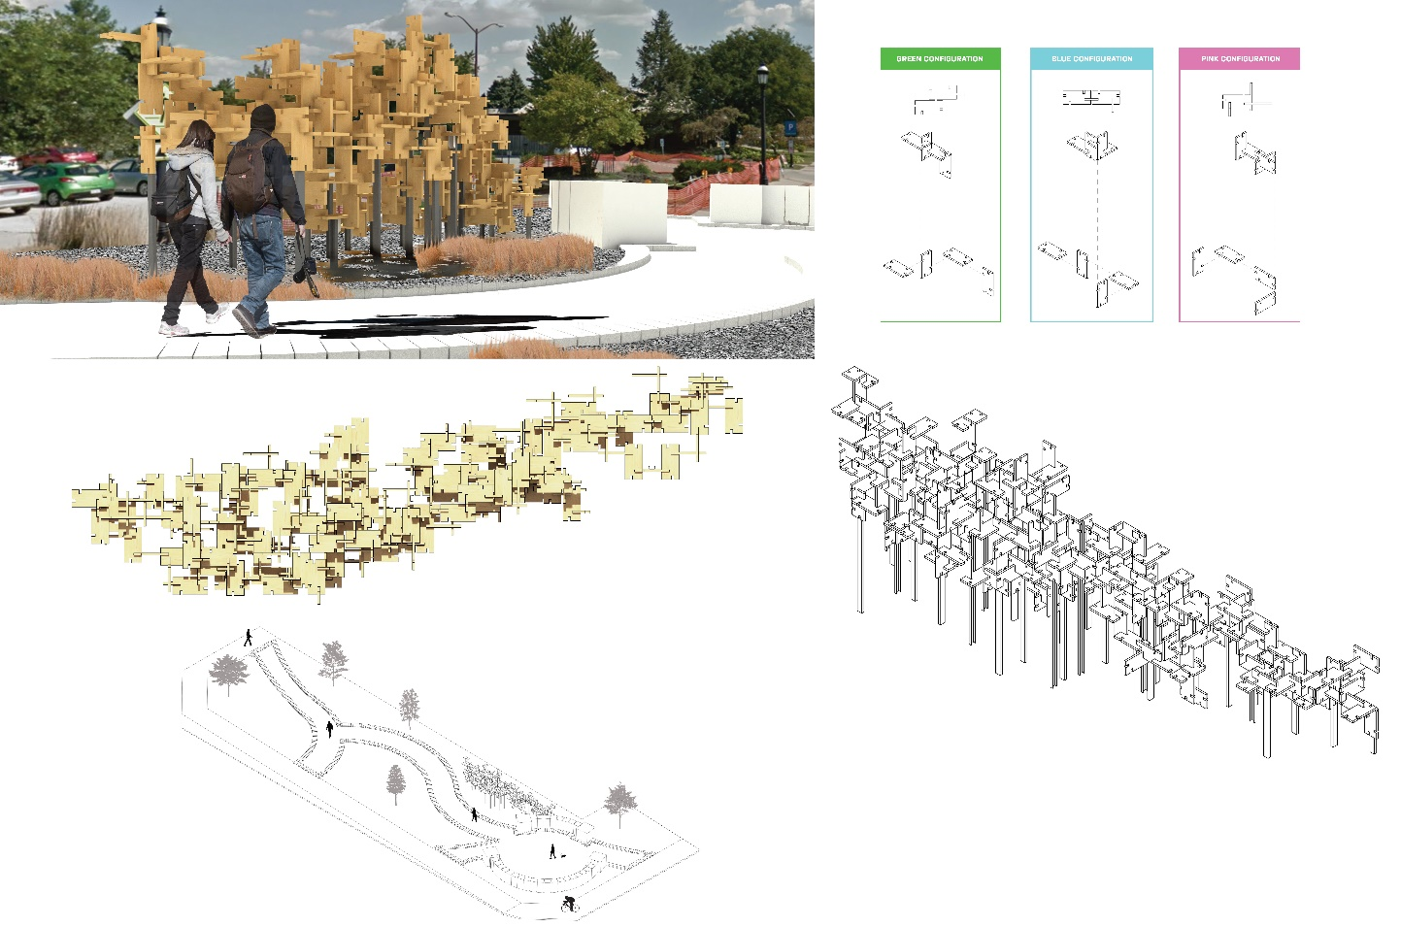

The drawings and rendering above show the development of a modular screen that will be located downtown Urbana. This is a student project that is part of the ARCH 571 Studio that Professor Brakke teaches.

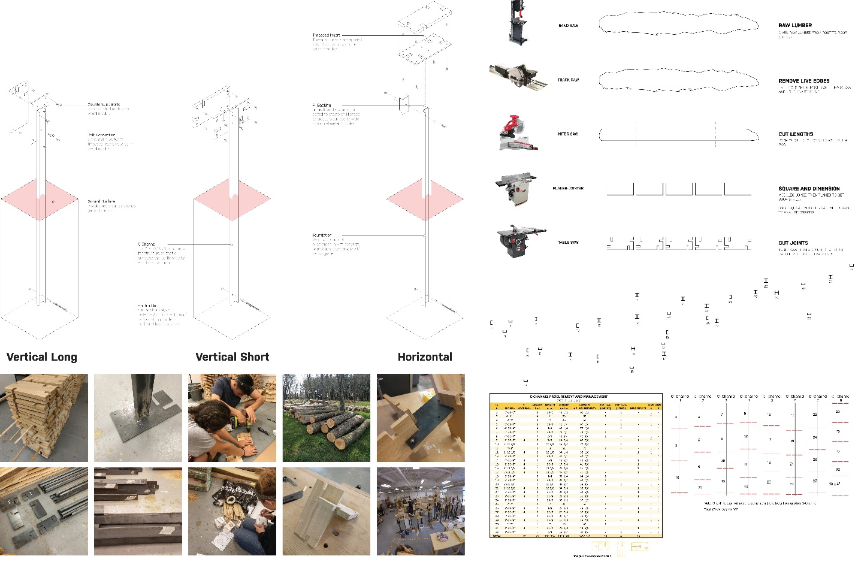

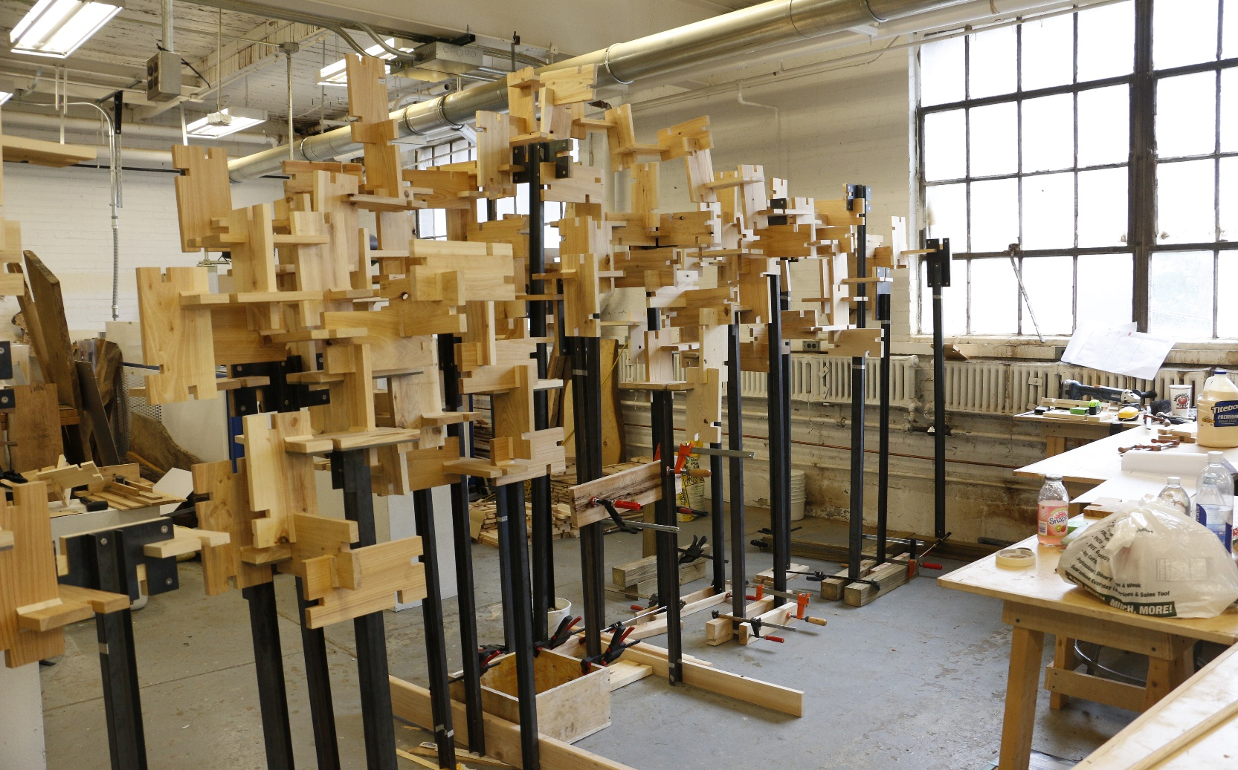

The drawings and images above show the development of a modular screen that will be located downtown Urbana. This is a student project that is part of the ARCH 571 Studio that Professor Brakke teaches.

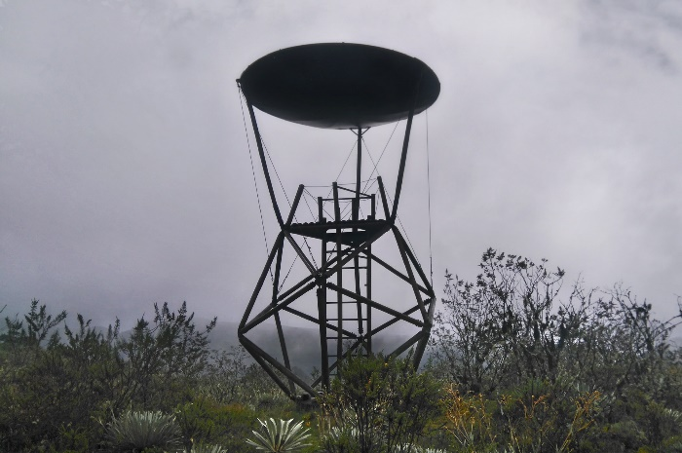 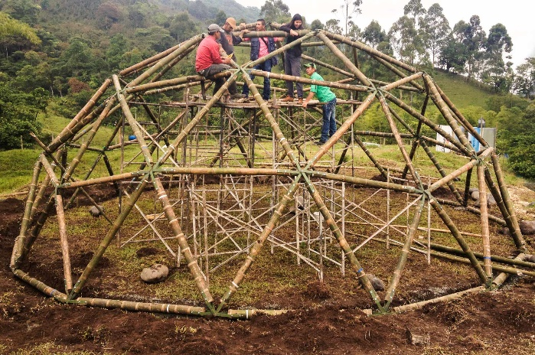

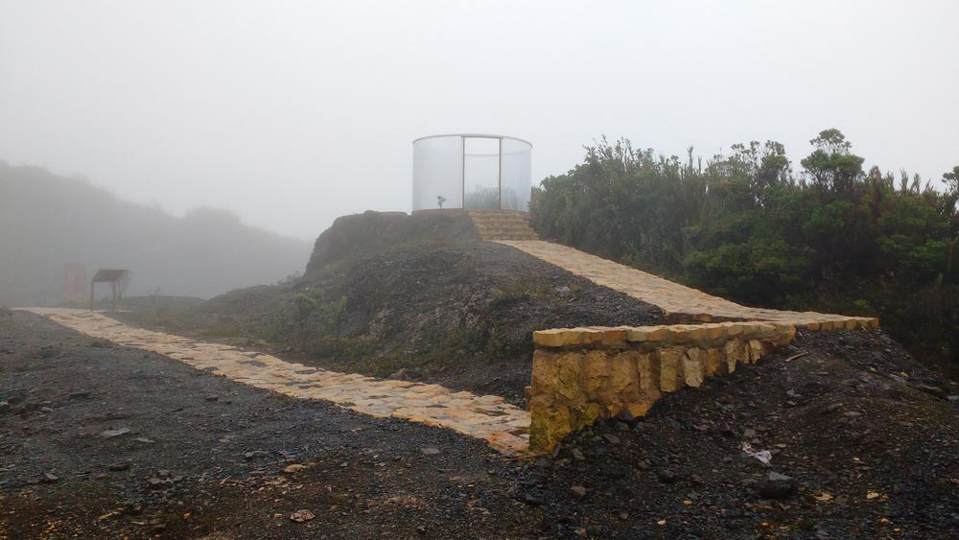

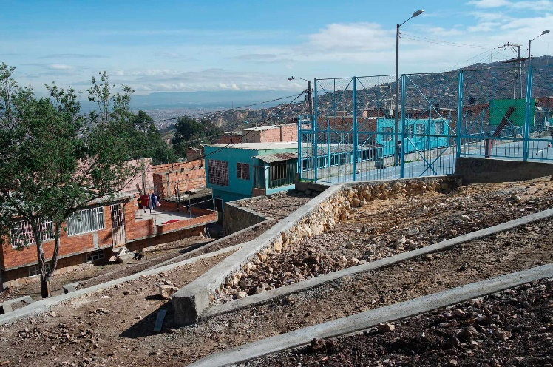 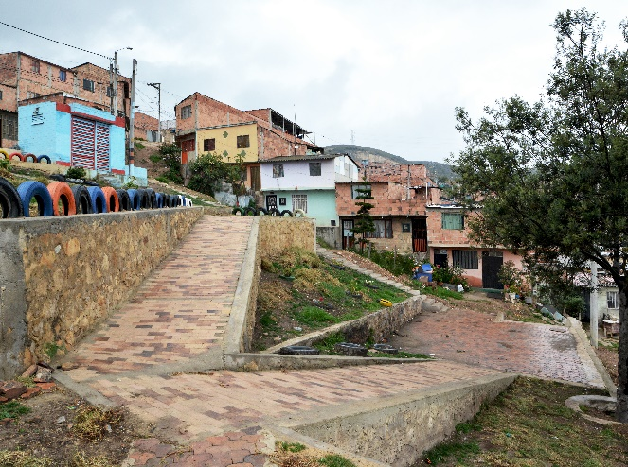

The images on this page show design projects that Professor Brakke has been involved with. These projects were completed with students and community members in Colombia. The projects were built with very limited resources. Rather than focus on quality of design, these images are evidence of how architectural projects have helped bring communities together.

**Information about the Pell Family and History of Their Estate**

* Information provided by Don and Nancy Uchtman, the current owners

**Farmer Pell and the Uchtmann 120 in Sec. 7, Philo Township**

On March 15, 2012, Don & Nancy Uchtmann, partnering with Deb & Pete Ronco for the purchase of thirty acres, acquired the 120 acre “Pell Farm” in Sec. 7 of Philo Township, Champaign Co., IL. The farm included an old farmhouse (rebuilt in the early 1930s after a fire), an old barn (probably the second barn on the farmstead) and a machine shed (built in 1978).

The Pell Family Connection. The Uchtmanns purchased the “Pell Farm” from Tom & Meredith Smith, brother and sister and great grandchildren of Frederick Pell. The farm is operated by Mark Douglas, a fifth generation descendent of Fred. Fred was born in September 1832 in Lewis County, Kentucky, the fifth of ten children. In 1856 Fred moved to Champaign Co., arriving with two horses and a small amount of money. He became a farm tenant and in September 1857 married Martha Jones. She had arrived the year before from Ohio with her married sister. Fred and Martha had four children – two daughters who died in infancy and two sons who grew to manhood. In 1861 Fred made his first land purchase – 80 acres in Philo Township acquired from the Illinois Central RR. He energetically proceeded to break the native prairie. But his life as husband, father, and farmer would soon be interrupted by the Civil War.

Fort Sumter and the Call to Arms. On April 12, 1861, Confederate batteries opened fire on Fort Sumter near the entrance to Charleston Harbor. Out gunned, out manned, and nearly out of ammunition, the small Union garrison surrendered the fort after thirty-four hours and a guarantee of safe passage. The Civil War had begun. President Lincoln’s call for states to send troops to recapture the forts and preserve the Union reverberated throughout the North, including Illinois.

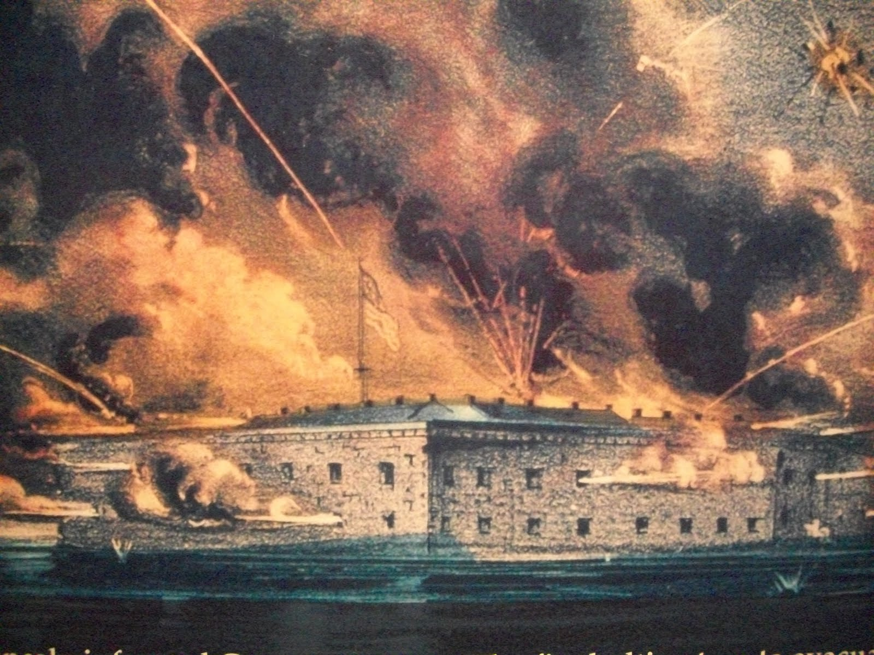***Firing on Fort Sumter, April 12, 1861***

Illinois Volunteers. Over 256,000 men from Illinois served in the Union army. Beginning with Lincoln's first call for troops and continuing throughout the war, the state mustered 150 infantry regiments, seventeen cavalry regiments, and two light artillery regiments. Illinois ranked fourth in terms of men in Federal military service, with Illinois troops fighting predominantly in the Western Theater. Among the 150 Illinois infantry regiments was the Seventy-Sixth Illinois Volunteer Infantry, and ***among the Champaign County recruits in Company G was Frederick Pell*** who enlisted in July of 1862, a few months before his thirtieth birthday. One officer in the 76th Infantry was Samuel T. Busey. Col. Busey would become Frederick Pell’s Regimental Commander in 1863 and, after the war and with his brother Simeon, would establish the Busey Brothers & Co. Bank in Urbana which operates today as Busey Bank.

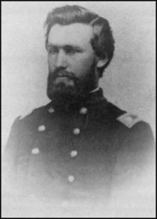***Samuel T. Busey, Pell’s Regimental Commander***

Frederick Pell’s Civil War Diary. Fred’s diary generally describes the everyday life of a soldier, e.g., the many times he drilled, marched great distances, or had picket duty, and the infrequent days he was paid or went berry-picking; the diary also records each day he received a letter from his wife, Martha (and when he replied – typically the same or the next day). Comparing dates on Martha’s letters with the dates received, it usually took about two weeks for a letter to pass from Urbana to a Union encampment. Many letters from Martha were received and answered, but the frequency dropped precipitously in 1865.

**Civil War Diary, Frederick Pell, Co. G, 76th Illinois Infantry (Entries from July 1-4, 1863)**

Wed, July 1. I went blackberrying, got one gal of nice berries and had a splendid berry pie. It being the first of July we thought we would have something good to eat and we did. Blowed up Fort bay McPherson.

Thur, July 2. Got a letter from Martha Pell and sent one to her. Got paid $26.00.

Fri, July 3. Very heavy firing up til 10 O’clock when all was quiet until about 4 O’clock when there was some firing by the gunboats for about one hour, and then all was quiet.

Sat. July 4. Vicksburg surrendered; about 27,000 prisoners.

Other diary entries record numerous events, including fighting during Gen. Grant’s siege of Vicksburg (May-Jul, 1863) and Gen. Sherman’s campaigns at Jackson (July 1863) and Meridian (Feb-Mar 1864), Miss. Later entries describe the April 1865 Battle of Fort Blakely, Ala., the last major battle of the Civil War. The battle’s final assault came hours after Gen. Robert E. Lee’s April 9 surrender at Appomattox (and about a week before President Lincoln’s assassination).

Pell’s diary: “Sun, April 2. Marched seven miles and found the Confederates entrenched and the fight commences*.*” Entries for April 3-5 describe digging rifle pits, no sleep, throwing up breast works, and getting close to the Rebels. Then: “Sun, April 9. Second Division assaulted and took all the Forts around Blakely. Losses of the 76th heavy. The 76th colors first on the parapet. Lasted about one hour”. And continuing: “Mon, April 10. We buried the dead and picked up the ground.” And “Tues, April 11. All is quiet today for the first time since we got here.” A few days later: “Sat, April 15. All quiet at Blakely, some talk that the war is over.”

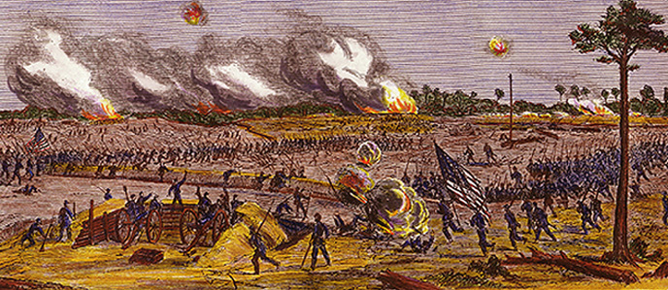 ***The Last Charge of the Civil War, April 9, 1865***

Preceding the battle-related entries of April 8-10 was a very sad, personal entry on April 5:

“Got a letter today that my wife is lying at the point of death.” Actually, Martha had died in Urbana sixteen days earlier – March 20, 1865 – seven and a half years after their marriage and two and a half years after Frederick Pell had marched off to war.

John Welch’s History of the 76th Illinois Infantry. This history notes that the regiment numbered about a thousand men initially; traveled over ten thousand miles during the course of the war; fought in thirty-four civil war campaigns, battles, and engagements; and suffered 426 known casualties – 52 killed, 167 wounded or missing, and 207 who died of disease.

Frederick Pell’s Life in Champaign County. Fred Pell was honorably discharged in Aug. 1865. He returned to Champaign Co. and resumed farming. In Sep., 1867, Fred Pell married Mary Cover, the widow of Fred’s fellow soldier who had died of illness eighteen months after enlisting in the same infantry unit as Fred. Mary and Fred had two children who survived infancy, a son and a daughter. Fred bought more land – a quarter-section in Philo Township, Sec. 7, and later

the adjoining 120 acres and additional tracts. He lived on his farm in Sec. 7 for seventeen years before moving to a home in Urbana Twp. in 1887 and his last home in 1898. A sketch of the old Pell farmstead (*circa* 1880) in Sec. 7, Philo Township is reproduced below.

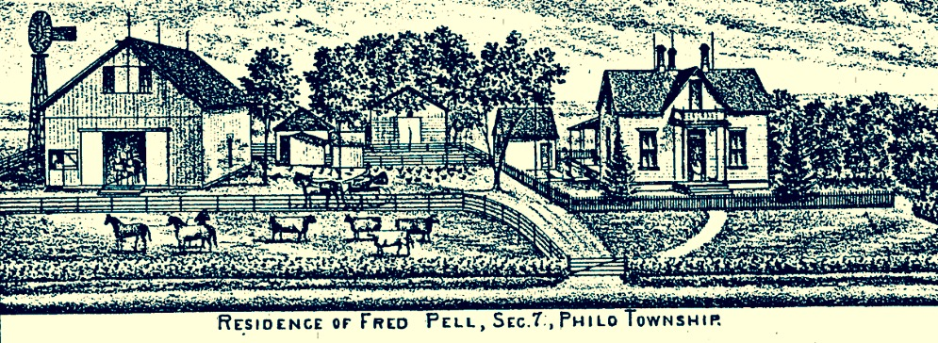

Fred Pell and Black Eagle Post 129, G.A.R. After the civil war, veterans began joining together – first for camaraderie and then for political power. The most powerful organization would be the Grand Army of the Republic (GAR), founded in Decatur (5 future U.S. presidents would come from its membership). The GAR founded soldiers’ homes, was active in relief work and in pension legislation, and helped establish Memorial Day as a national holiday.

Fred Pell’s 3rd Marriage in 1893 and Death in 1919. In 1890 Fred’s second wife, Mary, died. Three years later, at the age of sixty-one, Fred married for a third time, this time to Sarah J. Parkin. They raised a son, Thomas Parkin Pell, born in 1896. Fred died May 30, 1919, at the age of eighty-six, and is buried (Plot 9) with other family members in Mount Hope Cemetery (East of Memorial Stadium - home of Fighting Illini Football). Fred was survived by his wife, Sarah, sons Charles and James from his 1st marriage [James was the Great-Great-Grandfather of the current “Pell Farm” operator, Mark Douglas], son Henry and daughter Mary (Mosier) from his 2nd marriage, and son Thomas from his third marriage [Thomas was the grandfather of Meredith and Tom Smith from whom the Uchtmanns purchased the 120 acre “Pell Farm”].

The Pell Farmland Legacy. Frederick Pell & his descendants acquired hundreds of acres in Champaign County (including what would become the Uchtmann 120 in Sec. 7, Philo Twp.). Other Pell farmland would become the U of I Pomology Farm (Apple Orchard) at Windsor and Philo Rd. – later to pass into private hands. One farm – including the site of Fred & Sarah’s 1898 new home – later became a part of South Urbana, traversed by many streets including Pell Circle where, coincidentally, Don & Nancy now live and where they raised their three children.

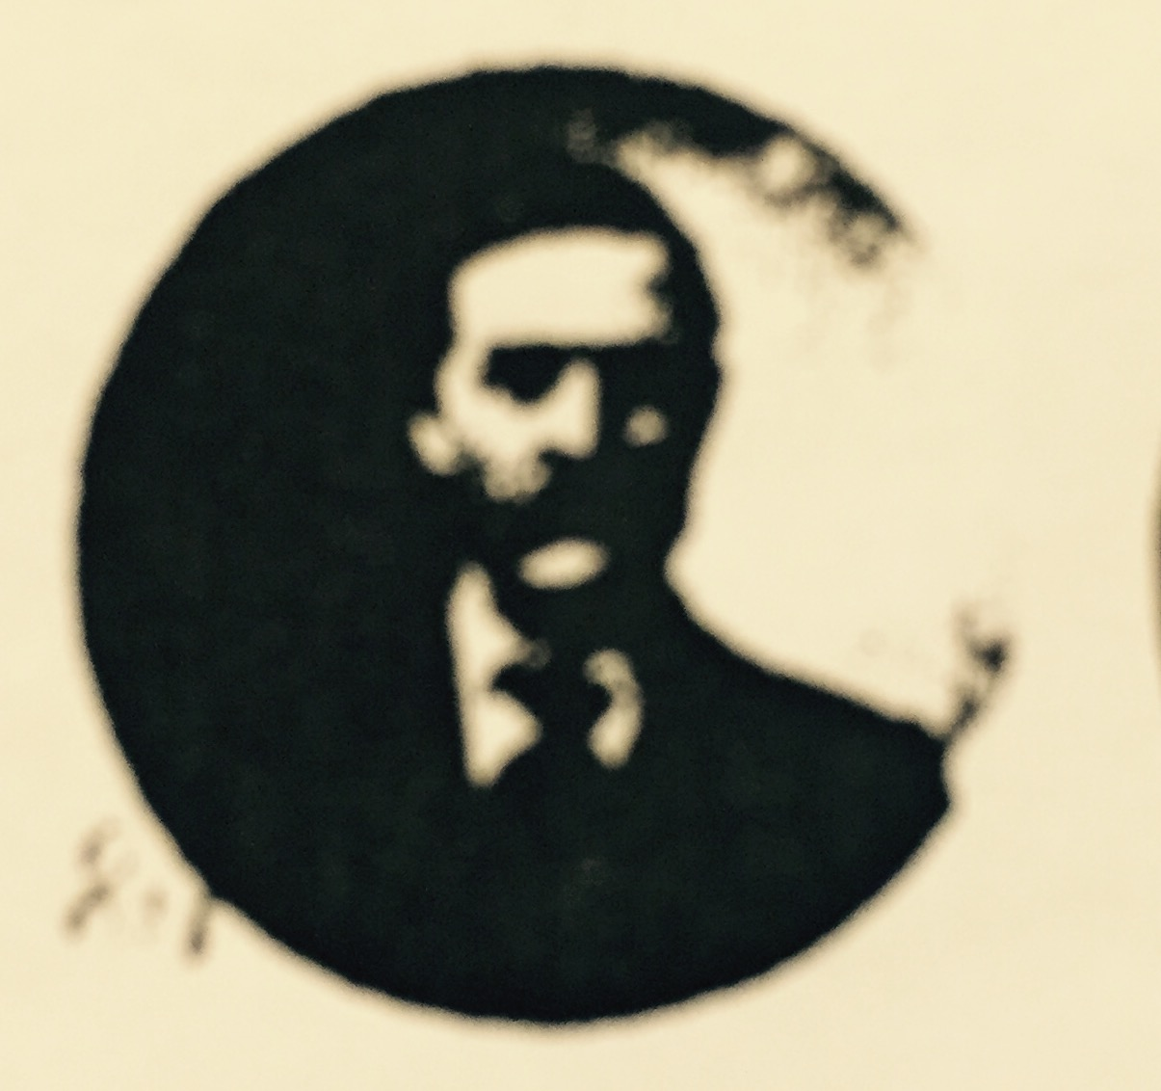 ***Fred Pell: GAR Photo -Post 129***