2008 Classroom Occupancy Sensor Installation
FINAL REPORT – February 2, 2010

I. Summary
- In 2008, the Student Sustainability Committee awarded $20,000 to Facilities & Services for installation of occupancy sensors to control lights in three campus buildings: Loomis Laboratory, Foreign Languages Building, and Armory. Later, the budget was increased to $50,000 and the scope expanded to include seven additional buildings: Davenport Hall, Everitt Electrical Building, English Building, Henry Administration Building, Psychology Laboratory, Mechanical Engineering Building, and Wohlers Hall. The funds were used to install a total of 332 occupancy sensors in 272 rooms in these ten buildings.

II. Project Execution
- The majority of sensors installed were wall switch replacements, with selected areas receiving ceiling sensors as appropriate. Wall switch replacements are the simplest and least expensive solution, but they are not feasible in all circumstances.
- We expect that this will reduce lighting costs in these areas by 30%, with an annual savings of $11,900 per year or a simple payback of 4.2 years.
- Work was undertaken using F&S in-house electricians. This allowed for the most efficient execution method and the best flexibility in installation, since our own crews are the most familiar with our buildings.
- We spent, on average, $151 per sensor. This includes materials and labor, as well as project costs such as engineering design and record keeping. This amount was slightly less than the initial projection of $200, primarily because we chose to install sensors only in those locations where costs would be lowest.

III. Building Data Summary Table

Building | # of Rooms | # of Sensors | Wattage Controlled
Armory | 20 | 36 | 12,096
Everitt | 25 | 32 | 17,472
Loomis | 50 | 50 | 13,680
Psych | 60 | 65 | 13,932
MEB | 4 | 9 | 7,896
FLB | 42 | 44 | 25,422
Henry Admin | 9 | 11 | 10,656
Davenport | 26 | 32 | 14,064
English | 25 | 27 | 7,680
Wohlers | 11 | 26 | 6,419
Total | 272 | 332 | 129,317

IV. Energy, Environmental, Social and Economic Impact
- Energy and cost savings.
The project should save $11,900 the first year, and $143,000 over a ten year period, based on an inflation rate of 4.0%. Annual electrical use will be cut by 170,000 kWH.

- F&S will seek incentive reimbursements of $14,200 from the Illinois Department of Commerce and Economic Opportunity (DCEO)’s Public Sector Electric Efficiency Program. This money will be used towards future energy saving projects on campus, most likely additional occupancy sensors.

Environmental Impact
This project will result in an annual reduction of greenhouse gases in the following amounts:
88,000 lbs CO₂ emissions reduction
323 lbs NO_{x} emissions reduction
1,079 lbs SO_{x} emissions reduction

- Social Impact
Lighting controls send a strong message to the community that the campus is serious about saving energy through lighting reduction. Community response has been generally very positive, and no serious malfunctions have been reported so far. One sensor was removed from a classroom in the Psychology building, due to the nature of research experiments conducted in that room. (Lights turning on/off unexpectedly could have affected their results.) Other than this single room, there have been no complaints from students or faculty about the new sensors.

V. Outreach and Education
- These sensors were installed in some of the most highly visible classrooms on campus, and will be seen by over 50% of the freshman and sophomore classes.

- A plaque (sticker) was installed on each sensor, mentioning the Student Sustainability Committee and emphasizing the impact of reducing lighting usage.

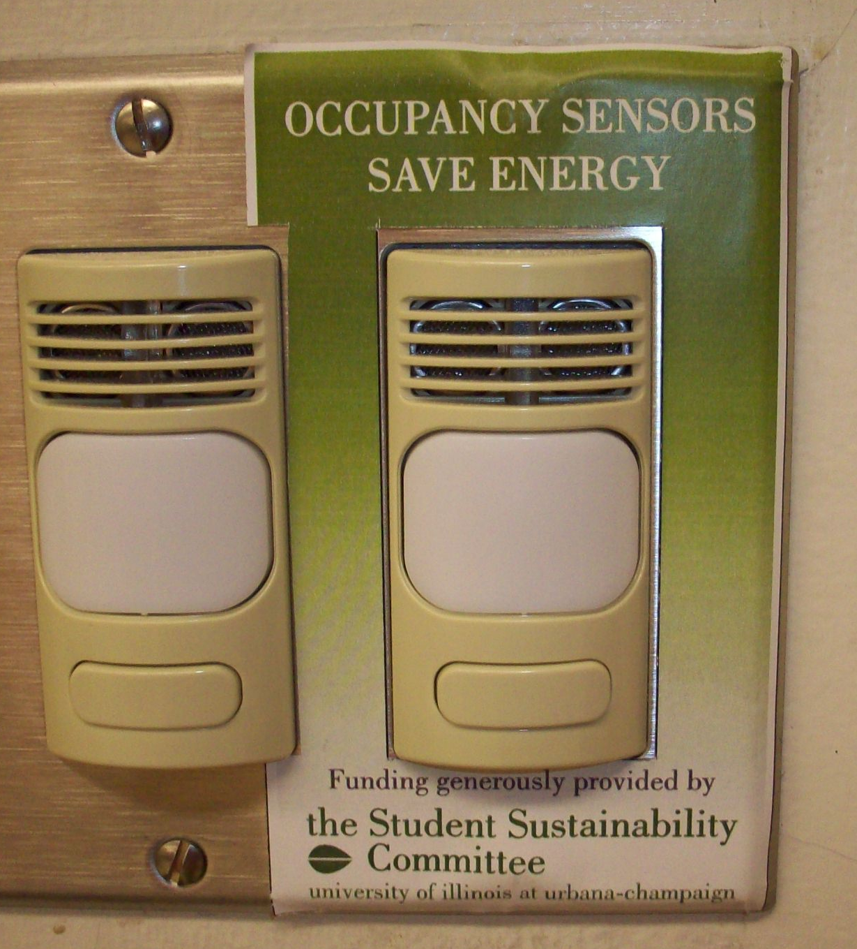

VI. Lessons Learned and Future Outlook

- Many of the classrooms initially targeted for occupancy sensors were not able to be completed, for various reasons. The most common problem was the existence of multiple switching locations in a single room (common in the A/V classrooms). The Mechanical Engineering Building in particular was affected by this obstacle. This prevents use of a wall switch sensor, and low voltage ceiling sensor installation is far more expensive. Fortunately, a new line-voltage ceiling sensor will provide an affordable solution for these types of rooms going forward.

- Access to some classrooms during the fall semester proved a challenge. For the most part, the work could be done during a time when the room was not used, however some of the most heavily scheduled rooms needed to be completed during breaks. In contrast, work done during the summer had far fewer interruptions.

- Although F&S considers this project to be a great success, there is much more work to be done. Classrooms in all remaining buildings could have occupancy sensors installed, and this is a very cost efficient approach. Our campus buildings also have vast numbers of research labs, private offices, corridors, etc. Most of these areas could achieve significant energy savings from occupancy sensors as well.

- Our submitted proposal to the SSC for the 2009 funding cycle requests additional funding to continue this installation program. This reflects our belief that occupancy sensors represent one of the best energy-saving strategies available.

- F&S thanks the SSC and the students of the Urbana-Champaign campus for their enthusiasm and support of this project. It has been a pleasure working for you.

Complete room-by-room data is available and has been provided via hard copy. Please contact Eva Sweeney, eva@illinois.edu for additional or electronic copies.

