APPLICATION INFORMATION

Project Lead Contact Information

Name: Eva Sweeney, P.E.
E-mail: eva@illinois.edu
Phone: 217-333-2271
Address: 1501 S. Oak St

Title: Electrical Engineer
Organization/Department: Facilities & Services

Secondary Contact Information
Name: John Prince, P.E.
E-mail: jmprince@illinois.edu
Champaign, IL 61820
MC-800

Phone: 217-333-3227
Address: 1501 S. Oak St

Title: Engineer
Organization/Department: Facilities & Services

Unit Financial Officer Contact Information:
Name: Stacey Wisegarver
E-mail: swisegar@illinois.edu
Champaign, IL 61820
MC-821

Phone: 217-265-4089
Address: 1501 S. Oak St

Title: Senior Associate Director – Financial Operations Champaign, IL 61820
Organization/Department: Facilities & Services

I. Detailed Project Description:

This request is a continuation and expansion upon the classroom occupancy sensors funded by the SSC in 2008. That $50,000 allocation was used to install 259 occupancy sensors in ten campus buildings. However, many opportunities remain in other buildings.

Classroom lighting is frequently left on after classes and cleaning activities. To encourage the community to reduce lighting consumption we will install sensors in public classrooms that will turn off lights automatically if no action is detected in the room for fifteen to thirty minutes.

- We will reduce lighting consumption in affected areas by 30% by reducing the number of hours that classrooms are lit.
- The sensors should last ten years, depending on frequency of use. They are a proven, lasting, permanent, public statement.
- The sensors will be located within classrooms, hallways, restrooms, lounges, and other public areas in twenty heavily used buildings, chosen according to number of student contact hours. The selection of the particular locations within the building will be influenced by the potential for energy reduction, ease of installation, and economic benefits. For example, although a particular restroom may be underutilized and present a significant opportunity for an occupancy sensor, the installation of a sensor to control a single fixture may be less attractive than installing a sensor to control an entire classroom. Since we do not yet have a financial commitment, a full survey has not yet been completed. If the SSC desires, we could present the details of our proposed locations once funding has been secured. The SSC can then provide additional input into the location selection process. If there is interest, opportunities for the members of the SSC or associated environmental groups to assist in the data collection process may be available.
- During the installation process, the electricians often encounter locations that cannot easily accommodate an occupancy sensor due to physical or electrical limitations. Thusly, although we can arrive at a proposed plan of action, the final results will be slightly different. We will share these results as we did at the end of the previous project.
- Although the default setting turns off the lights after 15 minutes of inactivity, the sensor actually adjusts based on usage patterns. If the lights are being turned on and off with high frequency, the sensor will increase the amount of inactivity time required for a shutoff, up to a total of thirty minutes.
- A major distinction between this round and the previous effort is the decision to change the setting of the sensors to act as a vacancy sensors. In the previous project, the sensors would turn on the lights if occupancy was sensed. In this project, the user will have to manually turn on the lights, with an automatic shutoff when vacancy is sensed. This should slightly increase energy savings by keeping lights off when the user does not feel the need for additional light, like when daylight is adequate.
- As requested by the SSC, we will look to minimize the usage of multiple sensors installed next to each other when practical. However, this can oftentimes be a more economical approach. Certain multi-sensor plates are not widely available or in stock within Facilities & Services. Therefore, it can sometimes be cheaper to install multiple sensors. In order to maximize the amount of controlled wattage and estimated annual energy reduction, we will look to employ the most economical installation method even if it may seem counterintuitive.
- Most other public institutions have installed these sensors in similar areas. The Urbana campus is seemingly behind in this arena, although we are gaining ground thanks to the SSC’s previous contributions.

II. Budget & Fundraising:
1. Detailed budget

The estimated cost of the project is $92,000. This cost was estimated based on the previous project with an approximately 20% cost increase to account for the higher per controlled-watt cost of non-classroom spaces. We request $50,000 in funding from the SSC, based on $0.25/controlled-watt.

The breakdown in proposed funding sources is below.

Student Sustainability Committee - $50,000
DCEO Public Sector Electrical Efficiency Program - $22,000
Quick Payback Energy Conservation Fund - $20,000

- This estimate includes sensor and labor. The funding will be used to cover the costs to specify, purchase, install, and commission sensors for up to 500 locations in twenty buildings. We expect that this will reduce lighting costs in these areas by 30%, with an annual savings of $18,000 per year (based on the $0.0689 rate provided by the SSC) or a simple payback of 5 years.
- The sensors have a life expectancy of ten years, with a present value replacement cost of $70,000, assuming 4.0% inflation and the standard life cycle definition of 50% failure.
- We are still finalizing the contribution from campus’ quick payback energy conservation fund, but Terry Ruprecht, Director of F&S Energy Services, has indicated support for the project and has requested a funding level of $20,000.
- The requested contribution levels from the SSC are essential to keep the project moving. The quick payback energy conservation fund requires a 2 year simple payback on campus’ investment, using the $0.0423/kWh variable cost rate. Any significant reduction in the SSC support would put the project in danger of exceeding this payback level. Since this request is already a decrease in requested support from the Letter of Intent – as asked for by the SSC – we hope the requested funding level is satisfactory.

2. Fundraising

We anticipate a minimum of $0.11/controlled watt from the Illinois Department of Commerce and Economic Opportunity’s Public Sector Electrical Efficiency Program. The program year starts on June 1, 2010 so we have not yet submitted an application associated with these projects. However, we have had a good track record with this program and the occupancy sensor project is a standard incentive. We highly anticipate a minimum of this year’s $0.11/controlled watt and possibly an increase.

We also anticipate a funding commitment of $20,000 from the campus’ quick payback energy efficiency fund administered by Terry Ruprecht, Director of Energy Services at Facilities & Services.

III. Timeline
Provide a detailed project timeline.

In order to qualify for the DCEO grant program, the project will need to start after June 1, 2010. We will target an aggressive schedule with the intention of completing the project by the end of summer. However, we have not yet confirmed this schedule with the electricians group and can not guarantee that this would be feasible. We propose a firm end date of December 31, 2010 to account for any unforeseen circumstances.

IV. Energy, Environmental, Social and Economic Impact

Energy Impact

We estimate that the project will reduce campus energy consumption by about 262,800 kWh per year. At the $0.0689/kWh rate provided by the SSC, the annual cost savings is approximately $18,000. For the purposes of the quick payback energy efficiency fund, the variable rate of $0.0423/kWh must be used, yielding a cost savings of about $11,000. Since campus’ contribution would be $20,000, this falls below the 2 year simple payback requirement.

Environmental Impact

We anticipate a greenhouse gas reduction of nearly 440,000 lbs of CO2 equivalent.

Effect on greenhouse gases (if applicable): Detail your project’s reduction of greenhouse gases by the offset use of fossil fuel energy sources normally used by the university. For vehicle projects, compare to oil fuel source. For other projects, compare to the mix of oil, natural gas, and coal used by the university. Unless you have data more relevant to your project, please use the following information on the cost of energy on campus and the amount of pollution created on campus.

Social Impact

Lighting controls send a strong message to the community that the campus is serious about saving energy through lighting reduction. Community members should turn their lights out more frequently in their offices and other private areas where the sensors are not installed.

Economic Impact

This project is estimated to save the campus approximately $11,000 per year in energy costs, based on the $0.0423/kWh variable rate. Due to increasing energy cost, this number will rise in the next following years.

V. Outreach and Education

These sensors will be installed in some of the most highly visible classrooms on campus with a diversified population. The rooms combine for almost 225,000 student hours per year and will be seen by over 50% of the freshman and sophomore classes.
The sensors will be installed with a plaque, mentioning the Student Sustainability Committee, which tells of the impact of reducing lighting usage.

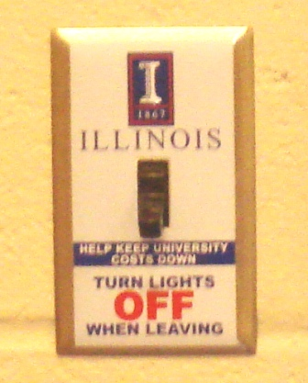

Typical Wall Switch to be replaced by

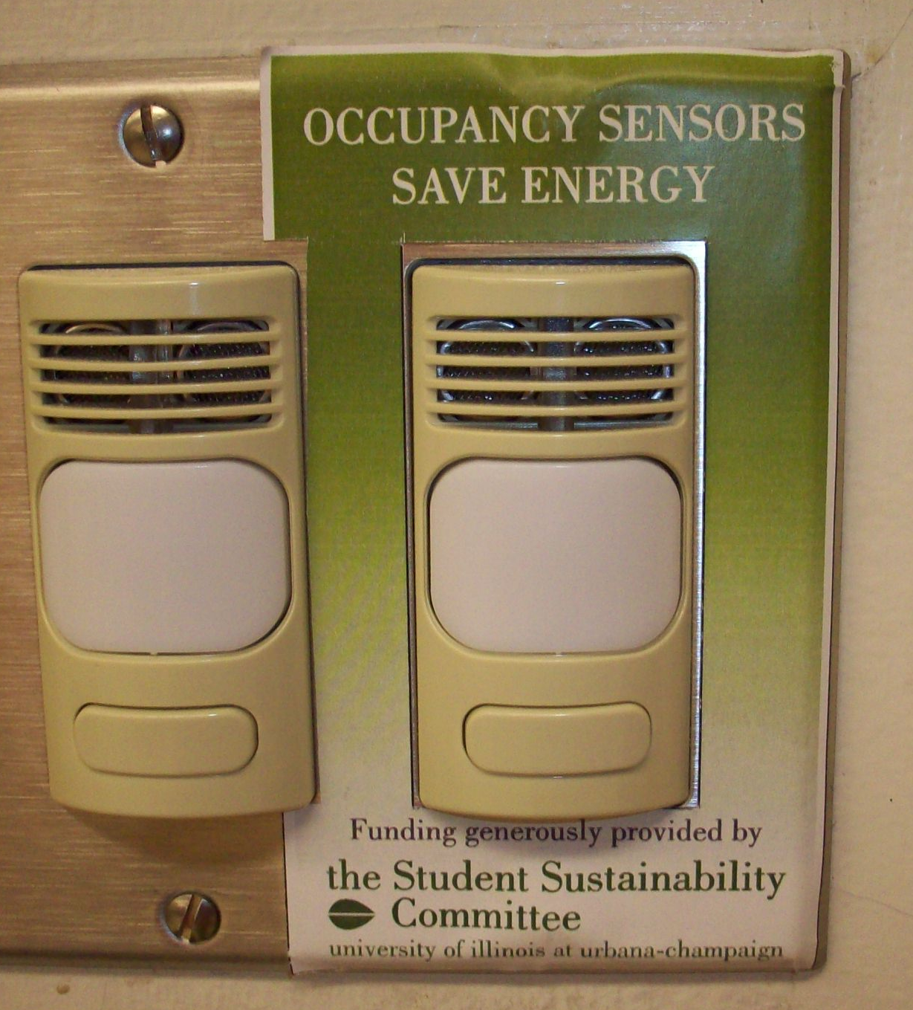

Automatic Occupancy Sensor

