The Prairie Project: Infusing Sustainability Across the Illinois Curriculum
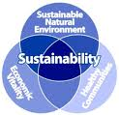

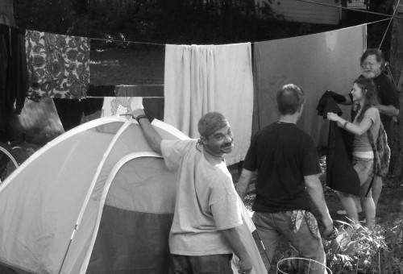
Sustainability is the great global challenge of the twenty-first century. The responsibility of a world-class university such as the University of Illinois is to offer and direct education of its students toward meeting these challenges, considering sustainability’s three interconnected principles of society, environment, and economics. The unprecedented scale and complexity of threats of climate change, poverty, resource depletion, population growth, and human and ecosystem health issues mean that the sustainability imperative touches every discipline, both technical and non-technical, even those formerly considered remote from environmental or social issues. Degree programs related to sustainability are among the fastest growing nationwide, student demand is high, and our peer institutions are committing resources to sustainability curriculum development. Central to Illinois’ mission in this new century should be to produce more and better-trained specialists who understand both the depth of their discipline and the breadth of system-level thinking required to foster sustainability. A greater goal should likewise be that no student, whatever their major, graduate from the university without a fundamental grasp of the principles of system-level sustainability.


To support faculty and instructors who are interested in contributing to this vision, we are pleased to announce the Prairie Project. The Prairie Project aims to create an open and supportive environment for faculty and instructors from all disciplines to engage in mutual learning about sustainability and brainstorming and experimenting with novel and interdisciplinary educational approaches. The project will use the local prairie environment, from the natural prairie to the highly modified urban and agricultural prairies, to illustrate how a place-based perspective allows consideration of the interconnected social, environmental, and economic issues surrounding sustainability.
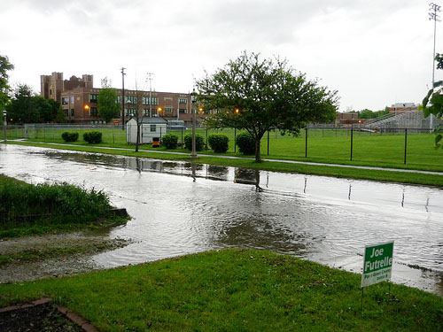
The project is modeled after the Piedmont Project and the Ponderosa Project. An extensive list of example course modifications can be found at http://www.scienceandsociety.emory.edu/piedmont/curriculum.htm. Examples include:

- Creating poetry on sustainability
- Introducing sustainability issues through discussion of the political world of Shakespeare’s plays and its influence on Russian culture
- Designing a new product that re-uses waste and creates no manufacturing waste
- Developing a Chinese brochure on campus sustainability activities
- Collaborating with poor communities to design a new business that is profitable and socially and environmentally responsible
- Investigation of medical waste streams and creation of an educational medicinal garden

The experience will consist of four primary activities:

- Retreat, May 24-26, 2010, for participants to intensively brainstorm ideas and approaches for infusing sustainability into their courses and to build connections with colleagues (see below for a preliminary agenda).
- Check-In, August 17, 2010, to discuss specific ideas, questions, or concerns that have arisen since the retreat and visit an off-campus environment with rich opportunities for sustainability education (a luncheon and afternoon event).
- Check-In, January 12, 2011, for those who taught in the fall semester to share experiences and lessons learned and for those who will teach in the spring semester to discuss specific ideas, questions, or concerns that have arisen since the last check-in (an extended luncheon event).
- Debriefing, May 17, 2011, to share experiences, lessons learned, and ideas for the future (a late afternoon event and dinner with next year’s cohort).

Faculty and instructors are invited to send an e-mail to sustainability@illinois.edu by April 14, 2010, if they are interested in participating in the Prairie Project. In the e-mail, please provide the following information:

- Your name and contact information
- Rubric and name of course that you plan to teach during the 2010-11 academic year and you propose to create or modify
- Recent or expected enrollment in the course
- Why are you interested in applying for the Prairie Project?
- What do you hope to learn or gain from participation in the Prairie Project?

Faculty and instructors will receive an honorarium for participation with a multi-disciplinary cohort of other faculty and instructors to share resources and experiences (subject to resource availability).
A limited number of spaces are also available for senior graduate students or post-doctoral research associates who are interested in teaching sustainability in the near future. Please submit a CV and transcript along with the information above, although the course information is not required.
By applying for this exciting and interactive opportunity, Prairie Project participants agree to:
- Participate in the retreat, field trip, check-ins, and debriefing.
- Commit to preparing and submitting a revised syllabus and description of the course modifications or creations by August 31, 2010.
- Provide a brief summary of outcomes from the experience by May 15, 2011

Please follow up with Suzanne Wingate (swingate@illinois.edu) if you have questions about this unique opportunity. At most 20 participants will be accommodated, pending funding availability. Applicants will be notified by the end of April if they have been selected to participate.

Preliminary Agenda
Sustainability Curriculum Retreat, May 24-26, 2010

Monday, May 24, 2010
6:30 Reception
Introduction to the creative power of place: the prairie as an ecological and human system

Tuesday, May 25, 2010 (I Hotel)
8:30-9 Coffee and conversation
9-12:15 Morning session, including:
    - Overview of sustainability and approaches for infusing sustainability into your course
    - Resource Person I: Addressing sustainability from an environmental perspective
    - Update on campus sustainability activities
    - Working-group discussions and activities
12:15-1:15 Lunch and panel discussion on the sustainability education experience from the student’s perspective
1:15-2:30 Prairie landscape walk and tour of Solar Decathlon House
2:30-5 Afternoon session, including:
    - Resource Person II: Addressing sustainability from a humanities and social science perspective
    - Panel Discussion: Solving real-world sustainability problems
    - Reflection and working-group discussions

Wednesday May 26, 2010 (Business Instructional Facility)
8:30-9 Coffee and book/resource browsing
9-12 Morning session, including:
    - Resource Person III: Addressing sustainability from an economics perspective
    - Sustainability learning outcomes, approaches, and assessment
    - Reflection and working time
  - Lunch
1-1:30 Tour of the Business Instructional Facility
1:30-4:30 Afternoon session, including:
    - Working and reflection time
    - Working-group and large-group discussions and exercises
4:30-5 Drinks and conversation

