Large Scale Food Waste Composting Project (Cancelled) Final Report
By Morgan Johnston -- May 12, 2014

Project purpose
This project was to fund the development of a large-scale food waste composting facility on the University’s property, in order to compost food waste from University dining halls. This project was precipitated by the commitment made by the University in the 2010 Illinois Climate Action Plan (iCAP): “The University will commit to… a large‐scale food composting project by 2012.”

This project was initiated at the request of students, via Associate Chancellor Pradeep Khanna. The Student Sustainability Committee (SSC) provided $15,000 for a Feasibility Study, and the Office of Sustainability supplemented the cost with an additional $7,400. The study ran from August 2012 to April 2012. A grant from DCEO was requested in January 2012, using the feasibility study draft report. The DCEO grant does not allow for administrative overhead, and requires a 50% match. We secured $200K from DCEO, $250K from the SSC, and about $40K from the F&S Executive Director (Jack Dempsey). Matt Edmonson in Capital Programs determined another $242K is needed to implement the project. Tim Hoss determined approximately $58K per year would be needed to operate the facility.

Project summary
The new facility would initially receive and process all acceptable pre- and post-consumer food waste from six dining halls on campus, as well as supplementary landscape waste as necessary carbon bulking material from Campus Grounds. The finished product would provide rich compost material to agricultural projects on campus such as the Sustainable Student Farm, as well as to campus grounds and athletic fields.

A Food-Waste Composting Feasibility Study was completed prior to this project funding allocation from the Student Sustainability Committee (SSC). This project was to implement the recommendations from that study, including purchasing the appropriate composting equipment, constructing the composting facility site, and modifying operational practices to accommodate the composting process. To accomplish this large endeavor, Tim Hoss, the retired Campus Recycling Coordinator, was hired as a part-time academic hourly. He was charged with implementing the composting program, and administering the DCEO grant requirements.

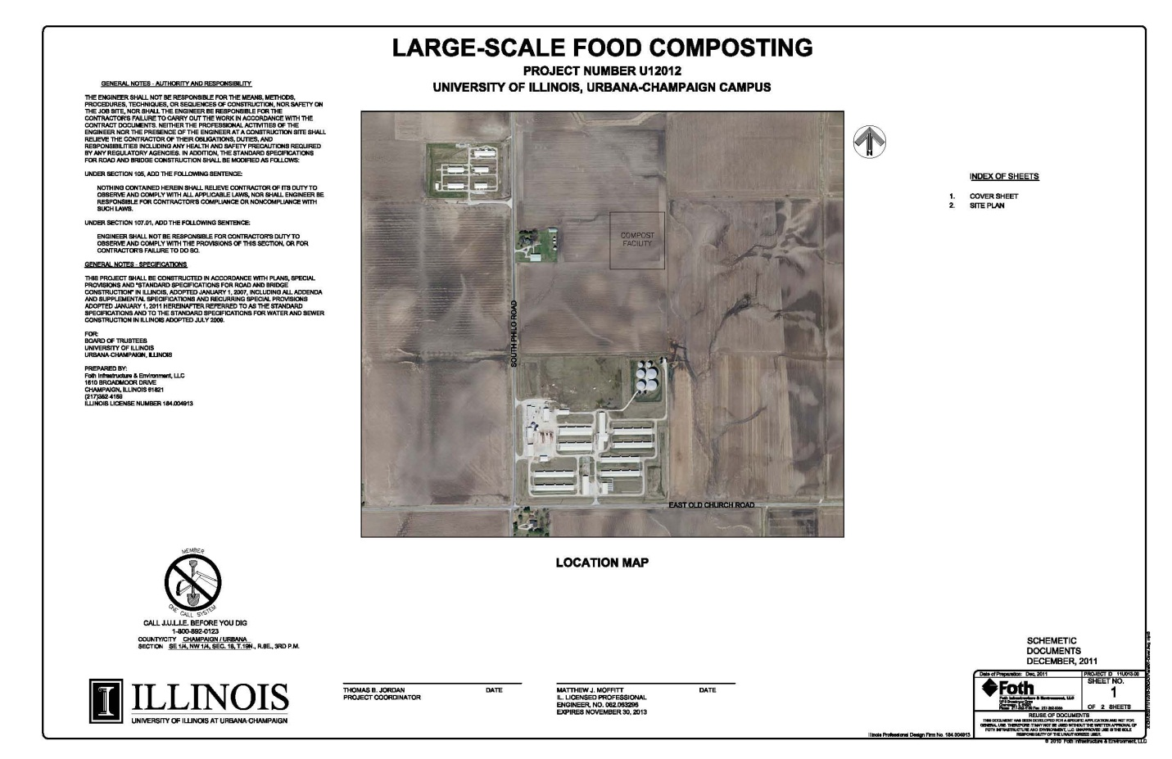
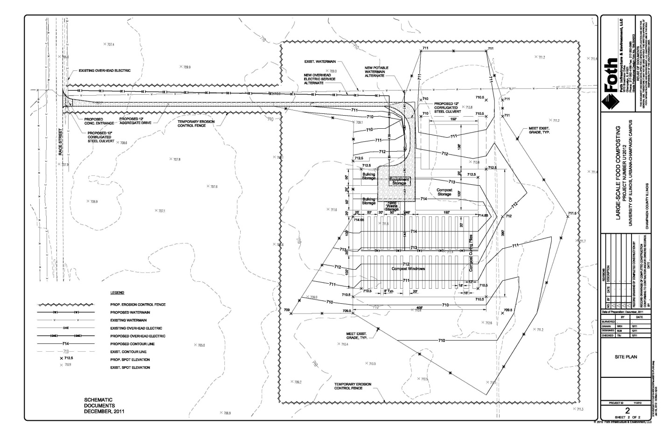

Problems encountered

Problem One
The first requirement was to obtain a construction permit from the IL EPA. Mr. Hoss worked with F&S Environmental Compliance staff to being the process, which was very involved (see process flow picture below)

Mr. Hoss and the Environmental Compliance staff found that it would be necessary to prove that the groundwater table was at a sufficient distance below grade. Therefore the first step taken when Mr. Hoss started working on this project was to arrange a formal study of the depth to the groundwater table. This required a four month timeframe, and did formally confirm the water table is low enough to allow the Composting site at the proposed location.

Problem Two
The grant from DCEO was to be used to fund the purchase of equipment and the construction costs, with matching funds from the SSC and F&S. The grant leader required us to purchase the equipment immediately upon award of the grant. Unfortunately, the ultimate cancellation of this project led to the need to return the grant funds, both to the SSC and to DCEO. F&S had to fund the cost of this equipment, even though the items are not able to be used on campus.

- $37,525 for a windrow turner
- $48,716 for a grinder/mixer

Problem Three
The construction cost for implementing this project was originally estimated as $488,185. SSC graciously agreed to contribute $250,000 to match the DCEO grant request. The DCEO grant award was for $200,000 instead of the requested $250,000. At that point, F&S allocated $40,258 to be able to accept the DCEO grant award.

Grant Category | Budget | Subcategory | Line Item | Budget
Expansion | $389,870.00 | Site Work | CONSTRUCTION STAKING | $10,000.00
Expansion | $389,870.00 | Site Work | EROSION CONTROL SILT FENCE | $9,010.00
Expansion | $389,870.00 | Site Work | EARTHWORK | $165,000.00
Expansion | $389,870.00 | Site Work | FILTER FABRIC OR LMS | $21,360.00
Expansion | $389,870.00 | Site Work | AGGREGATE SURFACE COURSE | $58,500.00
Expansion | $389,870.00 | Site Work | 8" PCC | $15,570.00
Expansion | $389,870.00 | Site Work | 12” CULVERT | $2,400.00
Expansion | $389,870.00 | Site Work | LANDSCAPING | $16,800.00
Expansion | $389,870.00 | Site Work | ESTIMATE CONTINGENCY ‐ 20% | $59,730.00
Expansion | $389,870.00 | Water (Alternate 3) | TAPPING SLEEVE AND VALVE | $1,800.00
Expansion | $389,870.00 | Water (Alternate 3) | 4" WATER MAIN | $25,500.00
Expansion | $389,870.00 | Water (Alternate 3) | DISTRIBUTION CONNECTIONS | $2,700.00
Expansion | $389,870.00 | Water (Alternate 3) | METER | $1,500.00
Equipment | $100,388.00 | Equipment | Windrow Turner | $36,315.00
Equipment | $100,388.00 | Equipment | Grinder Mixer | $48,718.00
Equipment | $100,388.00 | Equipment | 100 Composting Containers | $15,355.00
TOTAL | $490,258 |  | TOTAL | $490,258.00 | 100%
 |  |  | DCEO grant request | $250,000.00 | 51%
 |  |  | UI responsibility | $240,258.00 | 49.0%
Unfortunately, the final Capital Project costs required an additional $242,000 in campus funding. F&S presented this information to the Chancellor’s Capital Review Committee. They indicated that a business plan for the project would be needed before they would consider allocating additional funds.

Problem Four
Mr. Hoss was responsible for defining an operational business plan. The document he completed indicated that there would be an operating cost of $58,500.

Workers rate of pay plus Overhead (40%) days/week # of weeks Cost
OE $49.60 3 @ 2 hrs 32/year $ 9,500
OE $49.60 1 @ 2 hrs 20 $ 2,000
Project Manager $20.00 3 @ 4 hrs 52 $12,500
Total Labor $24,000
Collection Cost $12/container/30 containers 3 days/week 32 weeks $34,500
Annual Operating Cost $58,500
The business plan noted that using current estimates, 1450-4000 cubic yards of compost could be generated per year. The Student Sustainability Farm and Campus Grounds would use about 450 cubic yards of compost per year. This would leave 1,000 to 3,500 cubic yards per year for sale to the public at $20 per cubic yard. Therefore, if the permit and state laws could allow selling the compost to the public, and if the net cubic yards of compost to sell is over 3,000/year, then the composting program could be self-supporting.

Unfortunately, the Dining Services division had recently installed Enviropures in the largest dining facilities. This dramatically cut down on food waste going into the waste stream. The feasibility study for the composting site estimated 1450-4000 as a largest amount of compost to accommodate on the site. The estimated volume of compost that would actually be produced without further growth in Housing food-waste and with the reduction in food waste from the Enviropures, the anticipated volume of compost available to sell annually was not enough to cover the anticipated annual costs of the operation.

Pictures of finished project

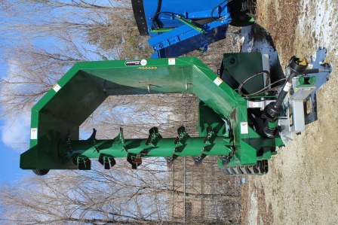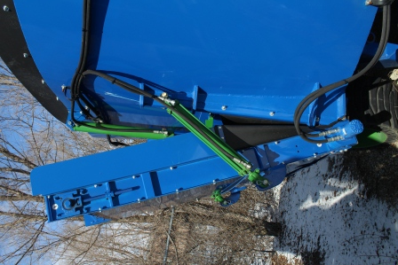

A financial statement that lists how the funds were specifically utilized
The SSC funds were returned in February 2014.

Statistics on student involvement/outreach
This project was initiated by students. Due to the described issues above and viable alternatives – such as the Anaerobic Digester, the Enviropures, and the Vermicomposting at the Sustainable Student Farm – this project was cancelled by Morgan Johnston, after consultation with SSC and campus leadership.

