
icap Portal user guide

August 22, 2016

Table of Contents
Access to Illinois Climate Action Plan (iCAP) Portal 3
1. Login to the iCAP Portal 4
2. Edit/Add your Profile 4
Chapter One: iCAP Portal overview 5
1. Home 5
2. Themes on iCAP Portal 6
3. Goals 9
4. Projects 9
5. Map 10
6. Suggestions 11
Chapter Two: Project Updates 12
1. Create a Project Update via specific Project 13
3. Published Project Update 18
Chapter Three: Editing the Project 19
1. Title 19
2. Associated Projects 19
2.1. Parent Project 19
2.2. Related Projects 20
3. Related Themes 20
4. Project Details: General 21
4.1. Description 21
4.2. Background 21
4.3. Conclusion 22
4.4. Notes 22
5. Contacts 23
6. Dates / Status 23
7. Money 24
8. Funding 24
9. Locations 24
9.1. List the project location 24
9.2. Creating a new location for the project 24
10. Files 25
10.1. Images 26
10.2. Related Files (Public) 26
11. Links 26
12. Collections 26
Conclusion 27

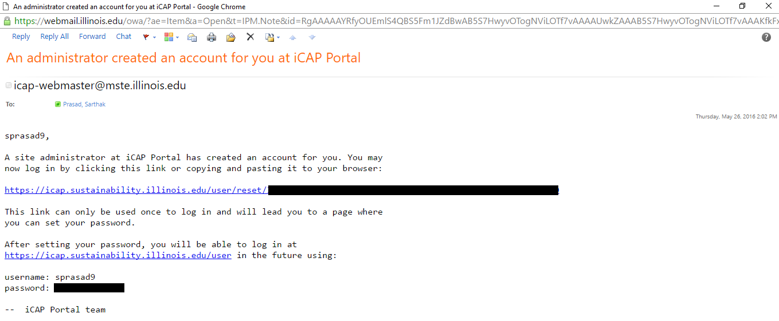
Access to Illinois Climate Action Plan (iCAP) Portal
Congratulations on becoming a SWATeam Clerk! Institute for Sustainability, Energy, and Environment (iSEE) staff will arrange for you to have Illinois Climate Action Plan (iCAP) Advocate status in the iCAP Portal. You will see an email from the iCAP Portal team as seen in the attached picture.
As an iCAP Advocate in the iCAP Portal, you will be responsible for regularly updating the iCAP Portal, regarding projects related to your SWATeam.
General Tips for writing in the iCAP Portal
Write this to an audience which understands basic concepts of sustainability and related technology, but which is not familiar with the project or its affiliated organizations. When writing a person’s name, include the full name and title at the first occurrence. Spell out organization names at the first instance (in any Project or Project Update) and include the abbreviation in parenthesis if it is used later. You do not need to spell out abbreviations for iCAP, iSEE, and UIUC.
Use absolute time references instead of relative ones: i.e, instead of “last year”, write “2015”. If you must use future tense in a project such as an upcoming event, remember to update it to past tense as soon as the event is over.
Write professionally in the first person (i.e. don’t write in a negative tone, don’t be overly critical, put forward the outcomes of a discussion instead of individual opinions etc.) and use the background information as well. For example, “The SWATeam met today and we agreed to each read the chapter and get comments by next week”. We want to be personable, and telling some stories from the first person, like a note in a diary can be more engaging.
Each SWATeam Clerk is assigned to one SWATeam, and each SWATeam has a project page (under the Reporting Progress Theme).
- Energy Conservation and Building Standards
- Energy Generation, Purchasing, and Distribution
- Transportation
- Agriculture, Land Use, Food, and Sequestration
- Water and Stormwater
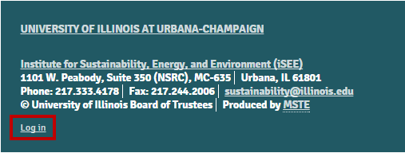
- Purchasing, Waste, and Recycling

Login to the iCAP Portal
- Go to the iCAP Portal website.
- On the bottom left corner of the page click on ‘Log in’.
- Enter your username and password.
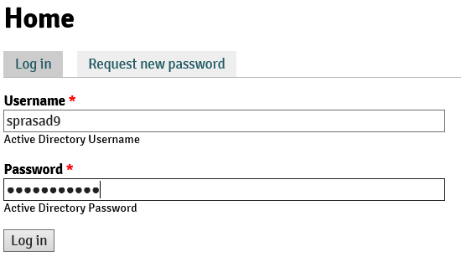
- Click ‘Log in’.

Edit/Add your Profile
- Click on ‘My account’ on the bottom of the screen.
- Click on ‘Edit’ next to the ‘View’ option.

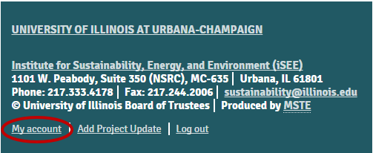
Adding your name
- The default screen under the ‘Edit’ option will be set at ‘Account’
- Scroll down and enter you first and last name in the respective field.
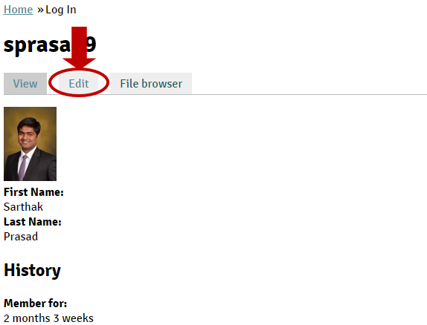
- You can also upload your picture.

Adding your research field and interests
- Click on ‘Researcher Profile’ which is the option next to ‘Account’.
- Put your title in the ‘Title’ field. For example, Sustainability intern, SWATeam clerk for eGen SWATeam. You could also put your major in this field.
- Select your department from the drop down menu under ‘Researcher Department’.
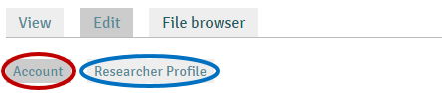
- In ‘Researcher Overview’, enter your current role in your SWATeam as well as a short bio about yourself. You could also include your interest in any other research field and what you are passionate about.
- Under ‘Link’, add all the relevant website links (for research papers/journals) for the sustainability work you have been involved in.
- Check all the boxes under ‘Research Themes’ and ‘Research Topics’, that match your interest.
- Click on ‘Save’ to save all of this information in your profile.

Chapter One: iCAP Portal overview
This chapter provides an overview of the iCAP Portal main pages and functionality. This site is a repository for summary information about each iCAP project, with frequent updates from project leaders and sustainability advocates, like yourselves.

Home
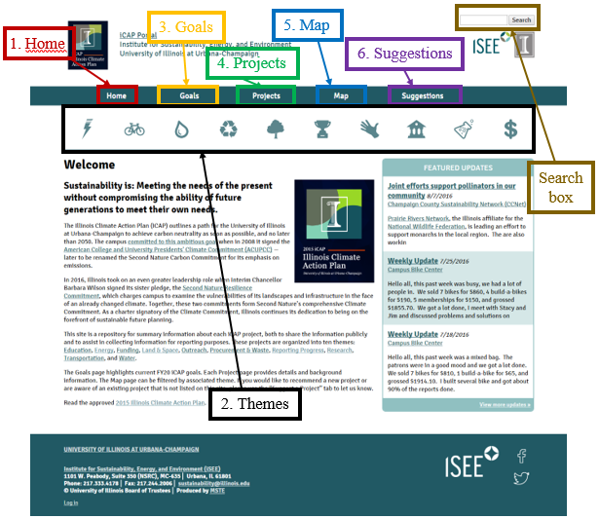
The Home page of the iCAP Portal welcomes you to the sustainability commitments and projects undertaken by the University of Illinois at Urbana-Champaign. It introduces the most recent Illinois Climate Action Plan (iCAP) and its goals and the motive behind the projects. It also contains the ‘Themes’ and Featured Updates on the projects along with the introduction for the iCAP Portal.

Welcome
This section of the page describes sustainability, the iCAP and the key commitments that the campus has made towards a sustainable future. This webpage introduces the visitor to the iCAP portal, various themes, and projects.

Featured Updates
This section of the page contains the three most recent project updates that were “Promoted to front page.” If a Project Update would be interesting to people outside of the particular project team, then it should be promoted to the front page, so it will show on this Home screen.

Themes on iCAP Portal
Each project in the iCAP Portal is categorized under a primary Theme, even though there are often multiple sustainability aspects to a project. For example, a green infrastructure stormwater class project could fall under water, education, or land use. The iSEE staff will determine the primary theme for the project when setting it up. The projects are organized into ten themes: Education, Energy, Funding, Land & Space, Outreach, Procurement & Waste, Reporting Progress, Research, Transportation, and Water; and the iCAP Portal is organized around these primary themes. 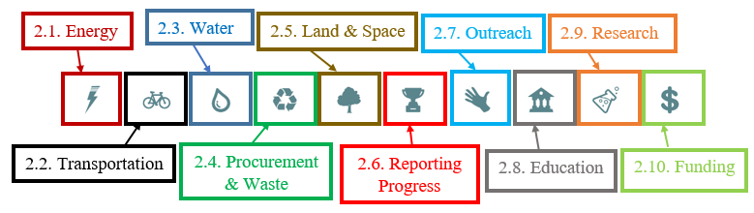
When you select a theme, you will be taken to the Theme page and be able see all the projects corresponding to that theme. The locations represented in the map within the theme page will have the theme logo and not the teal colored bubble. Similar to the filter option on the main Map page, when you click on a project location within the theme map, you will see projects categorized under that theme on the theme page. For example, if you select the ‘Water’ theme and find the projects at the Activities and Recreation Center (ARC), you will see only one project: the one related to the ‘Water’ theme, i.e. ‘Campus Rec Water Conservation Incentives.’ However, if you click on the building name, i.e., Activities and Recreation Center (ARC), you will go to the location’s page. The location’s page includes a map of the location, the address, a list on the right of the map sorted by name, and a list with descriptions at the bottom of the page.
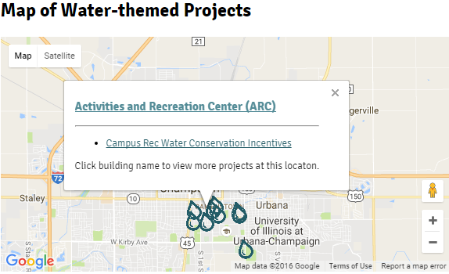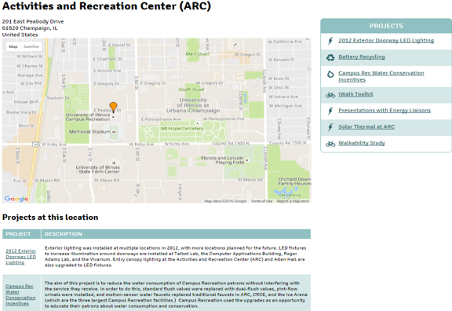
The six SWATeams are directly connected to the first five Themes, as follows:
- The Energy Conservation and Building Standards (ECBS)SWATeam works primarily with the Energy Theme (under Energy Conservation Efforts) and the Land & Space Theme (under Responsible Stewardship of Campus Buildings and Space).
- The Energy Generation, Purchasing, and Distribution (eGen) SWATeam works primarily with the Energy Theme (under Carbon-Neutral Energy for Campus).
- The Transportation SWATeam works primarily with the Transportation Theme.
- The Water and Stormwater SWATeam works primarily with the Water Theme and the Land and Space Theme (under Sustainable Landscapes Plan).
- The PWR SWATeam works primarily with the Procurement & Waste Theme.
- The ALUFS SWATeam works primarily with the Land and Space Theme (under Responsible Stewardship of Campus Land), the Procurement & Waste Theme (under Reduce Foodwaste and Sustainable Procurement), and the Water Theme (under Stormwater Management Program).

 Energy
Theme: Energy – Reducing Emissions from Energy Consumption
Energy is by far the largest contributor to the campus’ emissions inventory. The iCAP focuses on a detailed strategy of building energy conservation, de-carbonizing generation systems, and the addition of renewable energy sources. This “conserve-and-load” approach is achievable, affordable, and implementable. The 2015 iCAP calls for a reduction in building energy use of 30 percent by FY20.
Progress on the energy conservation efforts for campus are monitored by the Energy Conservation and Building Standards SWATeam.
Progress on efforts to de-carbonize our energy generation systems is monitored by the Energy Generation, Purchasing and Distribution SWATeam.

 Transportation
Theme: Transportation – Transportation emissions account for about 10 percent of the total emissions generated on campus. Generally, this includes commuter, air travel and fleet emissions, some of which are difficult to quantify. The target for this section is to reduce transportation emissions by 50 percent by 2025. This aggressive target will require strategic thinking in all components of transportation-based emissions.

 Water
Theme: Water – The University will ramp up water conservation efforts, with a potable water reduction target of 40 percent by 2025. Opportunities to utilize non-potable sources will be harnessed, including connecting the existing raw water system by 2020. Water costs will also be included in the energy billing program to encourage conservation.

 Procurement & Waste
Theme: Procurement & Waste – Our campus has committed to reducing the environmental impacts from the products and services we purchase and discard. These impacts are generated when our vendors produce and extract natural resources, process and transport them to us, and later collect them to be disposed of as waste. Reducing campus purchases, selecting environmentally-preferred products and services, and decreasing waste that ends up in landfills will reduce GHG emissions, improve use of natural resources, educate students about sustainable practices, and contribute to other environmental benefits.

 Land & Space
Theme: Land & Space – The University has enacted a “no net increase in space” policy for the entire campus, applicable to all space controlled by campus including auxiliary units and rental space. In addition, the University will develop and implement a sustainable landscape plan devoted to planning for and implementing sustainable landscapes and landscape maintenance practices.

 Reporting Progress
Theme: Reporting Progress – A major component of succeeding at our Climate Action Plan goals will be to effectively communicate our progress, both internally and externally. Documents such as the iCAP itself serve to outline the University's goals and intentions so that members of the broader University of Illinois community, as well as peer institutions and others, can stay abreast of our sustainability efforts. The University also reports on our progress to organizations such as the Second Nature Climate Commitment (formerly known as ACUPCC, the American College and University Presidents' Climate Commitment), on a regular basis. Finally, we are proud to be recognized as a leader in sustainability initiatives, and feel that awards play an important role in attracting new support for sustainability on campus.

 Outreach
Theme: Outreach

 Education
Theme: Education – As a world-class university, Illinois has the capacity and the obligation to assume a leadership role in climate destabilization research and action. We believe it can inspire a wide range of exciting and crucial scholarship, while developing cross-campus partnerships, and engage our students. Significant efforts are underway in addressing each of the University's core components of its mission—education, research, and public engagement, along with campus operations, as they relate to sustainability.

 Research
Theme: Research – Research is central to the sustainability of the University and the region. Already a world leader in sustainability and climate research, Illinois is developing opportunities for researchers from diverse disciplines to come together to explore new frontiers in discovering solutions to the challenges ahead. Innovative research collaborations focused on creating knowledge and new technologies are being developed to discover, analyze, and implement new approaches for addressing sustainability and climate change challenges.

 Funding
Theme: Funding – Funding is a core challenge of realizing the iCAP goals. Fortunately, many greenhouse gas reduction strategies are no-cost, low-cost, or will pay back investment costs over time. New funding and tracking mechanisms are necessary to verify cost savings and recycle a portion of those savings into other initiatives and projects. Achieving iCAP goals will require operational and accounting changes that affect all departments and units. A more concerted effort for financing and funding sustainability efforts in the long-term will require additional resources, including governmental and institutional grants, as well as funding commitments from the Foundation, the Student Sustainability Committee, and private donors.

Goals
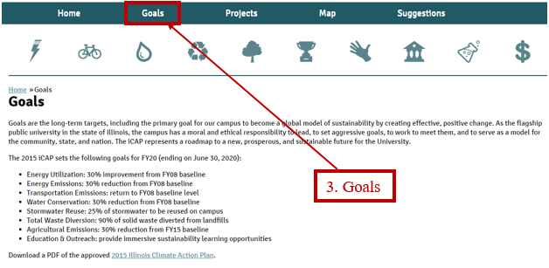
The Goals page is the second main page option, next to the ‘Home’ page button. It contains the long-term sustainability targets in the 2015 iCAP of the University of Illinois at Urbana-Champaign for the fiscal year 2020 (ending on June 30, 2020).
One can download a PDF of the approved 2015 Illinois Climate Action Plan from this page as well.

Projects
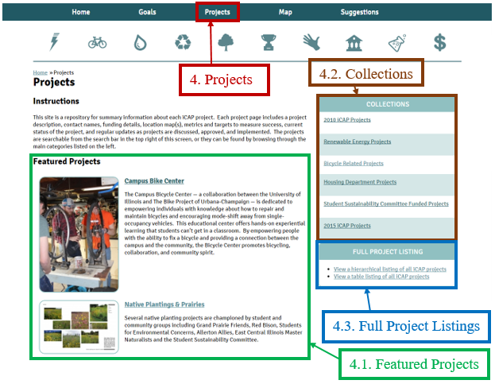
The Projects page provides access to the information about each iCAP project. Each project page can include a project description, contact names, funding details, location map(s), metrics and targets to measure success, current status of the project, and regular updates as projects are discussed, approved, and implemented. The projects are searchable from the search bar in the top right of this screen, or they can be found by browsing through the main collections listed on the right, or via the theme pages, accessible from the icons at the top of the screen.

Featured Projects
Two current projects are listed in the Featured Projects. These projects are rotated according to the themes and relevance. For example, May is National Bike Month, hence, the ‘Campus Bike Center’ project was designated as a Featured Project for May. If you think of a project that should be featured, let the iSEE staff know.

Collections
Projects can be categorized into collections of related projects. For example, the ‘Renewable Energy Projects’ collection contains the location and description of key projects that are related to renewable energy for campus and where to find those projects in the iCAP Portal (Theme>Project Name).

Full Project Listings
In this section, you can go to a list to see all the projects on the iCAP Portal according to the project’s hierarchy or in a tabular form with respect to theme and/or title of the project in ascending or descending order. Because the hierarchy listing builds from the iCAP Portal database, when you click the link, it may take a little time to load.

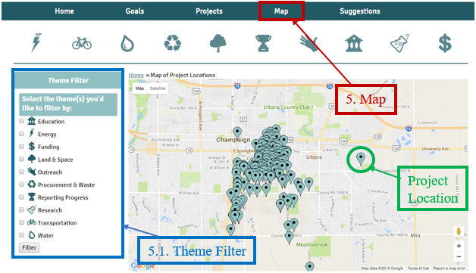
Map
This main Map page shows all the locations where sustainability projects are located. Click on a location bubble to see the list of all projects occurring at that particular location (from all of the respective themes). Zoom out to view off-campus projects.

Theme Filter
The Theme Filter on the left side of this page enables you to see all the projects under the selected theme. However, if you click on a location bubble (after using a filter), you will only see the projects categorized under the selected theme.
For example, Sustainable Student Farm location has three projects in the Energy, Land & Space, and Procurement & Waste themes, and you can see all these projects when you click on the bubble without filters. However, when you filter the map for the Energy theme, you will see only the one Energy project at the Sustainable Student Farm location.
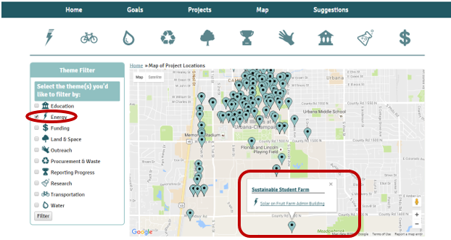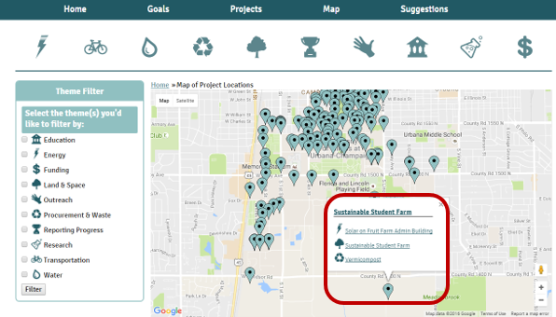

Suggestions
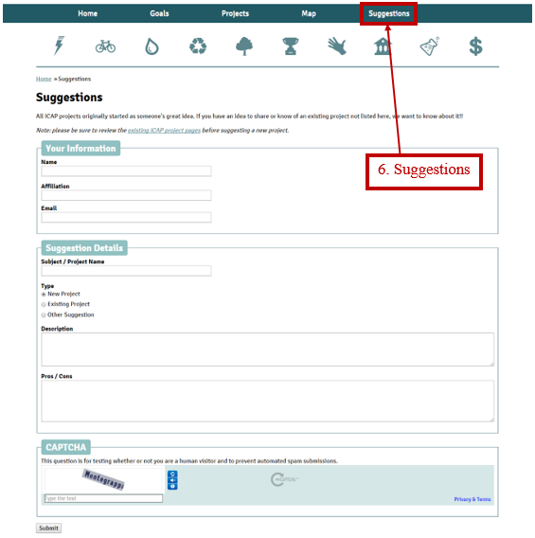
All iCAP projects originally started as someone's great idea! If you have an idea to share or know of an existing project not listed here, you can submit it on this page. The iSEE staff will read through your detailed suggestion and will make necessary changes before publishing it as a new project or adding it to an existing project.
However, be sure to explore the existing iCAP projects before submitting a new project suggestion.

Your Information
Before sending suggestion, please provide the sender’s information, so that the iSEE staff knows where to send the reply.

Name
The name of the sender. This will be your name, if you are submitting a suggestion.

Affiliation
Where do you work and how are you related to the project? SWATeam Clerks should list “[team] clerk” and other users can list departments, employees, project teams, etc.

Email
Sender’s email address.

Suggestion Details
In this section you describe and explain the details about the project.

Subject / Project Name
Name of the existing project or the suggested new project.

Type
Click in the appropriate bubble (‘New Project’, ‘Existing Project’, or ‘Other Suggestion’).

Suggestion / Description
In this section, you write the detailed suggestion and describe the project/changes.

Pros / Cons
Here you write the advantages and disadvantages of this project (if it is a new project) or how your suggestion will be advantageous to the existing project (in case of existing project).

Chapter Two: Project Updates
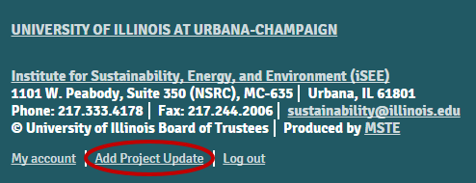
Any relevant information regarding the project needs to be added as an update. This information could include dates the project was approved, started, completed, and/or cancelled. It could also include any description of the site location, contracts, grants, any news article or video regarding the project, any demonstration, or any other project-related relevant information. These updates will build a base to provide a concise history of the project to public.
Once you have access to the iCAP Portal, and after you login, the bottom of the screen will have the ‘Add Project Update’ button next to the link for ‘My account’.
It is helpful to review the Project as already entered in the iCAP Portal before adding a new Project Update. If you are on the Project page already, we recommend you to use the ‘Add Project Update’ link under the ‘Administrative Options’ on the Project page (only shows when you are logged in) when you explore a particular project, so that you get some more details about the project and the theme.

1. Create a Project Update via specific Project
- The first step is to know which project or projects you are providing the update for. To consider this, review the full list of projects in the related theme(s).
- Select the appropriate theme.
- Scroll down and click ‘Expand all’.
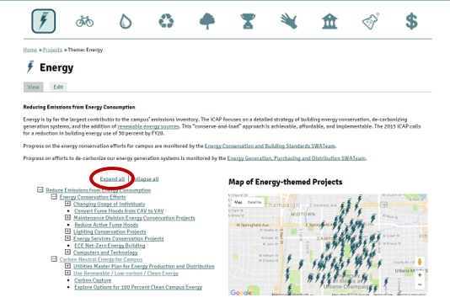
- Select the appropriate project.
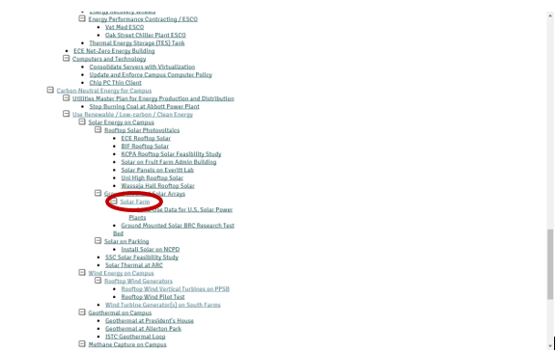
- On right hand side under ‘Administrative Options’, select ‘Add Project Update’. You can reach the same entry page if you click on ‘Add Project Update’ at the bottom of the screen.
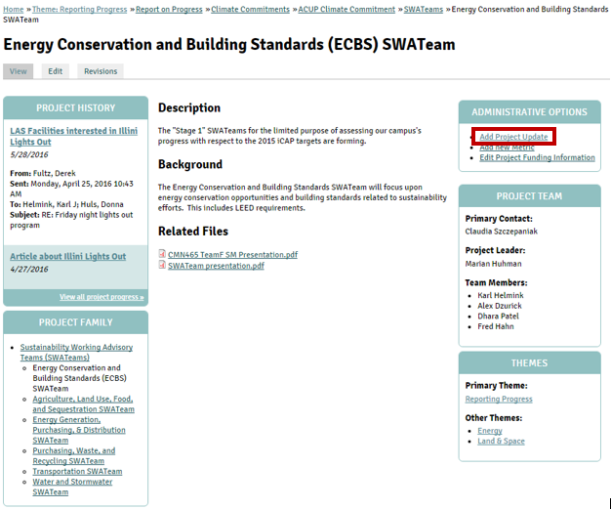

- When you click on ‘Add Project Update,’ the ‘Create a Project Update’ window will open.
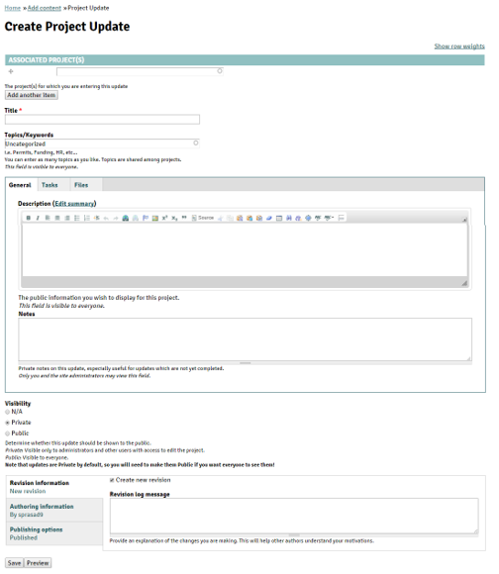

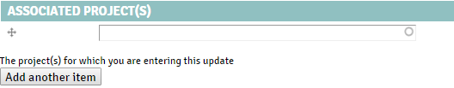
Associated Projects
First, specify which projects you are providing an update about. Add all the current projects that are related to the update (there could be more than one relevant project for an update). The majority of Project Updates entered by SWATeam Clerks will include at least the related SWATeam project.
For example, the following update from the ‘Energy Conservation and Building Standards (ECBS) SWATeam’ has two projects associated with it.
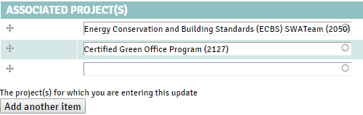

Title
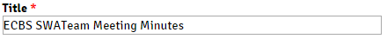
In this field type the title of the Project Update. This is like a headline for the item or any event that occurred. For example, “iSEE staff met with students interested in water infiltration” or “SWATeam meeting reviewed status of iCAP objectives” or “New policy recommended for the use of polystyrene products on campus.”

Topics/Keywords
All the keywords and topics that are related to the Project Update. Any relevant terms and/or subjects within the update should be listed in this field. You could ask your SWATeam members for suggestions.

General

Description
Type the project update in this section. This description will be displayed as the summary for the project update, so be concise and precisely describe the important events. This is the core information you are providing for people who are following the current progress of the project and for people who look back later to see what happened in the past. This is public information, so write with a professional tone, check for typos, and run the spell check. (Spell check is the highlighted option, there’s another option ‘Spell Check as you type.’ You can use either one of them.)
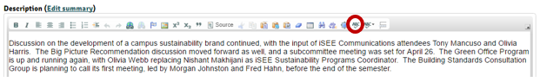
Updates Tips
Updates should still be written to a public audience unfamiliar with the project or the people involved in it. When describing a change to the project, try to include what it was changed from: for example, instead of “We decided to move the event to the Illini Union,” consider “The event was moved to the Illini Union from the original location of Foellinger Hall.”
The project update could be written in the future tense, however, use it minimally and always follow up with the results update. Need to not ignore updates for ‘In Progress’ projects. For ‘In Progress’, request an update every month from project leader or primary contact. For projects that occur annually, indicate that no updates will happen until next event.

Notes
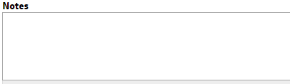
If you have any question or concerns regarding the update, use the ‘Notes’ field. The information in this section is not displayed to the public. Once your supervisor (for example the SWATeam Chair) has addressed your concern, you should delete the note.

Tasks
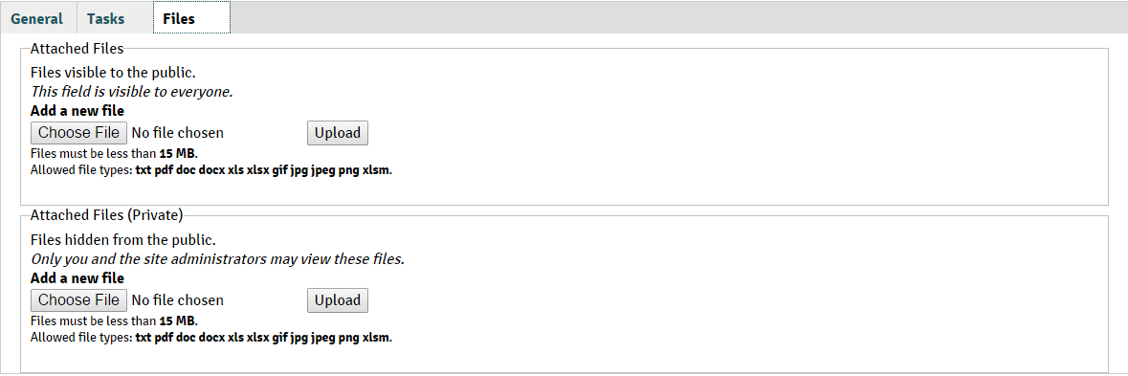
For Advanced users.

File
Any file relevant to the project update should be attached in this section.
Always attach the file in public mode.

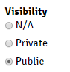
Visibility
When the update is first entered in the project, change it to public.

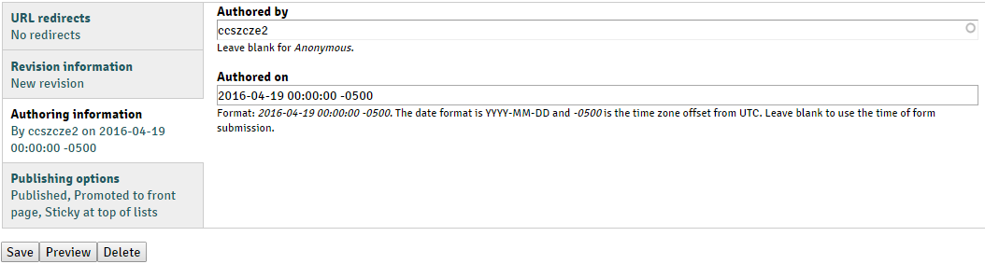
Authoring information
You can adjust the date under ‘Authored on” if you are adding old updates and want all the project updates in the correct chronological order (according to the date event occurred). However, you can leave the field blank to use the current date and time that you entered this update.

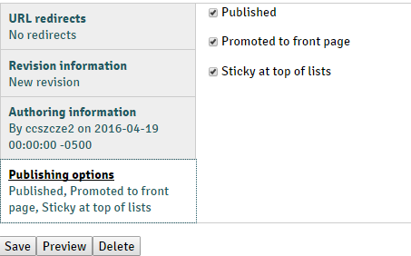
Publishing Options
There are three options within ‘Publishing Options’, and you should check the box adjacent to the option you deem most appropriate.
- If you want to publish this update, check the ‘Published’ box. Leave this box checked.
- By checking the ‘Promoted to front page’ box, this update would be displayed as a ‘Featured Update’ on the ‘Home’ page. If a Project Update would be interesting to people outside of the particular project team, then it should be promoted to the front page, so it will show on this Home screen.
- ‘Sticky top of lists’ would send the update to the top of the search list (using Search box). However, do not check this box for ‘Project Updates’.

Published Project Update
The published project updates will be found under ‘Project History’ on the left hand side of the project main screen (full history for that specific project can be accessed by clicking the ‘View all project progress’ button on the Project page. An example project update within project history section is shown as below:
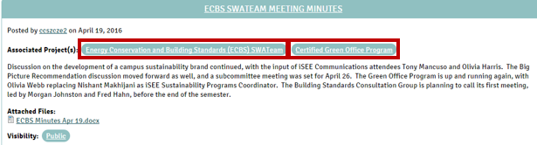

Chapter Three: Editing the Project
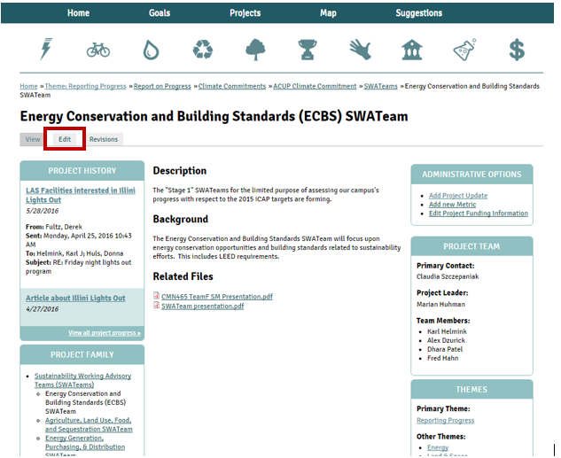
- Open the project using the procedure explained above.
- Click on the “Edit” button.
- On the next screen you can edit the project.

Title
The first field on the editing page is the Title, where you could enter the title of the project. Generally, there is no reason to change an existing project title. If you see a typo, go ahead and change it. Otherwise, check with iSEE staff before modifying a project title. The Long Title field is from a previous version of the iCAP Portal, and it should be left blank.

Associated Projects
All the projects associated with the current project, are listed in this section.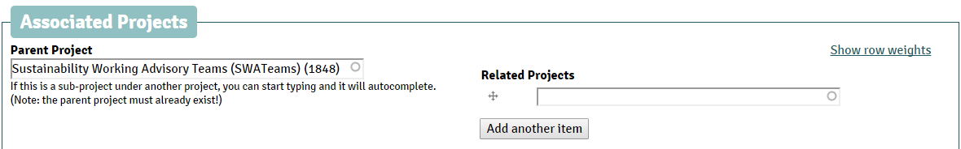
  - Parent Project
The primary project that directly supersedes the proposed project is listed as the parent project. Changing this needs to be done only by iSEE staff, as there are organizational impacts. The Parent Project defines the project’s place in the full hierarchical listing.
  - Related Projects
Any other project related to the proposed project, can be listed in this section. If there are more than one related projects, use the “add another item” button to add another related project.
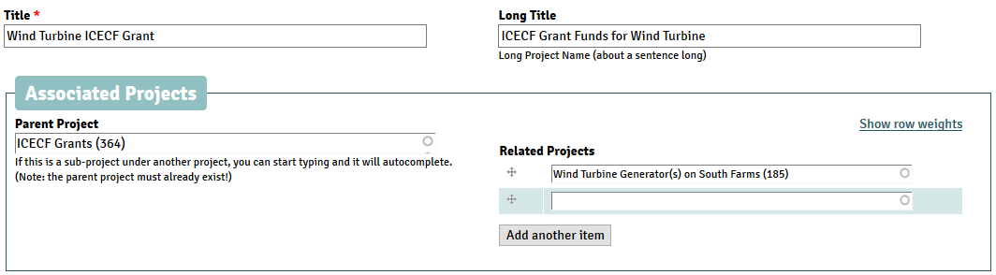

Related Themes
In this section, the iSEE staff who set up the project will have identified the ‘Primary Theme.’ Select any additional themes that are related to the project by clicking inside the checkbox next to the theme under ‘Other Themes’ option. There could be multiple ‘other themes’ and hence multiple ‘Themes’ related to the project. This will make the project show up on the list of “Other projects related to [Theme]” at the bottom of the other theme pages.
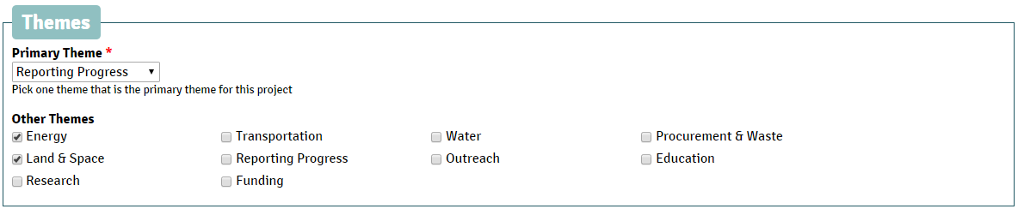

Project Details: General
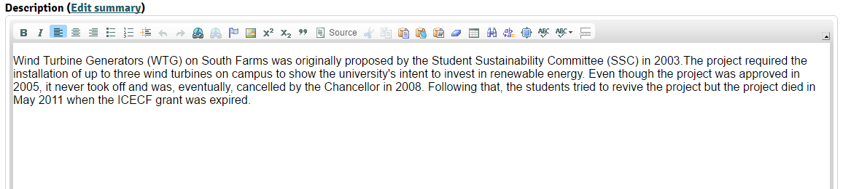
  - Description
This section of the general field should provide a concise description of the project. The text in this section is displayed on the home page of the project, and the first 4-5 lines of text will appear at the top of the project information on the project’s main page. The additional information in this section is visible when the user clicks “View full description >>”, so it is recommended to enter 2-3 sentences (maximum) to capture the essence of the iCAP project, then describe any additional key points or pertinent details in the following sentences.
Description Tips
Get straight to the point in explaining what the project is. Do not preface the description with justifications or statistics- if truly necessary, these can be added later or in the Background. The bulk of the description should be the project’s relation to campus.
In a specific project, do not explain well-known technologies such as solar panels; uncommon or experimental technologies can be given longer explanations. The parent project “Solar Energy on Campus” would be a reasonable place to describe solar technology and provide links to solar related resources.
The description should be updated as necessary to show the latest status of the project. Historical information should be archived in a project update.
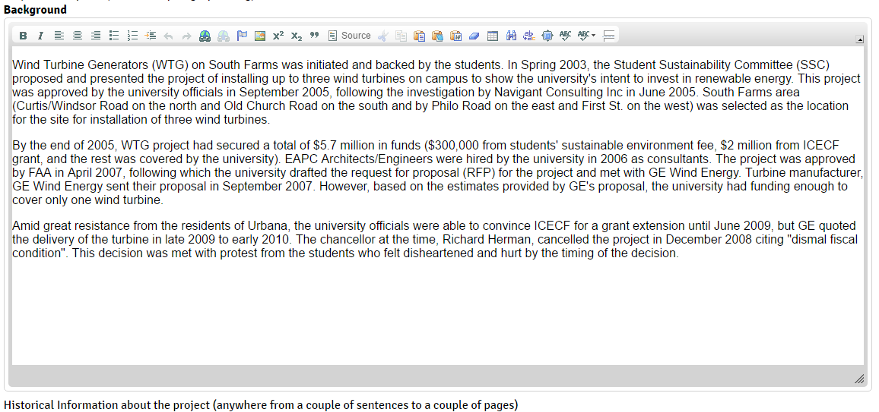
  - Background
If there is a project history that is relevant to the project, which could not be included in the main description of the project, that information is included in the ‘Background’ section. This information could be any relevant historical data or survey, and it could be a few paragraphs of information. If you do not have any background information to include, leave this section blank and it will not show on the project display page.
Background Tips
This can include any relevant information from either before the project started or while it was in progress. This can draw from the project updates section. Was there a significant change of direction midstream? Were we inspired by projects at other universities? If the project is scheduled to happen on an annual basis, this is the place to say so. Are you waiting on a piece of information or a big meeting?

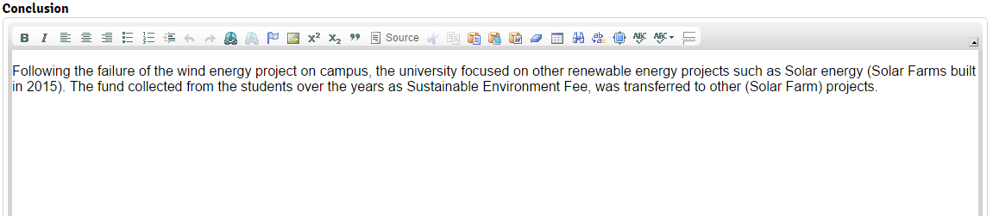
  - Conclusion
The Conclusion should be entered only when a project is fully concluded. This could be a few paragraphs of information.

Conclusion Tips
Use this section only if the project status is “Completed” or “Cancelled.” If it was cancelled, who cancelled it and why? If it was completed, what were the results? The advantages, disadvantages, challenges faced, and lessons learned should be described here. Any possible new opportunities for the future can also be included in this section.
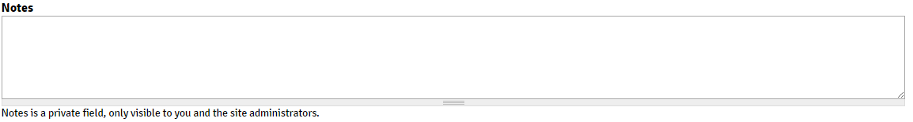
  - Notes
Any question or concern you have regarding the project can be expressed in this section. This section is not visible to the public and once you find the solution to your query, you should delete this note. Notes is a private field, only visible to you and other logged in users.
- Contacts
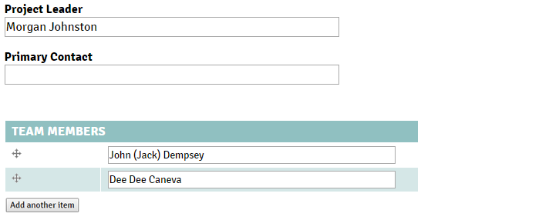
There are three fields under the ‘Contacts’ option: Project Leader, Primary Contact, and Team Members.
List the names of the current or most recent Project Leader, Primary Contact, and Team Members associated with the project. If the Project Leader and the Primary Contact for a project is the same official, list his/her name in the ‘Project Leader’ field and leave the ‘Primary Contact’ field empty.
- Dates / Status

The current status of the project is selected on this screen under the ‘Project Status’ drop down menu. There is a choice of four options in this drop down list:
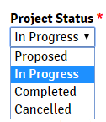
- Proposed: If the project is proposed by any committee or a group, but it has not been approved or the work on this project has not started, then it is considered a proposed project.
- In Progress: A project is ‘In Progress’ when the work has started or the project is a recurring effort, such as “energy conservation projects.”
- Completed: A project is ‘Completed’ when the work is complete and the results are achieved or the project effort has been closed out.
- Cancelled: If the project never finished and efforts have been stopped.
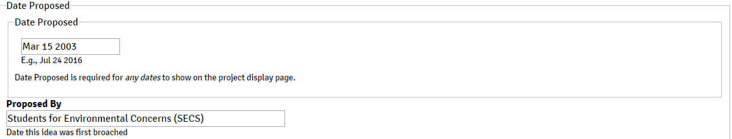
Under this field, important dates for the events are listed, including the responsible person (or group):
- Date Proposed: When the project was proposed to the relevant parties?
- Proposed by: Who proposed the project?
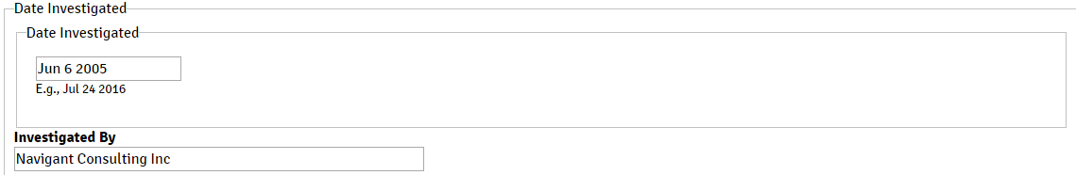
- Date Investigated: When the project was investigated by a student, faculty, volunteer, or staff member?
- Investigated by: Who is investigating the project?
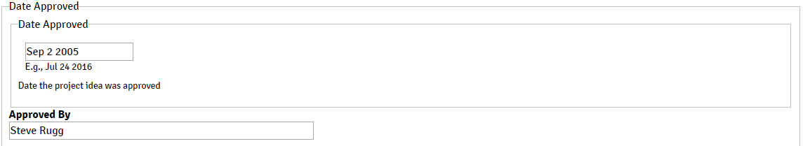
- Date Approved: When the iCAP project was approved by the official campus authority?
- Approved by: Who approved the project?
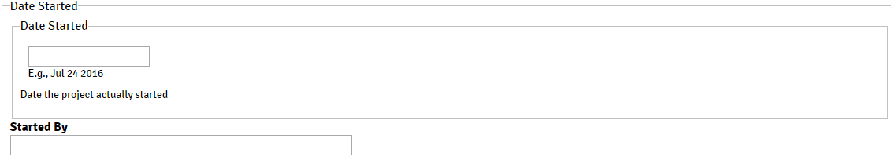
- Date Started: When did the project start?
- Started by: Who started the project?
- Date Completed: When did the project get completed?
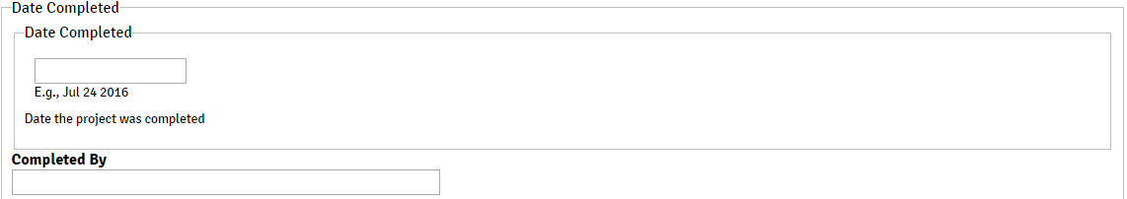
- Completed by: Who completed the project?
- Date Cancelled: When was the project cancelled? This is only applicable if the project is officially cancelled by the official campus authority.
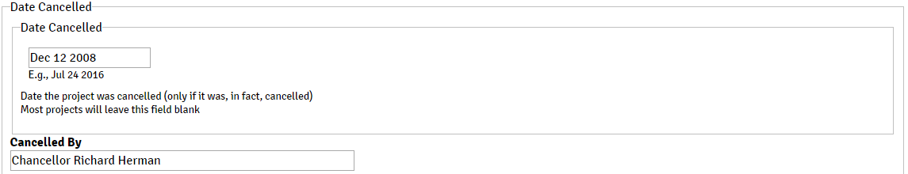
- Cancelled by: Who cancelled the project?
- Money
For Advanced users.
- Funding
For Advanced users.
- Locations

  - List the project location
Adding a Location to a Project is how the project gets added to the main Map. Include a project location if the project takes place at a specific location (or locations). It is possible the address has already been connected to another project, which will save you time. Simply start typing the name of the location in the Place field, and it will try to autocomplete the name of the place. If your location is found, then select it from the autocomplete list and add the room number, if the project location is in a specific room of a building. For example, one of the location for the theme ‘Reporting Progress’ is National Soybean Research Laboratory, Room #340.
  - Creating a new location for the project
If the location is not already included as a location choice, then add the location following these steps:
- Click on ‘Create Place’.
- Under ‘Title’, type the name for the location.
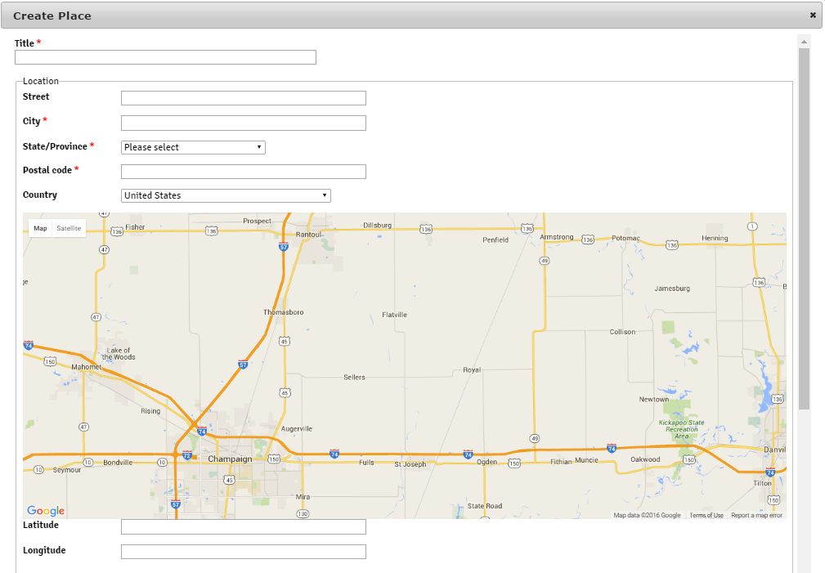
- Under ‘Street’, type the street name (for example, Pennsylvania and Sixth) – Not a mandatory field.
- Under ‘City’, type the name of the city under which this location falls (for example, Urbana).
- Under ‘State/Province’, type the name of state (for example, Illinois).
- Under ‘Postal Code’, type the zip code for the location.
- Select the country from the drop down menu under ‘Country’.
- Select the location from the Map included in this page.
- Once a location is selected on the map, it will generate the longitude and latitude for that location.
- Scroll down to the bottom of this screen and click on ‘Save’.
This is what others will use to look up the location you are entering later for their projects, so please use the most commonly recognizable title possible and avoid acronyms, shortenings of words in the title, and misspellings.
- Files
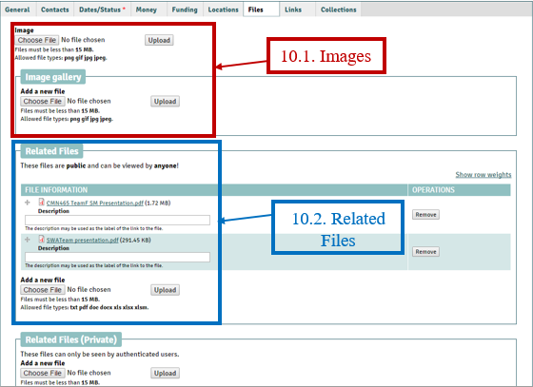
  - Images
Upload the image(s) in the ‘Image gallery’ option after choosing a file from your device, if there are one or more images related to the project. If there are no pictures for the project, leave this field blank. The image(s) uploaded here will be displayed on the main screen of the project.
  - Related Files (Public)
Any file related to the project should be uploaded here in this section. You don’t have to use the Private field for related files. These files could be the factsheet for the project or any report. These files will also be on the main screen of the project.
- Links
The website link/url related to the project should be included in this location. Add the title to the website and the link to that website.
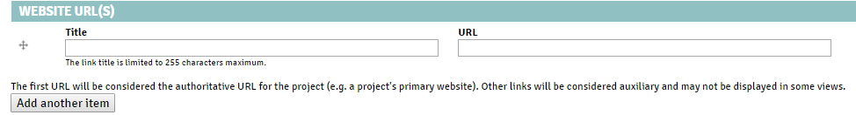
- Collections
For Advanced users.

Conclusion
Congratulations! Now you have a basic knowledge about the iCAP Portal and how to do basic tasks within the portal. Explore the website and learn more as you go. If you have any trouble regarding anything (on the portal), consult your SWATeam members and your SWATeam leader.
Stay tuned for the Advanced User’s Guide.

