
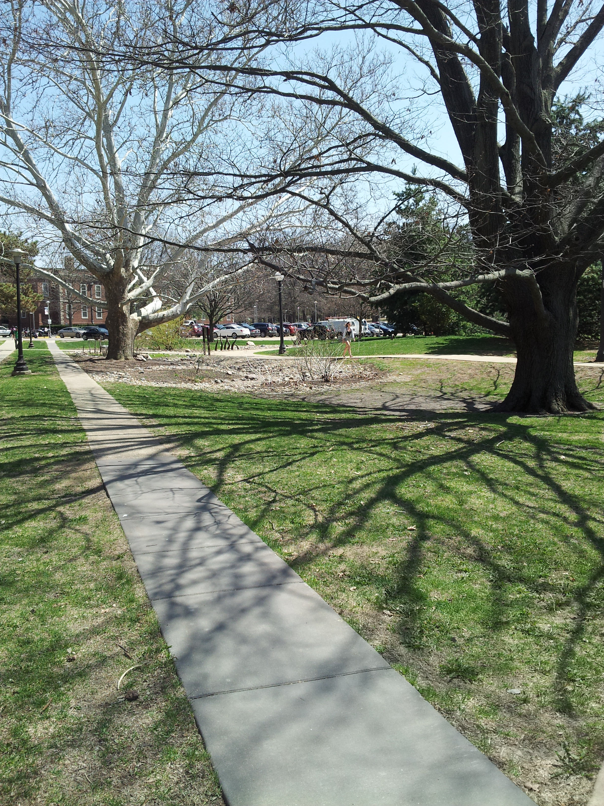
Shuying Guo
ICAP Portal Reporting Progress
College of Agricultural, Consumer and Environmental Science
University of Illinois, Urbana-Champaign
Red Oak Rain Garden Project Assessment
Executive Summary

The major goal of this report is to quantify and qualify the impacts of Campus Red Oak Rain Garden project from University of Illinois on various metrics, including environmental, economic and educational contexts and to make suggestions for plan implementations of future projects. However, due to limited quantitative information, suggested impacts analysis is primarily based on literature reviews.
Thanks to project coordinator Eliana Brown, Professor Anton Endress, Ground Maintenance Superintendent Ryan Welch and Professor James Miller to provide related information for project assessment.

Background
Rain garden, also called bioretention areas, is a depressed vegetated garden that can capture and infiltrate surface stormwater runoff from roofs, parking lots and impervious sidewalk. It is generally applied to urban area, where highly impervious land surface reduces the infiltration ability of land. It works like a wetlands which can manage flooding and improve water quality. Effective vegetation selected is usually native species with high resistance to drought and moisture condition.
Red oak rain garden is the first rain garden in our campus. The construction started from August 2006 and completed in April 2007. It is located in front of Allen Hall on Dorner Drive. In the past, the sidewalk near Dorner Drive regularly flooded after rains. Red oak tree and the surrounding lawn were damaged by accumulated flood. Red Oak Rain garden was designed to solve this problem. In spring semester of 2006, students from NRES 420 (Restoration Ecology) developed rain garden plans. Later in summer, NRES 285 class finalized the design and ordered supplies and construction materials. At last in fall, students from NRES 294 built the rain garden. Anton Endress is the project principal investigator and course instructor. Other professional consultants of this project include Carol Emmerling-diNovo and Douglas Johnston from Landscape Architecture department and Edwin Herricks from Civil and Environmental Engineering Department.
The project was Funded by Facilities & Services in conjunction with environmental council. Total original estimated cost was &12, 500. The Estimated cost for site preparation and rain garden installation was $10,000. The rest was for teaching assistant’ salary. After the construction, the rain garden has been managed by campus ground maintenance also funded by Facilities & Services. Monitoring program was developed by students but has never been carried out due to fund limitation.
Original draft of the plan, students’ notes and partial purchasing plans provided by Anton Endress and the project coordinator Eliana Brown were analyzed for evaluation of construction phase. Post-construction information is very limited due to no existing monitoring program and no maintenance and operation data record kept. Photographic records before and after construction were also collected for visual evidence.

Major Goals
The primary goal of red oak rain garden project is to demonstrate that rain gardens are possible to mitigate local flooding issues, and how ecological principles can be applied to solving environmental problems. Second, improve the landscape sustainability and reduce carbon emission. Third, improve sustainability consciousness by education and outreach program.

Siting and Design Considerations
Rain garden is a kind of green infrastructures designed for low impact development (LID) practices. According to United States Environmental Protection Angency, LID is “an approach to land development that works with nature to manage stormwater as close to its source as possible.”(USEPA) It preserves and recreates natural landscape features to mimic natural process to infiltrate onsite water runoff. The original ecological and hydrological conditions near Allen Hall location were analyzed. Site analyze the pre-construction conditions of the site including soil composition, subsurface condition, slope, sun exposure, existing vegetation and storm water runoff, and pedestrian movement. A grading plan and a layout of planting plan are developed based on the site analysis. In order to meet the standard of a LID requirement, vegetation species, quantities and sizes were carefully selected and choose. Total 27 kinds of non-invasive plant species were selected with total cost of $3,137.95 (Table 1). However, the overall plant performance was not measured after construction. No convincible and further conclusion can be draw from current available data.
Table 1 Plant Species Lists of Red Oak Rain Garden (Endress, 2006)
Plant Species List | Quantity
American bellflower | 33
blue flag iris | 22
bottle brush grass | 15
butterfly milkweed | 20
buttonbush | 11
cardinal flower | 39
garden phlox | 15
kalm hypericum | 22
little bluestem | 36
marsh milkweed | 16
midland shooting star | 20
pale purple coneflower | 18
Pennsylvania sedge | 120
Pennsylvania sedge | 100
prairie dropseed | 12
prairie smoke | 10
purple sheathed graceful sedge | 20
queen of the prairie | 6
red osier dogwood | 4
spicebush | 5
sweet joe pye weed | 5
sweet pepper bush | 5
wild blue sage | 7
wild columbine | 14
wild geranium | 15
wild white indigo | 30
winterberry | 15

Operation & Maintenance
According to Ryan Welch, the general rain garden maintenance work includes basic cleanups and weed control during growing season, like leaves and litter removal, hand weeding and round-up. Mulch is added in the areas that are not rock once a year. They haven’t replaced any plants for couple years. Unfortunately, they didn’t keep daily record and financial cost for maintenance work.

Life Cycle Assessment
Based on current available quantitative and qualitative data, a complete project assessment is hard to achieve. However, possible assessment methods like Life Cycle Analysis can be applied if we keep the record of construction details of the project. Life Cycle Assessment is a kind of risk management sustainable technology tool to make more informed decisions through assessment of environmental aspects and potential impacts associated with the project by four major steps:
- Define the goal and scope
- Analyze construction inventory
- Assess the impact
- Interpret the results

Rain garden vs. alternative solutions
Lacking of specific monitoring program and specific inventories of materials, equipment operations and onsite labor information makes quantitative assessment of red oak rain garden impossible. However the similar assessments on the rain garden projects from other university can be good examples for future improvement of our project. Program SimaPro 7.2 (ISO 14040-2006), a life cycle assessment and footprint software is used for LCA. SimaPro 7.2 is used in the inventory and model construction and post construction phases for green infrastructure practices.
In the study down by Kevin Martin Flynn from Villanova University, LCA was used to provide an indication of the effectiveness of two different stormwater treatment practices--- rain garden and green roofs by using SimaPro 7.2. Construction phase environmental impacts and operation phase impacts are simulated through the software. Result shows the impact of rain garden construction phase and post-construction phase or operation phase on climate change, terrestrial acidification, eutrophication, terrestrial ecotoxicity, etc. Impact was based on LCA functional unit of “impact per acre of impervious drainage area (DA)” Green roof construction phase has overall larger environmental impacts compared to rain garden (Table 2). The Operation phase shows that rain garden is an infrastructure with very low maintenance cost compared to green roof. Negative number means the avoidance of environmental impacts. Table 3 indicates that the operation benefit of rain garden are smaller than the operational benefits of green roof with same land size for the goal of stormwater management (Flynn, 2011). However, in terms of expense, the rain garden would be more cost-effectives with per dollar spent. Construction impact offset and breakeven analysis are also important indicator of the effectiveness of the project. shows the projected year takes to reach the break-even point of rain garden and green roof in Flynn’s study. The break-even comparison allows decision makers to choose the better options when dealing different situations or specific problem they want to solve.
Table 2. Rain garden vs. green roof construction phase impacts per acre impervious DA (Flynn, 2011)
Impact category | Units | Rain Garden | Green Roof
Global warming | kg CO2 eq | 9,884 | 636,932
Acidification | H+ moles eq | 10,219 | 120,156
Carcinogenics | kg benzen eq | 31 | 3,068
Non carcinogenics | kg toluen eq | 87,883 | 17,070,597
Respiratory effects | kg PM2.5 eq | 51 | 713
Eutrophication | kg N eq | 14 | 1,681
Ozone depletion | kg CFC‐11 eq | 0.0007 | 0.032
Ecotoxicity | kg 2,4‐D eq | 3,419 | 2,472,982
Smog | g NOx eq | 226 | 1,240
Onsite labor | hrs | 472 | 8,042
Cost | 2011 USD | 80,224 | 4,182,867

Table 3. Rain garden vs. green roof operation phase impacts per acre impervious DA, (Flynn, 2011)
Impact category | Units | Rain Garden | Green Roof
Global warming | kg CO2 eq | ‐126,608 | ‐265,842
Acidification | H+ moles eq | ‐4,953 | ‐61,239
Carcinogenics | kg benzen eq | ‐33 | ‐2,763
Non carcinogenics | kg toluen eq | ‐225,580 | ‐78,673,315
Respiratory effects | kg PM2.5 eq | ‐26 | ‐324
Eutrophication | kg N eq | ‐158 | ‐798
Ozone depletion | kg CFC‐11 eq | ‐0.0004 | ‐0.012
Ecotoxicity | kg 2,4‐D eq | ‐40,308 | ‐1,062,942
Smog | g NOx eq | ‐27 | ‐365
Onsite labor | hrs | 120 | 3,518
Cost | 2011 USD | 3,214 | 325,413

Another study down by R. Bennett and D. Bishop from Department of Civil and Natural Resources Engineering at University of Canterbury in 2011 compares the effectiveness of stormwater treatment among rain garden, subsurface sand filter and downstream defender. With same kind of assessment method like Flynn’s study, rain garden was determined to have the greatest impact on overall categories in its specific scenarios(Bennett, 2011).
Table 4 Operation phase offset summary, (Flynn, 2011)
Impact Category | Rain Garden Projected Break‐Even Year | Green Roof Projected Break‐Even Year
Global warming | 4 | 72
Acidification | 62 | 59
Carcinogenics | 28 | 34
Non carcinogenics | 12 | 7
Respiratory effects | 59 | 67
Eutrophication | 3 | 64
Ozone depletion | 59 | 80
Ecotoxicity | 3 | 70
Smog | 253 | 102

All these studies are good example of rain garden assessment, indicating the necessity of conducting a monitoring program to collect convincing quantitative and qualitative evidence during and after construction of the project to demonstrate the environmental benefits of rain garden and the fulfillment of project goals--- how ecological principles can be applied to solving environmental problems and how rain garden improves the landscape sustainability and reduce carbon emission.

Improvement Suggestions
Other potential ecological and social benefits of rain garden
There are many other potential benefits of rain garden that could be taken into consideration. Ecosystem services like biodiversity and recreation provided by rain garden are hard to quantify. Further indirect effect on other systems like air pollution removal requires more studies and data analysis.
The education goal of red oak rain project is partially achieved. Students’ journals from NRES 420 class in 2006 were studied. Frequently communication with clients, construction professionals and other work groups indicated a great improving in students understanding of campus sustainability and the importance of collaboration process in sustainability projects. Red oak rain garden was highly used for educational demonstration in 2006-2007, but it has hardly involved in education programs after that.

Management Plan Improvement
Current rain garden project needs a well-documented master plan. Information of the project is segmented without clarified and integrated long-term goals and objectives defined. Though collaboration work was carried out during construction phase, the actual implementation work and the outcomes of collaboration were not completed. Based on the journals of students who participated in design process, concerns about their ability to influence the actual decision making for the project and difficulties to receive funds for future modification are noticed (Robinson, 2006).
Lacking of available data becomes the major obstacle to assess this project, and it is also the major limitation for gathering fund resources with limited public attention and stakeholder interests. The project draws little public attentions after it was built because very limited information is open to public. “Current ecological restoration class no longer teaches about rain garden. It is a very small specific topic. Different professors have different focuses.” according to Dr. Miller, who is the NRES 420 professor now in our campus. The educational value of red oak rain garden is also limited.
For future improvement of similar project, an integrated master plan with long-term goal may work out well than current one. Using of public media for information delivery and advocate is also important. The sustainability Tracking, Assessment & Rating System (STARS), a program of Association for the Advancement of Sustainability in Higher Education (AASHE), is a very good platform for university to share sustainability information. However, the information about stormwater management of our campus is very limited. According to the studies done by Kyle Peterson from our university, the STARS could be a driving force promoting stormwater management projects in our campus (Peterson, 2013). In conclusion, Red Oak Rain Garden, to certain extent, represents a paradigm shift of stormwater management practices from installing drainage pipes to a more natural solution, but it could be more successful if we have a long-term well-documented plan.

References and Interviews
Brown, Eliana. 2014. Interview with author. Telephone interview.
Welch, Ryan. 2014. Interview with author. Email correspondence.
Endress, Anton. 2014. Interview with author. Email correspondence.
Miller, James. 2014. Interview with author. Personal interview. University of Illinois at Urbana-Champaign.
"Low Impact Development (LID)." EPA. Environmental Protection Agency, Web. 9 May 2014. <http://water.epa.gov/polwaste/green/>.
Life Cycle Assessment (LCA)." EPA. Environmental Protection Agency, Web. 9 May 2014. <http://www.epa.gov/nrmrl/std/lca/lca.html#define>.
"What is Green Infrastructure?." EPA. Environmental Protection Agency, Web. 9 May 2014. <http://water.epa.gov/infrastructure/greeninfrastructure/gi_what.cfm>.
Bennet, R, and D Bishop. "Life Cycle Assessment of Stormwater Treatment Systems ." University of Canterbury: Web. 8 May 2014.
Flynn, Kevin. "Evaluation of Green Infrastructure Practices Using Life Cycle Assessment." Villanova University. Web. 1 May 2014.
Peterson, Kyle. "Sociotechnical System in Campus Stormwater Management: Impediments and Driving Forces for Refined Sustainable System." University of Illinois at Urbana-Champaign. Web. 1 May 2014.

