Peter Whitney
Sustainability Analysis of the Campus Bike Center- University of Illinois at Urbana-Champaign
- Introduction
Each year, the University of Illinois and the Student Sustainability Committee review, select, and fund a growing number of sustainability projects. According to the US EPA, “Sustainability creates and maintains the conditions under which humans and nature can exist in productive harmony, that permit fulfilling the social, economic and other requirements of present and future generations”. Sustainability is really a relatively new lens for the examination of actions at all levels. And with any new development, it is imperative that a body of language and a conceptual framework is developed around the consideration, implementation, and evaluation of projects that have goals related to an increase in sustainable practices. There has been significant development in this area in recent years. But, as evidenced by the UIUC Department of ACES’ NRES 285 Spring 2014 class examination of UIUC sustainability projects, there are significant areas for improvement. The class examined various projects funded in part by the Student Sustainability Committee, and aimed to examine their true effects with a closer lens.
The framework for that lens is Sustainability Metrics, wherein different actions with the goals of increasing sustainability can be considered using common units for purposes of evaluation and comparison. For example, energy savings can be translated into a weight of CO2 or Green House Gas Equivalent. The same could be done for an action such as planting trees, or perhaps ceasing to mow certain areas of turf. Sustainability metrics allow us to examine these different kinds of projects with common units. This helps us to make more effective decisions and evaluations. This is vital, as funds and person power hours are often limiting factors for sustainability projects.
While sustainability metrics are highly valuable, and will only continue to be expanded, developed, and included in institutional decision-making, it is clear that there are certain limitations to the system as it stands. Intrinsically, certain aspects of sustainabilty are easier to quantify. For example, there is still significant debate as to how one can assign a metric to aesthetic, cultural, and social values included in sustainability projects. In my project, I hoped to look more closely at these non-traditional sustainability metrics. Using the Campus Bike Center as a case study for the valuation of virtues offered by the center that cannot be readily assigned a quantitative value, and to development framework plans and suggestions for the integration of data collection that would allow sustainability metrics to more easily be applied.
- The Campus Bike Center
The campus Bike Center opened for business in May 2010, funded by The Bike Project of Urbana-Champaign, a grant from the Student Sustainability Committee, the Center for a Sustainable Environment, and supplementary funding from the Facilities and Services Department at UIUC. The Center offers a hands-on, educational space in which students and community members can have access to knowledge and experience in maintaining and fixing bicycles, as well as all of the necessary tools and products to do so. The Center’s outlined mission is to teach bicycle maintenance, providing access to affordable equipment, support overall safety education, and participate in campus bicycle community outreach². The Center also has described goals for sustainability; to contribute towards the ICAP goal to reduce transportation emissions by 50% in 2025, support those who use bicycles for transportation, to make bikes a more feasible alternative to motor vehicles on this campus, and to expand these efforts even more through increased outreach and publicity efforts, increased staff capacity, more events outside of the shop to reach new audiences, more refurbished bikes to sell to students, and more courses, workshops, and demonstrations to educate the campus about bikes^{2.}
As a part of its sustainability goals, the Center does a lot to limit their outputs and contribute to the larger community. An estimated ~90% of all equipment transport to the shop is done by bicycle. Thus includes transport of salvaged bike parts/frames, products from the Urbana location, and employee travel. The majority of bike parts are used/salvaged from dump or abandoned, and a small minority of products sold as new (bike lights, locks, batteries). There have also been collaborations with other community groups, such as their local farm equipment collaboration projects (provided used materials for farm equipment development – bike rims and used parts used to create seeding equipment, bed preparations – more accessible farm equipment. The Center also recently completed their first international bike aid shipment, sending working bikes and maintenance parts as aid.
The Campus Bicycle Center is located at 608 E. Pennsylvania Avenue in Champaign, IL. It is open five days a week, The main source of revenue comes from memberships. Annual memberships are available at different rates for students, community members, and families/partners, and can also be obtained in exchange for eight hours of volunteer work. Memberships are valid for both the Campus Center and the Urbana Bike project, and acts as a “stock” in the cooperatively owned project, where all members are encouraged to participate in steering committees and the operation of the business as shareholders. Patrons are also allowed one free visit and use of the shop, without membership. The shop has a total operating budget of $70,000 each Fiscal year²; which includes 1 salaried shop manager, 5 student workers, product orders, and various operating costs of the space
The center operates on principles of mentorship and education. It is not a "drop it off for repair" bike shop. It is a space where you will perform all of the repairs necessary for the maintenance or build of bicycles, albeit under guidance and supervision of the center’s manager and rotation of student workers and volunteers. The center is equipped for a variety of repair/maintenance tasks; including fixing flat tires, making brake adjustments, adjusting bearing systems, correctly adjusting your bicycle to your body, help with shifting and chain issues, installing safety devices, build your own bike from scratch, and much more. The center encourages members to build their own bicycles, and also sells refurbished bicycles (built by employees and volunteers) and low-cost lights, locks, and other safety devices. The vast majority of items for sale are from abandoned or thrown away bicycles and parts, diverted from landfills. As it is an on-campus location, students make up the primary membership, visitor, and volunteer base of the center. Student employees and volunteers help to shape the form and future of the shop by sharing ideas and input into new events, outreach efforts, and services provided by the shop.
In the future, the Center plans to continue its development towards financial independence and to develop new and improved tactics for publicity and outreach efforts for the shop. Each year the center has experienced positive growth in all aspects of sales, visits, and use. As a sustainability project on campus, it is claimed by many different stakeholders. The bike center is a prominent fixture in the Campus Bike Plan, Illinois Climate Action Plan transportation goals, Student Sustainability Committee materials, and in general campus sustainability literature.
- Existing and Possible Future Metrics
While the Center is actively working towards sustainability through bicycle transportation and a variety of different partnerships and projects, there is currently very little data being collected on actions towards sustainability. The center’s data records, as provided to me by Manager James Roedl, track business/operational costs, numbers of memberships sold, and daily visits.
Evaluating sustainability in a business environment is widespread practice. Principles for evaluation are well defined by the National Association for Environmental Management. Major categories for measuring sustainability in businesses include global EHS (Environmental Health and Safety), GHG reduction, data and metrics, leadership development, staffing and infrastructure, compliance, and workplace health and safety. As with most evaluations of sustainability, certain categories are more easily adapted to quantitative evaluation (GHG reduction, compliance), while other topics may be assessed more qualitatively (leadership development, staffing). However, as outlined in their publications, research, and affiliates council guide there are ways to analyze all of the measurement categories^{4.}
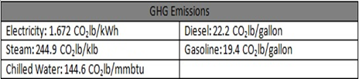
The center’s services primary contribution towards sustainability goals is their support for members in making bicycles their primary mode of transportation. Increased membership and shop use can be associated with an increase in campus sustainable transportation. However, given current lack of data, it is difficult to provide concrete data towards that claim. While soft evidence and personal testimony may provide backing for the shop’s contributions towards sustainability – there is still no means for comparison or measurement of the center’s effect over time. Data on the center’s use will provide the necessary backbone for the metrics evaluation of the center’s contributions towards sustainability, and will allow for analysis towards the valuation of use and non-use values, including traditional measures of energy usage/reduction and production outputs, as well as social, cultural, aesthetic, and other values associated with campus use of the center. Thus far, metrics data has been mostly absent. In the SSC application, the Center did not include any report of estimated GHG impacts of the project. It was unclear if the lack of this data estimate was due to a lack of metering availability or insignificant contributions. A first step in counting the Center’s footprint could be the metering of utility costs, and use of the provided campus GHG equivalent estimates, provided by Facilities and Services¹⁰.
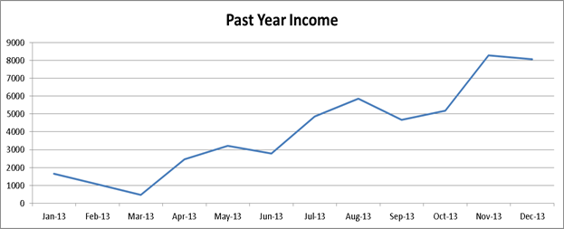
The center serves as a highly effective, practical resource for the campus’ thousands of bicycle riders, and its presence enforces the value and viability of the uses of bicycles as an alternative to more resource-intensive modes of transport. And there is a wide background of empirical evidence supporting the low-impacts of bicycle transportation. Bicycles produce 0.912 metric tons of carbon equivalent per $1,000 of manufacturing cost. Interestingly, this value is actually higher than that of cars, which produce 0.628 MTCO2E per $1,000^{5,6}. So, bike manufacture is actually dirtier per thousand dollars. However, considering the total weights and costs, cars are in aggregate far more resource intensive to produce. Beyond production, tailpipe emissions, the impacts of gas exploration, congestion, infrastructure damages, impacts on human health and increased risk, and other issues must be considered⁵. Additionally, for the majority of bicycle Life Cycle Analyses, average life of a bicycle is assumed to be 15 years. This is set to be consistent with the average car life. In the case of the campus bike center, however, many of the bikes and parts are older than 15 years, which is important to consider in ROI values and GHG equivalent emissions. Also, bicycle Infrastructure costs, which are a factor of 10x lighter than motorcycles, and parking costs (one car spot is ~+100x more expensive than bike parking spots) are considered negligible and ignored⁷. Bicycles require 319 kJ of energy input and releases 33 grams of greenhouse gases per passenger mile traveled⁷.
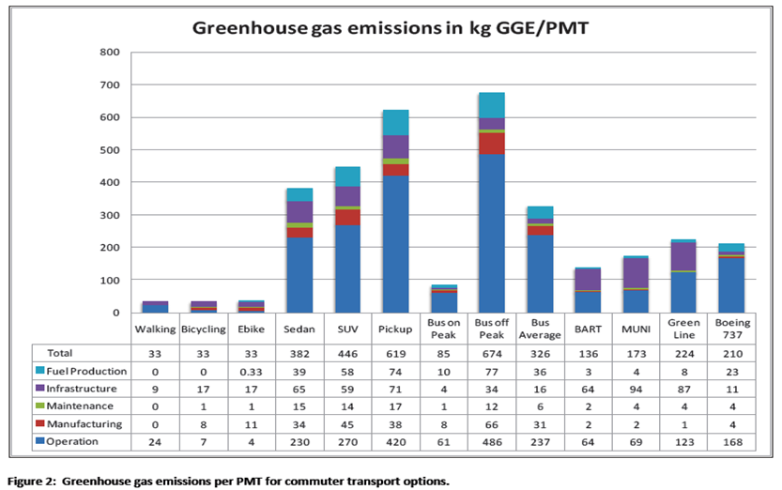
According to Life Cycle Analyses done on all major transportation modes, biking is one the most efficient form of rapid transport⁷. Bicycling, Walking, and Electric Bikes all ranked the same – contributing 33 kg in greenhouse gas emissions per mile travelled. Long-term, however, one should note that bicycling will have the lowest emissions, due to their useful life lasting much longer than the assumed 15 years done by the study. Especially on a used bike from the Campus Bike Center, where the majority of bicycles and parts are older than 15 years, bicycling takes less metabolic output than walking and (if older than 15 and from the Center) essentially has no manufacture costs and is actually diverting waste from Landfills. There can be no question that the Bike center and biking for transportation has a positive impact on the environment, but without metrics there is no effective way to communicate this to the public.

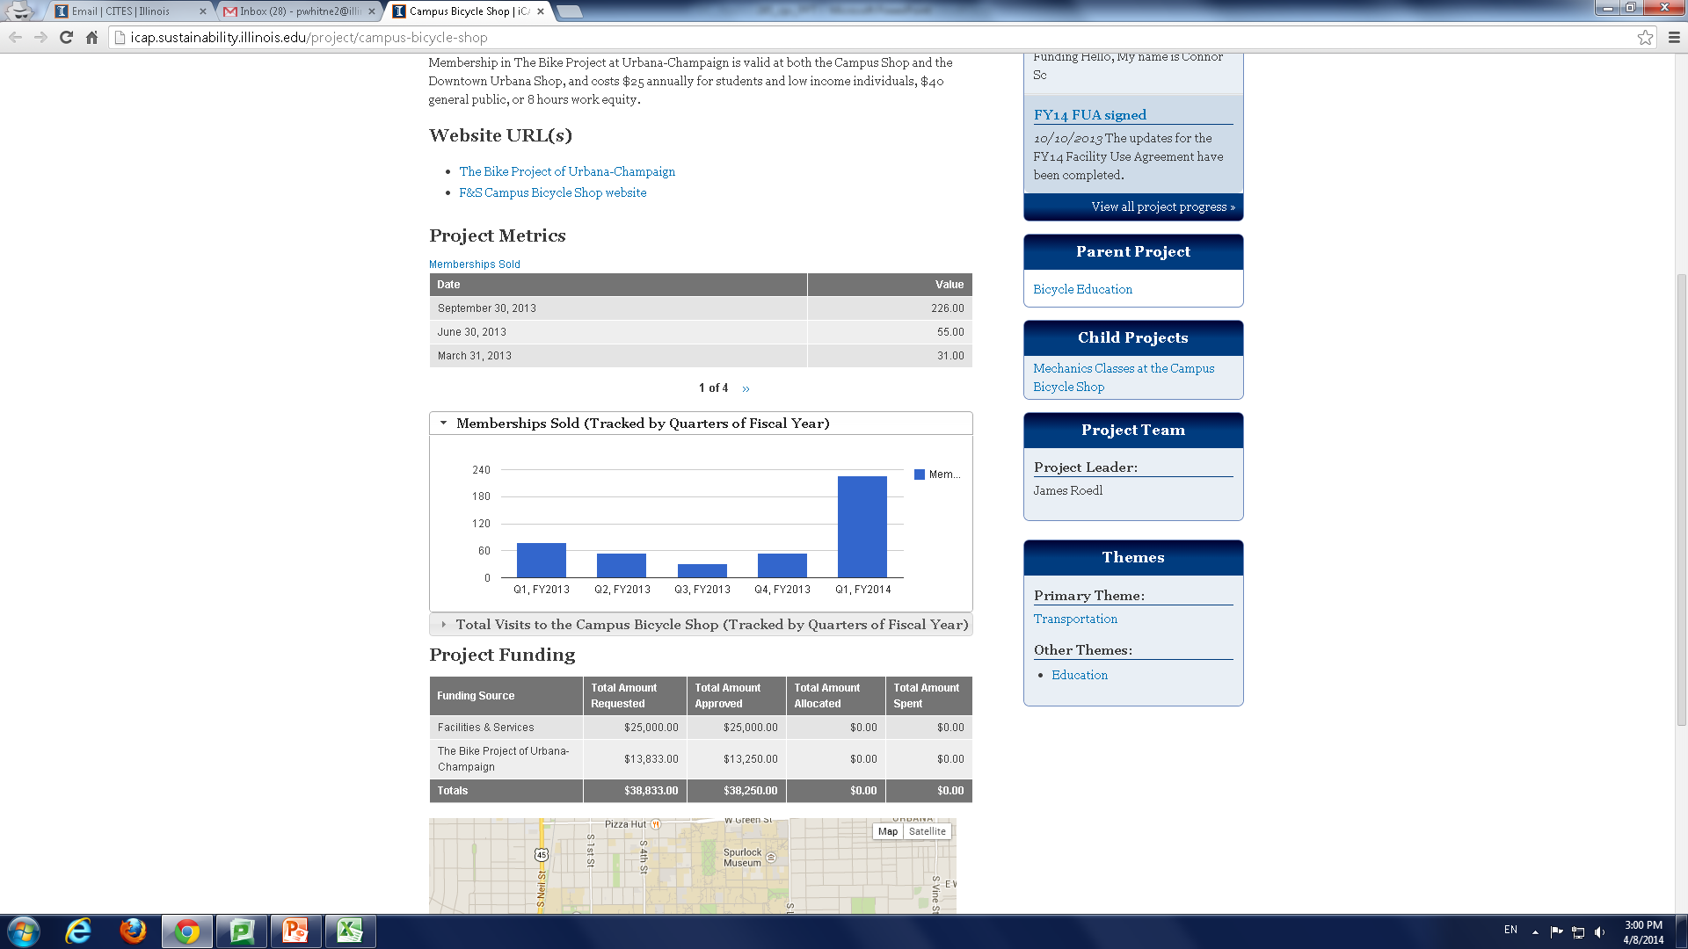
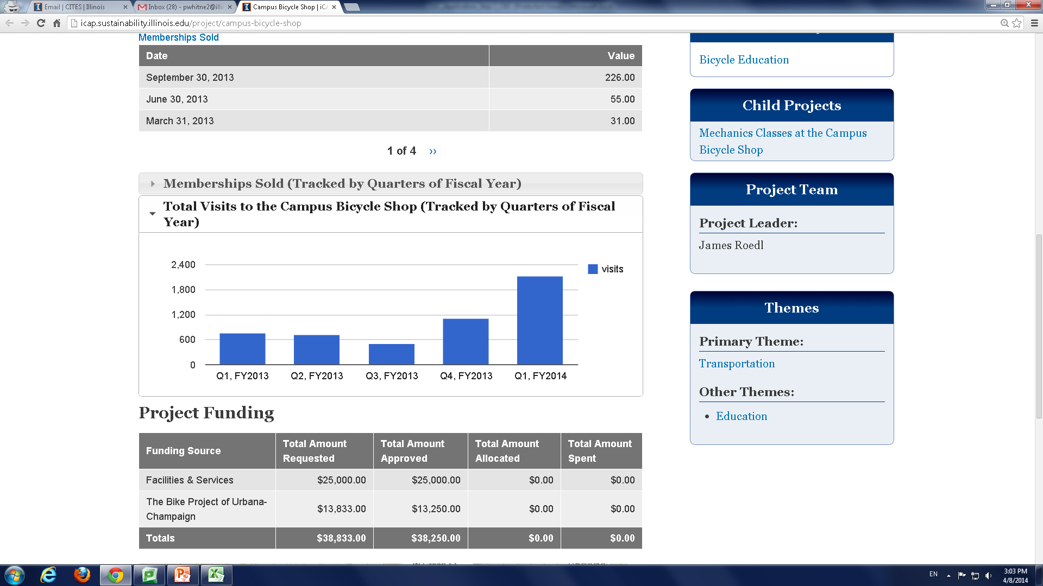
In FY13, the center made $55,869.84 in total product sales³. The center sold 131 refurbished bikes, and provided products for 60 bikes to be entirely built by patrons³. 138 sets of lights were sold, allowing patrons to comply with local law and also increase campus safety³. 36 students participated in the first round of offered classes held at the campus shop, which taught students a wide variety of skills for the building and maintenance of bikes³. 31 donations were made to the center, totaling to over 600$³. Yearly developments in the Center’s use are clearly rising. By comparing Quarter 1 in FY 2013 to Quarter 1 in FY 2014 in terms of both memberships sold and total visits, there is clearly a high positive trajectory in use.
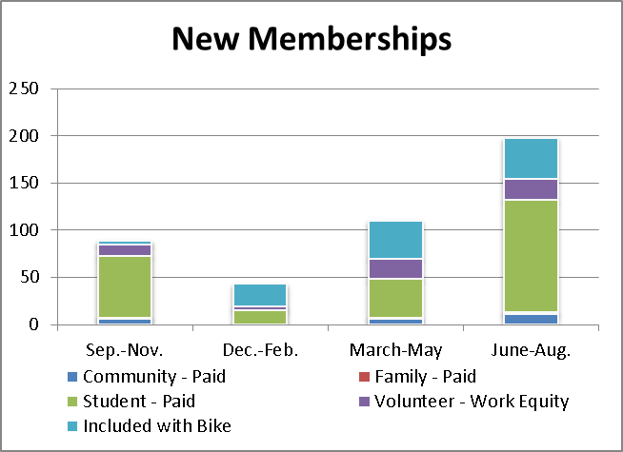
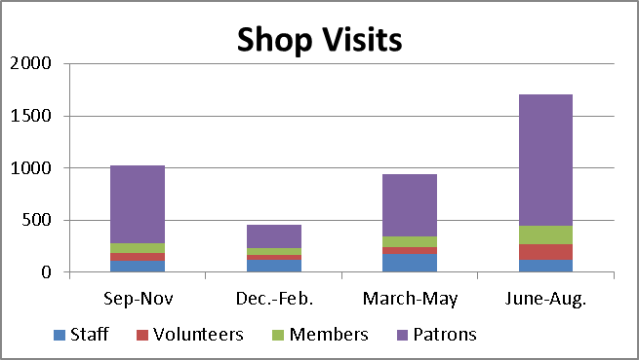
Within a Fiscal Year, it is also important to note that there are definite seasonal differences in both the use of the center and the memberships sold. One might associate these changes in number of visits is due to weather, but there is no concrete way of knowing without a user survey or other form of data collection of patrons.
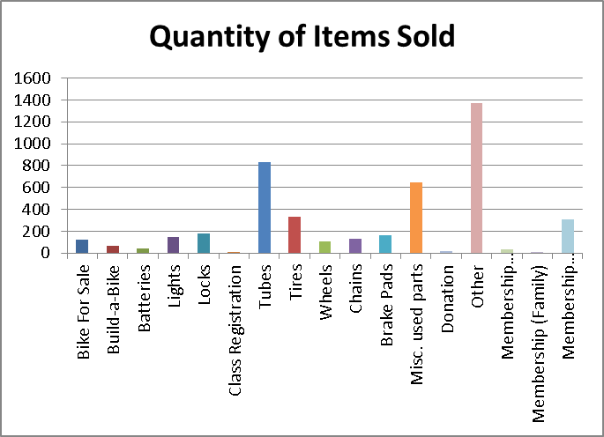
There were 1070 bikes and tubes sold in one year at the center³. I will specifically highlight this number, as it could easily be adapted for a case-study in social science research and the development of a sustainability metrics. Tire/Tube flats were identified as the primary issue for patron visits and the most common issue for bicyclists. It also represents a direct opportunity for the development of a metric towards bicycle use.
Without the Center, how many of those flats would have been fixed? How much more quickly were they fixed? Did the reduced price available at the center make students more likely to fix the issue? How many flats were fixed because of knowledgeable students that learned how to repair the tire at the center? Did these students teach other students? As a result of fixing the issue, were patrons better able to maintain their bike? Did this issue introduce you to the bike center, and prompt future use of the center or the purchase of a membership?
Without careful data collection, we have no way of answering these questions. With simple user surveys or other forms of data, however, we could find the answers to these questions and attach significant metrics to this singular aspect of the center. This methodology could be applied to a variety of repairs at the center. With data collection and scientific analysis, we may find that this number represents a hugely important aspect of student sustainability on campus. Without it, however, we simply have a number of items sold with no significant value towards campus sustainability.
Even with the data already collected by the center, there are a myriad of analyses available for the valuation of sustainability. From the number of shop visits, 4443+ unique visits³, further research could reveal the typical use per visit, with the ultimate goal being the finding of the effective extension of bicycle-life per visit of patron visit. This value could then be compared to the production costs of new bicycles, or perhaps compared with the values found by a study showing the likelihood of using other modes of transport when a patron is unable to fix their bicycle.
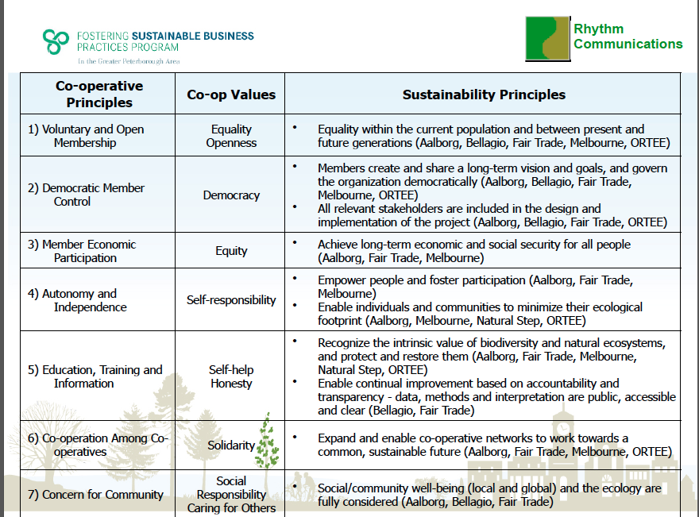
In FY13, 328 new members of bike shop were added³. Data could be collected on new members about their increased bike usage vs car usage, reasons for joining, empowerment/usage resulting from knowledge learned, cultural values, etc. Product sales could also be analyzed for sustainability values. In FY13, 131 pre-built bikes sold and 60 bikes built, totaling in 191 used bikes bought³. These bikes were almost entirely built from used parts that were diverted from landfills, and also carry their educational and promotional value towards bicycle use. One could measure reduced impact by landfill avoidance, analyze each part for production emissions and costs for upkeep (used vs new). Ultimately, a normalized value for a Campus Bike Center used bike could be compared to that of a new bike, a used bike from another source, as well as any other form of transportation.
Beyond the function of the bike Center, the cooperatively owned membership model of the Bike Shop contributes inherent sustainability values. The chart below illustrates the 7 main identified principles of co-operatives, as identified by a study done by Rhythm Communications. Each value relates to distinct sustainability principles, and certainly can be said to have some value in the promotion of ecologically sensitive values, but needs to be further explored with sustainability metrics.
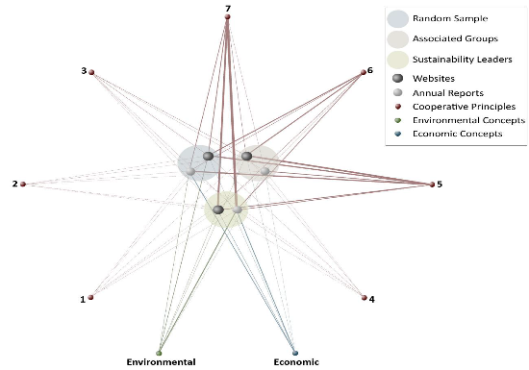
Another study related the 7 principles of cooperative ownership to the other stated values of sustainability (Social), Environmental, and Economic. The study looked into co-operatives stated Sustainability principles – looking at random samples of co-operatives, associated group co-operatives, and co-operatives identified as leaders in sustainability. These co-operatives were searched by literature (ie Annual Reports, websites, publications, etc) and linked based on hits related to sustainability principles. Results below indicate the relationships between cooperatives and these principles, and represents one technique for relating highly qualitative values to empirical study.
- Suggestions for improved Analysis
Speaking with the shop manager, there were two main identified areas for improvement in the Center’s sustainability. First, they occupy a highly inefficient space (formerly a garage for fleet vehicles). There are visible cracks in areas, garage door openings – solutions could include possible weatherization of space or the replacement of garage doors. Also, the shop uses some high-consumption equipment (bandsaw, welding) – these could be considered for eventual replacement for more efficient models, or perhaps fed by an alternative energy source. The shop welcomed any sustainability study, limited in funds and staff. It would be important to consider metrics in these decisions, to find what course of action truly has less of an impact.
In analyzing the Center’s success, the first question is whether or not they have achieved their stated goals. To this end, I would conclude that yes, the center achieves what it is created to do. And the shop has been highly successful, given constraints in budget and time. But, as with any sustainability project, the real question is to what degree were goals achieved. There is significant room for improvement in metrics quality and quantity for sustainability measurements. Until data is collected, it is hard to assign realistic values for rough estimates and qualitative project descriptions. As is the case with many campus projects, the Center illustrates need for the campus to move beyond one-time project evaluations and colloquial review. From the bike shop to solar panel installations, a much more thorough and developed review process is needed to accurately assign measures of reductions, improvements in sustainability.
Upon completing my review of the Campus Bike Center, I have developed a few preliminary recommendations for the Center. In the short term, given the opportunity, there are many actions that could be taken to increase data collection for the purposes of measuring sustainability. Currently, patrons sign in each time they enter the shop – indicating their arrival as patron, volunteer, or worker. This could be used to collect far more user data, from User surveys to more specific questions on use to receiving feedback. Additionally, a policy of signing-out (instead of signing in or in conjunction with signing in) could have users track their time, travel, and specific actions taken during their visit. For the Center operation; simple figures such as tracking the amount of miles travelled by bike when transporting goods could be a great aid to developing metrics. Overall, there could be an increased focus on messaging and framing illustrating the Center’s aspects of sustainability.
In the Long-term; greater integration of the shop into campus programming and advocacy could increase membership and general use of the Center. Using newly collected data, research could establish Life Cycle Analyses for each product and service offered by the Center. The Center’s relative effect on biking transport could be compared to other modes of campus transport, and given a more specific value in the university’s ICAP goals for reduction. The space could be better weatherized to decrease energy consumption, or a possible relocation could be considered. The could also be LCA’s done on the equipment used at the shop, and cost-benefit models run to determine whether or not they should be replaced. Since the Center is a highly dynamic, active body; there are innumerable opportunities for development of projects focused on sustainability.
Using the Center’s new data and assigned sustainability metrics, the Student Sustainability Committee could use the Center as a case study for the development of revised application standards which include specific and separate budget sections for long-term monitoring and reporting. Overall, SSC projects could benefit from a more scientific approach and have a goal of using projects to create active bodies of data collected. If all projects were required to require certain standards of sustainability data; students, faculty, NRES 285 and LINC courses, statistics courses, and any other interested parties could take part in the evaluation of projects using empirical data through the lens of sustainability. With a renewed focus on student involvement and data collection; the SSC could use student body surveys, votes, and employee students in the decisions made regarding funding proposed projects. A more accessible application process, balanced with more aggressive use of funds for monitoring/implementation, could yield a much more efficient SSC program. The SSC would then, in turn, be used as a case-study for the UIUC campus at large, and perhaps eventually the entire UI system.
On the campus level, the SSC model of increased student involvement and data collection centered on sustainability metrics could be used to develop a Sustainable Communities Strategy (SCS) specific to Campus. SCS’s are municipal strategies with goals of aligning transportation investment, land use, and housing policies to meet greenhouse gas emission reduction targets. Currently, under California’s climate strategy AB32, SCS’s are required and municipalities must show plans for increased bicycling and models for reducing vehicle miles travelled – or they risk losing state transportation funding¹¹. The implementation of an SCS on campus would be an interdisciplinary effort, using campus units such as F&S, ICAP and ISEE, and the student body. This would lead to an increased awareness and motivation for sustainability metrics, and in turn a shifted paradigm that values a holistic focus on conserving and preserving resources at an institutional level.

"What Is Sustainability?" US Environmental Protection Agency. US EPA, n.d. Web. 7 May 2014.
Neptune, Amelia. Bike Shop Student Sustainability Committee Application. UIUC ICAP Portal. http://icap.sustainability.illinois.edu/project-updates/102. 11 Nov 2012. Accessed 8 May 2014.
Roedl, James. 2013 Funding Reports. Provided 17 April 2014.
NAEM Publications. National Association for Environmental Management. http://www.naem.org/?page=Publications. Accessed 8 May 2014
Umbra. "Impacts of Biking." Grist. N.p., 3 June 2008. Web. 08 May 2014
Mathews, Scott et al. "Economic Input-Output Life Cycle Assessment (EIO-LCA)." Economic Input-Output Life Cycle Assessment (EIO-LCA). Carnegie Mellon Green Design Institute, n.d. Web. 09 May 2014. 10 Bass, Micheal. UIUC FY13Budget and Rate Approval. UIUC ICAP Portal. http://www.energymanagement.illinois.edu/pdfs/FY13UtilityRates.pdf. 15 June 2012. Accessed 8 May 2014.
Shreya, Dave. “Life Cycle Assessment of Transportation Options for Commuters” Massachusetts Institute of Technology (MIT). http://files.meetup.com/1468133/LCAwhitepaper.pdf. February 2010. Accessed 6 May 2014.
“Making Environmental Sustainability” Paula Anderson, Peterborough Green-Up. Russ Christianson, Rhythm Communications. Accessed 6 May 2014.
“Cooperatives and Sustainability: An investigation into the relationship” Sustainability Solutions, Inc. Community Research Connections. International Co-Operative Alliance. Accessed 6 May 2014.
11 "Sustainable Communities Strategies (SCS)." Legislation and Policy. Bay Area Bicycle Coalition, n.d. Web. 07 May 2014.

